Anna wants a report on the pricing of the medicine. She wants a list of the most expensive and most affordable medicines only. Assist anna by creating a report of all the medicines which are pricey and affordable, listing the companyName, productName, description, maxPrice, and the price category of each. Sort the list in descending order of the maxPrice.
#Note: A medicine is considered to be “pricey” if the max price exceeds 1000 and “affordable” if the price is under 5.
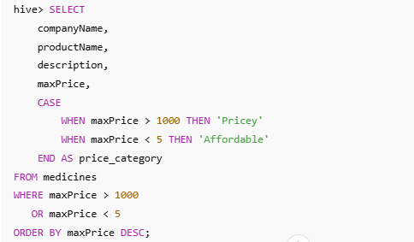
Output:
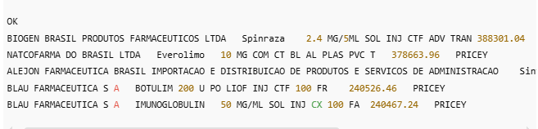

Joseph from Healthcare department has requested for an application which helps him get genderwise report for any disease.
#Write a stored procedure when passed a disease_id returns 4 columns,disease_name, number_of_male_treated, number_of_female_treated, more_treated_genderWhere, more_treated_gender is either ‘male’ or ‘female’ based on which gender underwent more often for the disease, if the number is same for both the genders, the value should be ‘same’.

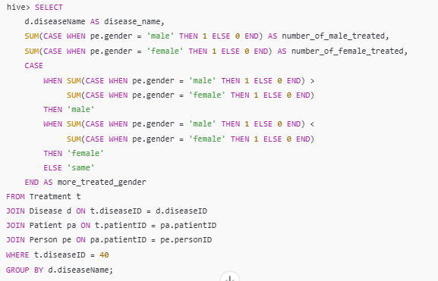

Output:
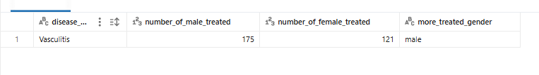

The Healthcare department wants a report about the inventory of pharmacies. Generate a report on their behalf that shows how many units of medicine each pharmacy has in their inventory, the total maximum retail price of those medicines, and the total price of all the medicines after discount. Note: discount field in keep signifies the percentage of discount on the maximum price.
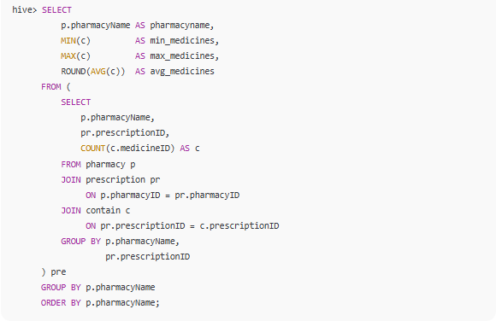
Output:
