KAFKA

KAFKA PRODUCER
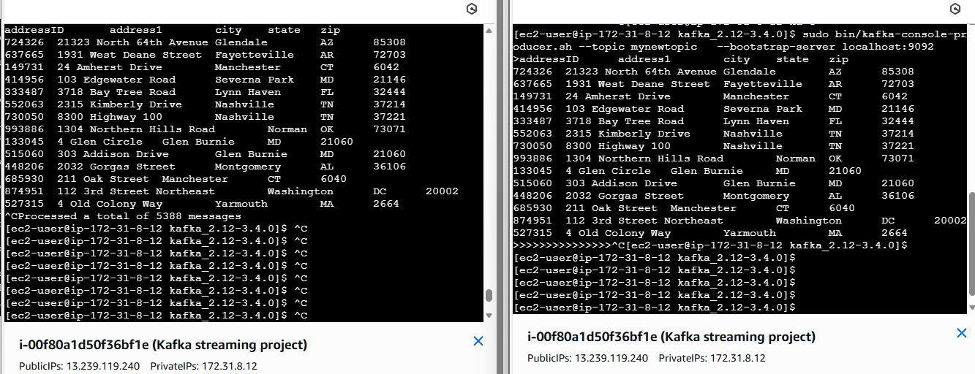
KAFKA CONSUMER

