

**CSE307– Internet and Web Programming**

**Assignment**

**iWebkit**

**Satvik Dhandhania**

**11BCE0431**

**COURSE INSTRUCTOR**

**ANTHONIRAJ AMALANATHAN**

**Submission Date: 06/05/2014**

**Introduction**

iWebkit is a file package designed to help us create our own iPhone, iPod Touch and iPad compatible website or webapp. iWebkit uses basic HTML, CSS and JavaScript to allow anyone who has basic web skills to create a fairly complex website that is optimized to look and act like a native iPhone application.

iWebKit is the framework of choice because it is very easy to use, loads extremely fast, is compatible with all devices & extendable. It is simple html that anyone can edit contrary to some other solutions that use a lot of  javascript & Ajax.  The basic between this framework and other frameworks is that this has been designed keeping the iPhone in mind. All the icons and various types of display icons, lists and input types are like the ones used in the iPhone. The advantage here is that just assigning a class or simply said assigning an element a class will categorize it as a input which has been generalized with the structure of an iphone webapp. This allows us to work on the desktop but the screen size and display has been optimized according to the phone.

Thus it just copy and paste of existing code and then modifying it according to our need, further it is easy to simply assign classes just to get our desired fields of proper size. It is the best working framework for making webapps for the iPhone.

This framework is highly recommended for static sites where there is no content management system.

The sites built with iWebKit look and act like a native app. I finished the basic layout of a site within hours of using this framework. The framework contains all basic navigational elements, form fields and other things necessary for any basic mobile website.

To develop a site that truly works with any browser this framework is not at all recommended.

**Installation**

The package we download from the website contains no executable file. It just consists of various codes snippets in the folders like framework, iwebkit demo. These code snippets need to be copy pasted as per our need to create websites.

The only prior preparation we can need is a basic comprehension of the overall HTML structure and CSS. The manual present in the package is enough to guide us how to proceed with developing webapps using iWebKit. The type of coding that has to be done consists mainly of copy and pasting sections of code in the appropriate position and adding the text and some properties to those pieces of code.

**The simple steps to start working with iWebKit are as follows :**

* Download the package,
* unzip it,
* read the user manual,
* follow the steps from beginning to end,
* Copy and paste the right bits of code in your document,
* add your own content,
* find some web hosting and deploy your website there using FTP.

**Detailed Description**

The various features of iWebKit are as follows

* extended computer compatibility
* images for extended plugins and top right buttons
* navigation buttons
* automatic image resize
* top-bar
* music lists
* item list with or without images
* slide effect as a plugin
* smaller and optimized code
* enhanced auto bug repair/avoiding structure
* mixing of items is possible
* comments on menu items
* sliding pop-up
* fullscreen support

**TOPBAR**

We have topbar which is present in the top of the navigation window. We can add many buttons for navigation on the topbar.

<div id="topbar">

<div id="title">Title</div>

</div>

**Navigation Arrows**

To create navigation arrows to the left of the topbar we can use this code inside the topbar div:

<div id="leftnav">

<a href="index.html"><img alt="home" src="images/home.png"/></a>

<a href="page1.html">Back</a>

</div>

**Navigation Buttons**

To create a button to the left of the topbar we use this code inside the topbar div:

<div id="leftbutton">

<a href="page.html">Back</a>

</div>

**The Content**

The content section consists various classes like graytitle, pageitem, textbox, header, menu, comment, arrow etc which can be used to generate our desired form of display along with the predefined HTML elements.

**Lists**

The content can be filled be lists which can each point out to different pages for navigation. These list items can have images, names, comments and arrows for display on the list. iWebKit also offers lists for music with class=”musiclist”

<ul>

<li>

<a href="page.html">

<span class="number">1</span>

<span class="name">Name of song</span>

<span class="time">(3:58)</span>

<span class="arrow"></span>

</a>

</li>

<li>

<a href="page.html">

<span class="number">2</span>

<span class="name">Name of second song</span>

<span class="time">(5:12)</span>

<span class="arrow"></span>

</a>

</li>

</ul>

Apart from these features the iWebKit provides FullScreen support, statusbar, embedded RSS feeds, mail, telephone, youtube, itunes , appstore and popup support which needs to be defined in the code using the code snippets provided by the user manual. A simple syntax of the code is given in the manual which can guide us to use the feature properly.

**Example of popup code**

<div id="cover" class="nocover"></div>

<div class="popup">

<div id="fullscreenfix" class="fullscreenfixclosed"></div>

<div id="frame" class="confirm_screen">

<span>popup example</span>

<a href="page.html">

<span class="gray">Gray Button</span>

</a>

<a href="page.html">

<span class="red">Red Button</span>

</a>

<a class="noeffect">

<span class="black">Cancel</span>

</a>

</div>

</div>

**Implementation**

**Source Code**

**<!DOCTYPE html PUBLIC "-//W3C//DTD XHTML 1.0 Strict//EN" "http://www.w3.org/TR/xhtml1/DTD/xhtml1-strict.dtd">**

**<html xmlns="http://www.w3.org/1999/xhtml">**

**<head>**

**<meta content="yes" name="apple-mobile-web-app-capable" />**

**<meta content="text/html; charset=utf-8" http-equiv="Content-Type" />**

**<meta content="minimum-scale=1.0, width=device-width, maximum-scale=0.6667, user-scalable=no" name="viewport" />**

**<link href="css/style.css" rel="stylesheet" media="screen" type="text/css" />**

**<script src="javascript/functions.js" type="text/javascript"></script>**

**<title>Satvik Demo</title>**

**<meta content="keyword1,keyword2,keyword3" name="keywords" />**

**<meta content="Description of your page" name="description" />**

**</head>**

**<body>**

**<div id="topbar">**

**<div id="title" class="black">Title</div>**

**<div id="duoselectionbuttons"><a href="A.html">Clock</a><a href="B.**

**html">Go to Page B</a></div>**

**<div id="triselectionbuttons"><a href="A.html">Time</a><a href="B.**

**html">B Text</a><a href="C.html" >C Text</a></div>**

**<div id="leftnav">**

**<a href="page.html" id="pressed">**

**<img alt="home" src="images/home.png" />**

**</a>**

**<a href="page2.html" >**

**<img alt="home" src="images/navrightblack.png" />**

**</a>**

**</div>**

**<div id="rightnav">**

**<a href="page.html" class="black" >Next</a>**

**</div>**

**</div>**

**<br><br><br>**

**<div class="searchbox"><form action="" method="get"><fieldset><input**

**id="search" placeholder="search" type="text" /><input id="submit"**

**type="hidden" /></fieldset></form></div>**

**<li class="bigfield"><input placeholder="Username" type="text" /></li>**

**<li class="smallfield"><span class="name">Satvik Dhandhania</span><input**

**placeholder="Logged in" type="text" /></li>**

**<li class="textbox"><textarea name="TextArea" rows="4"> Programmer , Music lover , Game addict </textarea></li>**

**<li class="checkbox"><span class="name"> Sound</span><input**

**name="checkbox" type="checkbox" /> </li>**

**<li class="radiobutton"><span class="name">Auto-save Feature</span><input**

**name="GroupName" type="radio" value="A" /></li>**

**<div id="content">**

**<span class="graytitle">Hello ! Satvik Dhandhania</span>**

**<ul class="pageitem">**

**<li class="textbox">**

**<span class="header">So what do you want to do ? </span>**

**<p>Let's work with iWebkit</p>**

**</li>**

**<li class="menu">**

**<a href="page.html">**

**<img alt="Description" src="thumbs/basics.png" />**

**<span class="name">Learn Basics</span>**

**<span class="comment">Start</span>**

**<span class="arrow"></span>**

**</a>**

**</li>**

**<li class="menu">**

**<a href="page2.html">**

**<img alt="Description" src="thumbs/ipod.png" />**

**<span class="name">Music Player</span>**

**<span class="comment">Play</span>**

**<span class="arrow"></span>**

**</a>**

**</li>**

**<li><a href="page.html"><span class="number">1</span><span**

**class="name">Burning Gold</span><span class="time">(1:33)</span><span**

**class="arrow"></span></a></li>**

**<li class="menu">**

**<a href="A.html">**

**<img alt="Description" src="thumbs/clock.png" />**

**<span class="name">Clock</span>**

**<span class="comment">What's the Time</span>**

**<span class="arrow"></span>**

**</a>**

**</li>**

**<li class="store"><a href="page.html"><span class="image" style="backgroundimage:**

**url('thumbs/youtube.png')"></span><span class="comment">Youtube</**

**span><span class="name">Star Wars</span><span class="stars5"></span><span**

**class="starcomment">5 ratings</span> <span class="arrow"></span></a></li>**

**<li class="store"><a href="page.html"><span class="image" style="backgroundimage:**

**url('thumbs/clock.png')"></span><span class="comment">Youtube</**

**span><span class="name">Spiderman</span><span class="stars3"></span><span**

**class="starcomment">10 ratings</span> <span class="arrow"></span></a></li>**

**</ul>**

**</div>**

**</body>**

**</html>**

**Screenshots for the above source code**

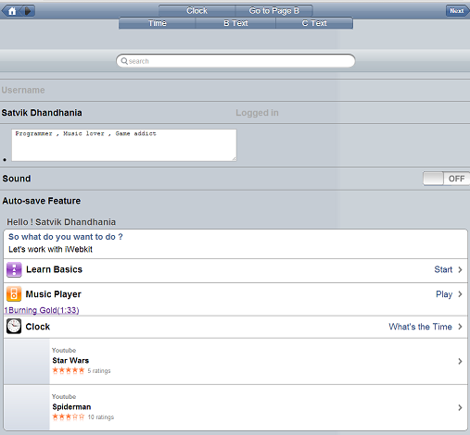

The topbar along with navigation arrows and duoselection buttons and triselection buttons. The topbar also contains leftnav and rightnav elements which have home, right arrow and next. Apart from this there is the searchbox, bigfield, smallfield, textbox, checkbox (sound) and radio button. This screenshot also consists of the list I created with various options for lists like Music, learn basics, clock, youtube items using time, comment, arrow, name, store, star4,youtube classes.

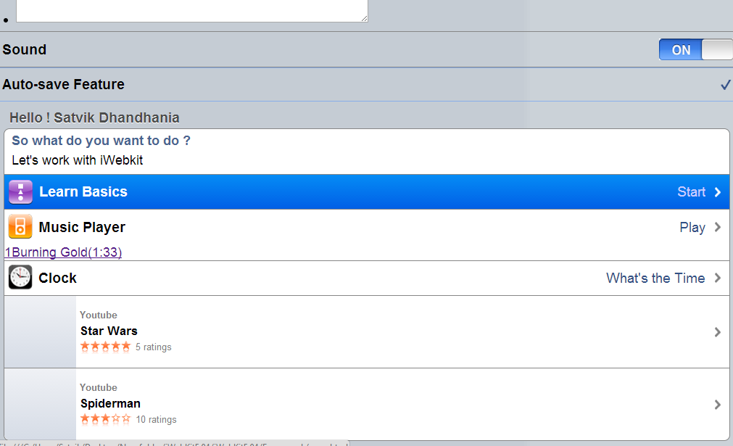

In this screenshot I have shown the working of radiobutton and checkbox. This is the general design of checkboxes/togglebutton present in iphone apps.

**Conclusion**

**iWebKit** can be a great framework for newcomers, who want to make iPhone webapps. However a good knowledge of HTML, CSS and Javascript is recommended before starting to use this framework. Cross-browser application should not be made with this framework as this is mainly designed for safari and chrome. This framework has code snippets for almost all features needed by the webapps.

This design however has been discarded from the iOS interface with the launch of iOS7 for the new iPhones. Thus the future of this framework depends on the factor whether they provide an update for the iOS7 design interface as most of the users have shifted to iOS7.

This is one of the best framework that is available on the net for creating website for iPhones. Its easy to use and easier to understand. Working on it for a few hours gives us a good grip of website development in the mobile domain. The code snippets are self-explanatory and easily understandable.