Introduction
This project aims to address the problem of efficient bicycle rental on a large academic campus. University campuses typically contain multiple important locations such as hostels, classrooms, libraries, laboratories, and campus gates, creating a need for quick and convenient mobility between different areas. Bicycles offer a simple and cost-effective solution to this need. However, traditional bicycle lending systems, which are often human-mediated, paper-based, and dependent on trust, are difficult to manage. Such systems usually suffer from poor visibility of available bicycles, unauthorized usage, incorrect return locations, and difficulty in tracking missing bicycles.
To address these limitations, the Campus Bike Sharing System (CBSS) was designed and prototyped. CBSS is an Internet of Things (IoT)-based system that supports smart bicycle booking, controlled rental access, and location tracking within the institute campus. The proposed system uses a Raspberry Pi as the backend server, ESP32-based controllers at bicycle stands, and ESP32-based units on bicycles for monitoring and tracking. A web-based interface is also provided for both students and administrators to view rental status and manage bicycle bookings.
The project is intended to demonstrate a complete end-to-end IoT application in which embedded devices communicate over the internet with a centralized backend and a web-based user interface for campus deployment.

Problem Statement
The institute requires an effective campus bicycle-sharing mechanism that supports:
- student-initiated online bicycle booking
- authorized bicycle rental through a controlled access mechanism
- real-time monitoring of bicycle movement and associated devices
- intelligent detection of anomalies such as misuse, tampering, abnormal movement, and delayed returns
- an administrative interface providing centralized monitoring and alerts
Therefore, the problem is to design and develop a smart, connected, and secure bicycle-sharing system for campus deployment using Internet of Things technologies.

Objectives
The objectives of the project are as follows:
- to develop a digital interface for bicycle booking by campus users
- to implement a secure stand-side bicycle unlocking mechanism using OTP-based verification
- to enable real-time tracking of bicycle location and device status
- to generate automatic alerts when unusual situations such as tampering, delayed returns, or movement outside the normal riding area are detected
- to provide web dashboards for both users and administrators for status monitoring and management
- to design a scalable system capable of supporting multiple stands and a large number of bicycles

Literature Survey
Smart mobility and IoT-based asset tracking have been major areas of research in recent years. Many existing studies on smart campus and smart city bicycle-sharing systems focus on features such as digital booking, GPS tracking, or docking automation. However, several low-cost solutions primarily emphasize either software functionality or position tracking and do not fully integrate device-to-device verification, stand-side control, or real-time monitoring of bicycles.
For example, studies such as Chouhan, Singh, and Srivastava (2017) and Singh, Singh, and Kushwah (2018) employ GPS together with GSM or Wi-Fi technologies for real-time vehicle tracking and transmission of location updates to a central server. While effective for location reporting, such systems do not provide secure control over physical access to the bicycles.
In another category of systems, RFID cards or QR-code-based access methods are used to authorize bicycle unlocking. These solutions are useful for access control, but they often depend on external devices such as smartphones, RFID cards, or dedicated readers. This increases dependence on external infrastructure and may reduce flexibility in practical campus deployment.
Several IoT-based fleet monitoring systems also use MQTT for device communication, as seen in works such as Ramakrishnan, Muneeswaran, Kumar, and Manivannan (2017). These systems effectively support telemetry and remote monitoring, but they generally do not address the complete booking workflow or student-side application integration in a campus environment.
In contrast, CBSS combines:
- a web-based user interface and booking platform
- secure OTP-based stand-side verification
- a centralized backend server that determines whether a bicycle lock should be opened
- real-time bicycle location tracking and device status reporting
- automatic alert generation for administrators
Thus, CBSS is closer to a complete end-to-end campus bicycle-sharing solution than a single-feature prototype.

Requirement Analysis
5.1 Functional Requirements
The system must provide the following functionalities:
- user authentication and registration
- display of available stands and bicycles on the interface
- booking of a bicycle for a specified duration
- generation and display of an OTP to the user through the web application
- entry of the OTP by the user on the stand keypad
- server-side verification of the entered OTP
- unlocking of the designated bicycle upon successful OTP validation
- collection and display of bicycle location and status data
- return of bicycles when they are brought near a valid stand
- logging of all bookings and alert history
- display of a live map showing the location of active bicycles
5.2 Non-Functional Requirements
The system must satisfy the following non-functional requirements:
- low-latency response during OTP verification
- scalability to support multiple stands and many bicycles
- reliable wireless communication between devices and the backend
- maintainable code and well-documented device logic
- practical deployability within a campus environment
5.3 Constraints
The following constraints are considered in the project:
- preference for low-cost hardware
- variable wireless connectivity across the campus
- limitations of prototype hardware compared to a full-scale deployment
- advanced telemetry and cloud features are still under development

System Architecture
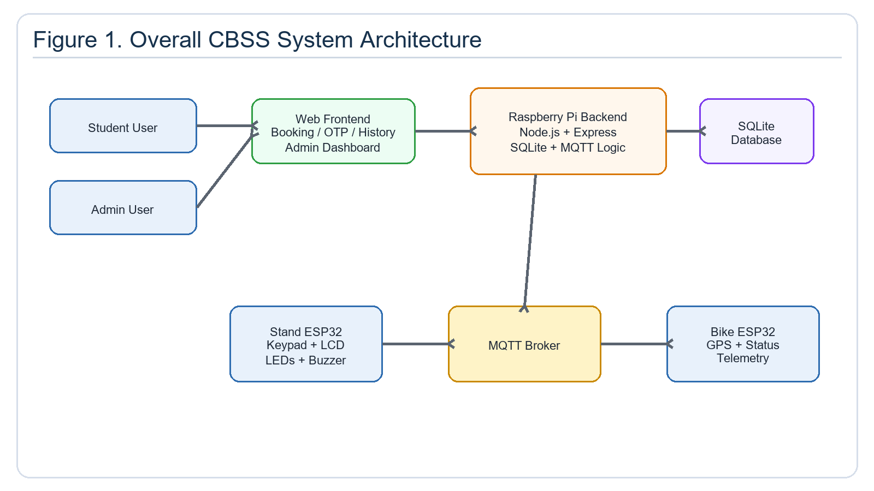
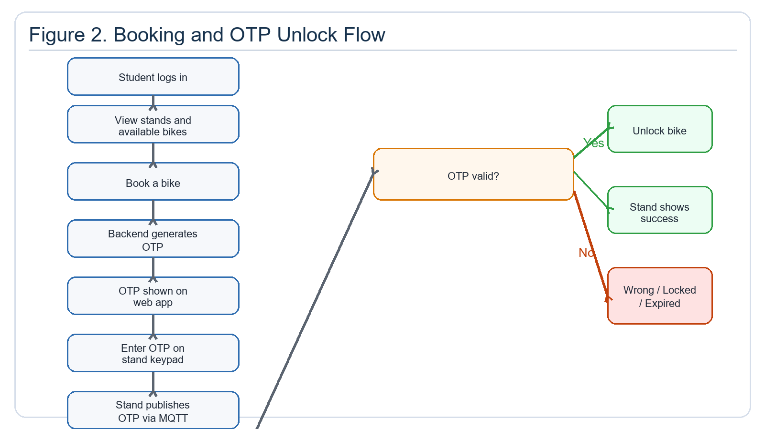
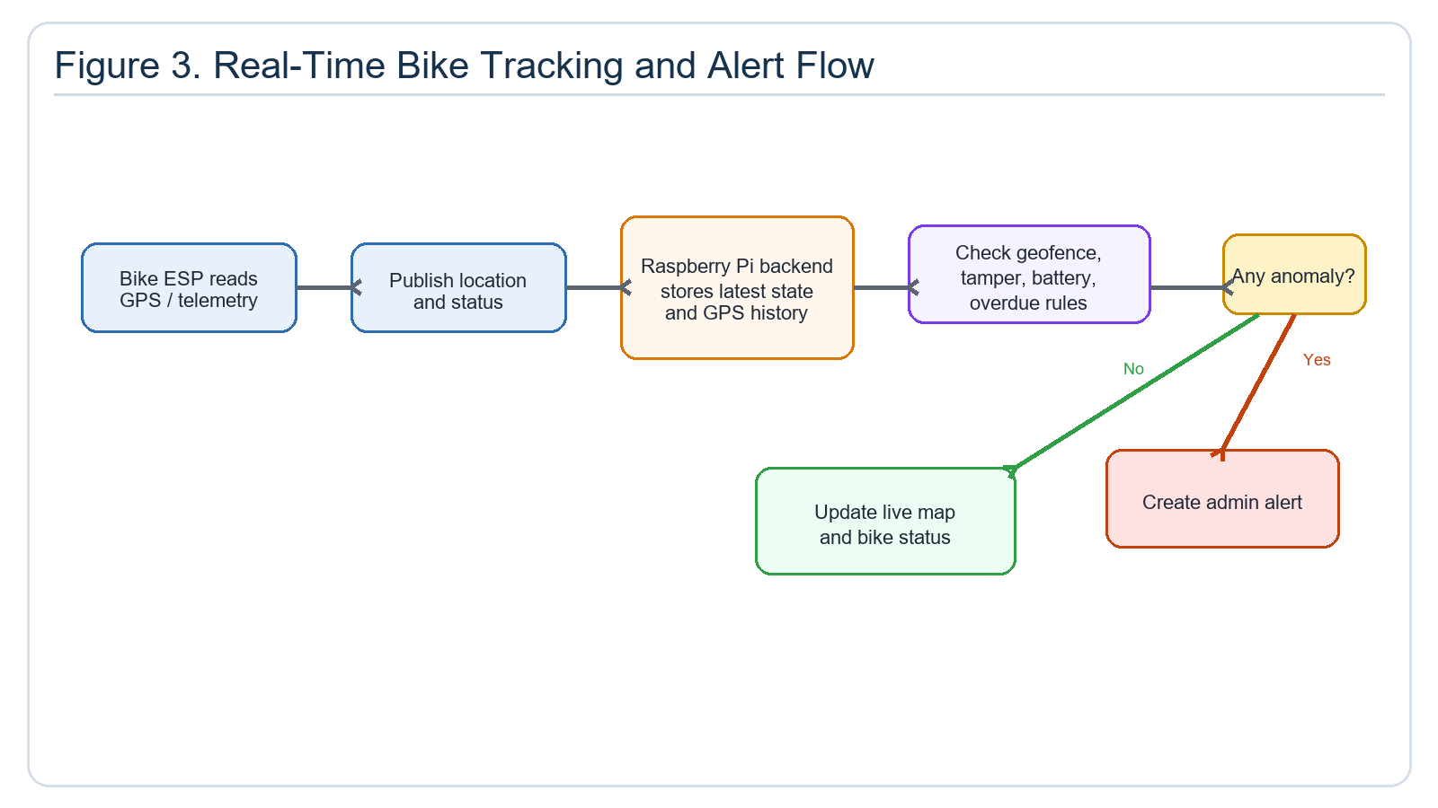
The CBSS is designed as a complete end-to-end IoT system consisting of four major layers:
- Device Layer
- Communication Layer
- Backend Layer
- Application Layer
6.1 Device Layer
The current system includes:
- one Raspberry Pi acting as the central backend server
- one ESP32 at each stand serving as the stand controller
- one ESP32 planned for each bicycle to transmit live location and device status
The stand controller is responsible for:
- reading keypad input
- displaying information on the LCD
- providing audible feedback through a buzzer
- communicating with the backend using MQTT
The planned bicycle-side ESP32 unit will be responsible for:
- real-time location tracking
- battery status reporting
- lock-state monitoring
- future support for multi-sensor ride telemetry
6.2 Communication Layer
The system uses the following communication technologies:
- Wi-Fi for data connectivity
- MQTT for device-to-server communication
- HTTP/REST for frontend-to-backend communication
MQTT topics are structured according to stand and bicycle identifiers. Example topics include:
- cbss/stand/{standId}/otp
- cbss/stand/{standId}/result
- cbss/stand/{standId}/status
- cbss/bike/{bikeId}/location
- cbss/bike/{bikeId}/status
- cbss/bike/{bikeId}/command
6.3 Backend Layer
The Raspberry Pi backend is developed using:
- Node.js
- Express.js
- SQLite
- an MQTT client library for communication with embedded devices
The backend is responsible for:
- booking management
- OTP generation and validation
- bicycle and stand state tracking
- telemetry storage
- alert generation for tampering, delayed return, and unauthorized movement
6.4 Application Layer
The web-based application provides interfaces for both students and administrators. Its features include:
- login and user registration
- bicycle booking
- OTP viewing
- booking history
- live monitoring of active bicycles
- administrative alerts and system status visualization

Hardware Design
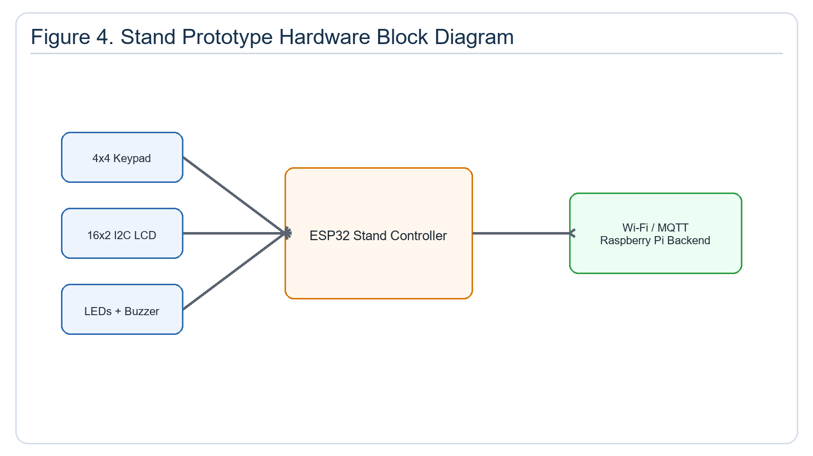
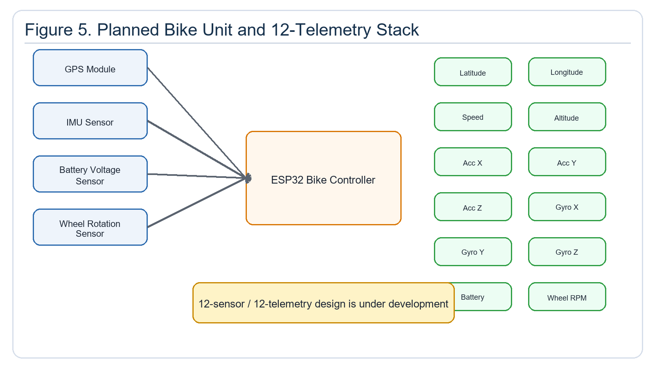
7.1 Current Prototype Hardware
The current prototype consists of the following hardware components:
- Raspberry Pi as the backend server
- ESP32 stand controller
- 4x4 keypad
- 16x2 I2C LCD
- two LEDs for status indication
- buzzer
7.2 Working of the Stand Prototype
The stand controller accepts the OTP entered through the keypad, displays corresponding messages on the LCD, and transmits the entered OTP to the server using MQTT. After receiving the validation result from the backend over MQTT, it provides visual and audible feedback using LEDs and the buzzer, while also displaying the success or failure message on the LCD.
7.3 Planned Bicycle Hardware
The planned full-scale bicycle-side prototype will include:
- ESP32 controller
- GPS module
- battery status monitoring circuit
- wheel or motion sensing capability
- IMU-based movement detection
- interface for lock-state sensing or actuator control
This part of the project is still under development and has not yet been fully incorporated into the current repository.

Network and Connectivity
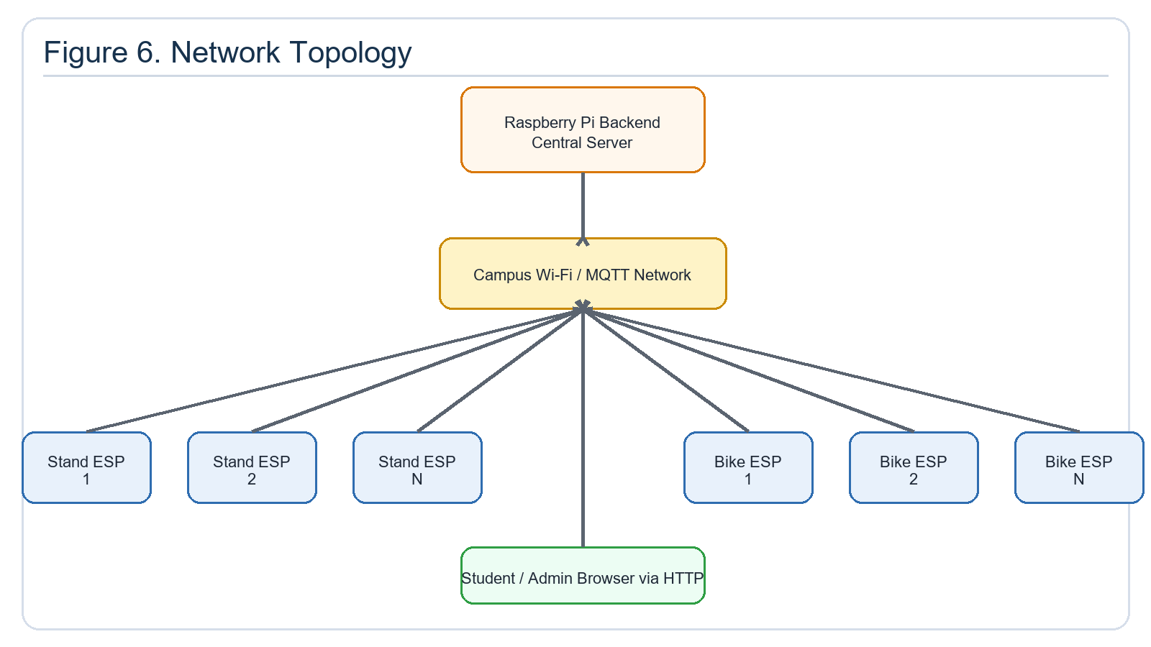
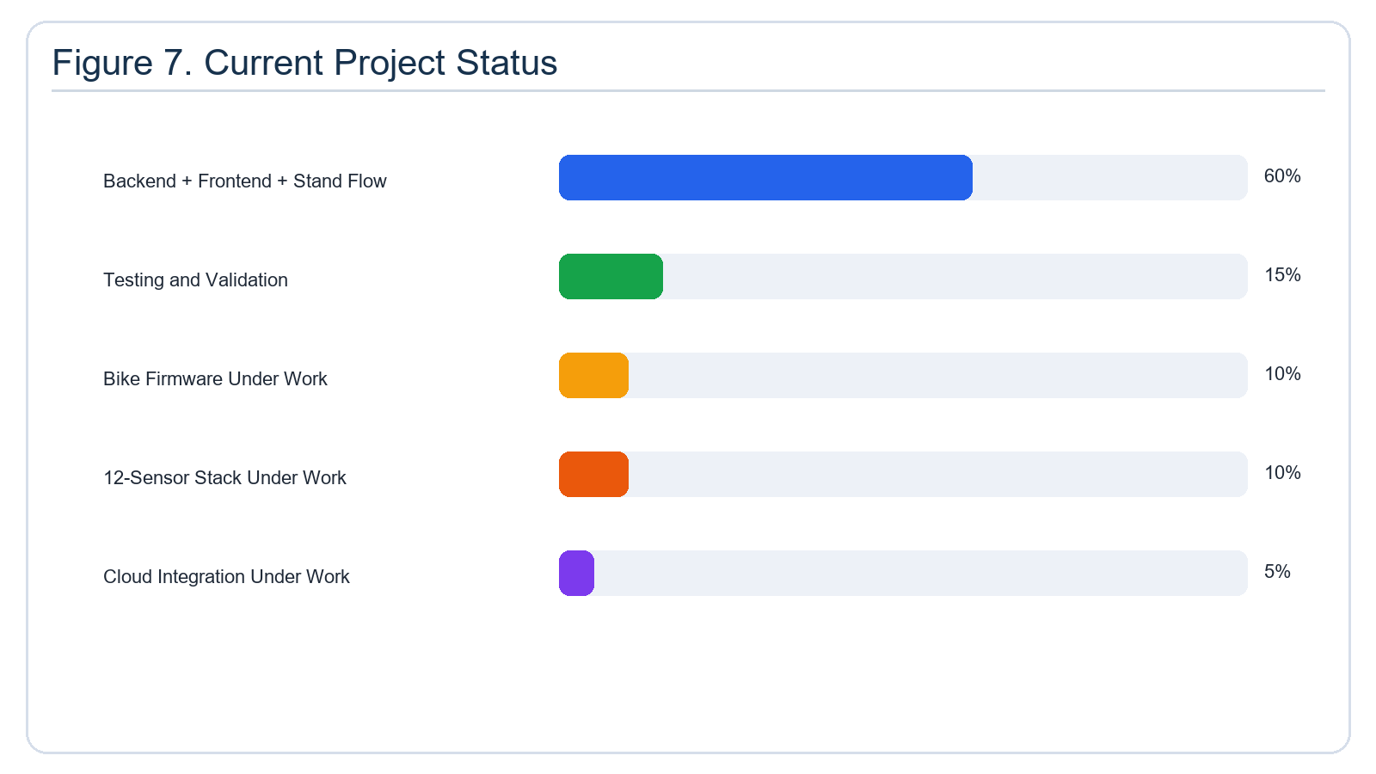
The system follows a star-like network topology in which the Raspberry Pi backend acts as the central communication node.
- stand ESPs publish data to and receive responses from the Raspberry Pi
- bicycle ESPs publish telemetry data and receive control commands from the Raspberry Pi
- web clients interact with the backend through HTTP APIs
This design is suitable because MQTT is lightweight and efficient for embedded device communication, while the Raspberry Pi provides a practical centralized coordination unit for multiple stands and bicycles.

