BigMart Sales Prediction
Analytics Vidhya Hackathon — Project Submission

Team Details
Team Name | Swastik
Member(s) | Satvik Jain
Course | AMBA
Competition | Big Mart Sales Prediction (Analytics Vidhya)
Platform Username | satvikjain007
GitHub Repository | https://github.com/satvikjain007/bigmart-sales-prediction
Date of Submission | 24 October 2026

Leaderboard Rank
Screenshot of the public leaderboard standing:
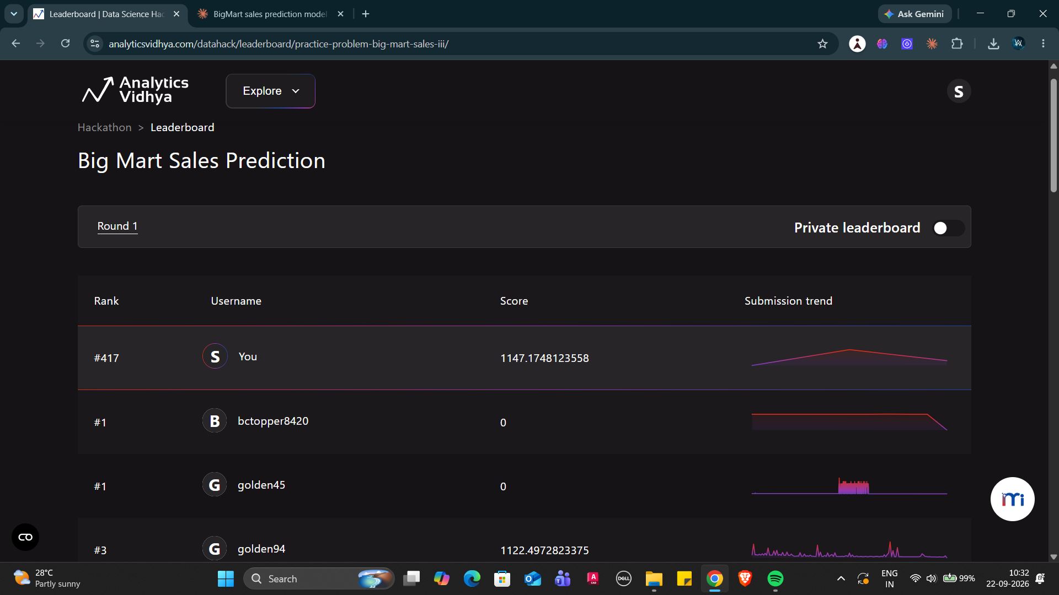
Replace this image with your current leaderboard screenshot before submitting.

Summary of Approach
The target decomposes exactly: every sale in this dataset equals a hidden base price multiplied by a whole number of units. Recovering that base price (an exact integer fit was found for 1,378 of 1,559 items) removes jitter present in the published Item_MRP column.
Building on this, a structural model that predicts base price × the outlet’s average unit rate — two parameters per store — outperformed tuned XGBoost, LightGBM and CatBoost models trained on the full engineered feature set. The final submission blends this structural model (70%) with CatBoost (30%) for diversity.

Results
Model | 5-fold CV RMSE
Outlet mean only | 1488.6
Ridge (one-hot, all features) | 1131.9
LightGBM (all features) | 1085.8
XGBoost (all features) | 1080.4
CatBoost (all features) | 1075.3
Structural model (2 params/store) | 1071.7
Final blend (70/30) | 1071.1
Theoretical noise floor | 1070.3
The final model sits within roughly 1–2 RMSE points of the computed theoretical floor, meaning the remaining error is irreducible noise rather than unexploited signal.

Business Finding
BigMart asked which product and outlet properties drive sales. The evidence points to price and the outlet, and essentially nothing else. Item weight, visibility, fat content and product category carry no measurable predictive signal once price and store are known. Differences between stores — a grocery store averages roughly ₹340 per item against ₹3,694 for a Supermarket Type3 — are where the variance lives.

Repository Contents
• BigMart_Sales_Prediction.ipynb — full analysis notebook with EDA, modelling and results
• bigmart_solution.py — standalone script reproducing the final submission
• submission_final.csv — the submitted predictions
• train.csv, test.csv, sample_submission.csv — competition data
• README.md — project overview and how to reproduce
Note on leaderboard score: the notebook appendix documents a public-leaderboard calibration experiment that lowered the public score but is excluded from the final model, as it fits the public test split rather than generalising.

