

**Module 5:** Small Molecule Drug Design FEP+ Guided Case Study

**5.2 Guided Case Study Observations [Worksheet]**

1. **Please paste your tiled view screenshot displaying your aligned, prepared, 5 – 7 case study new ligand designs here:** (See Module 5.1 Section 2 step 23 for instructions)

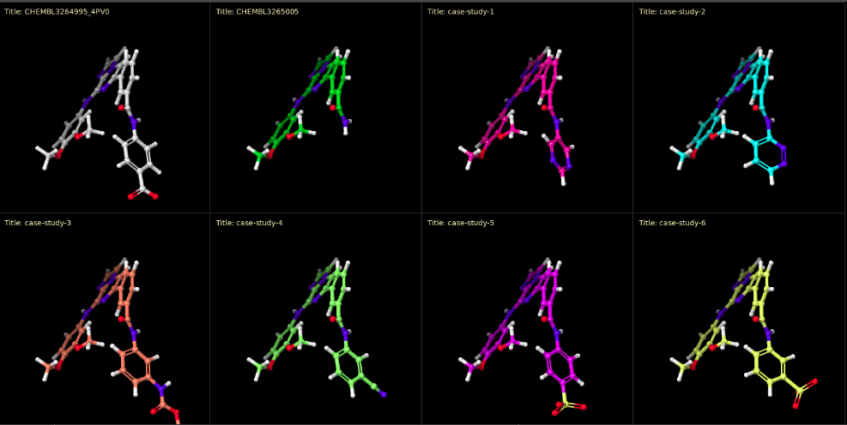

1. **Please paste the screenshot of your prospective relative-binding FEP+ perturbation map here:** (See Module 5.1 Section 3 step 13 for instructions)
2. 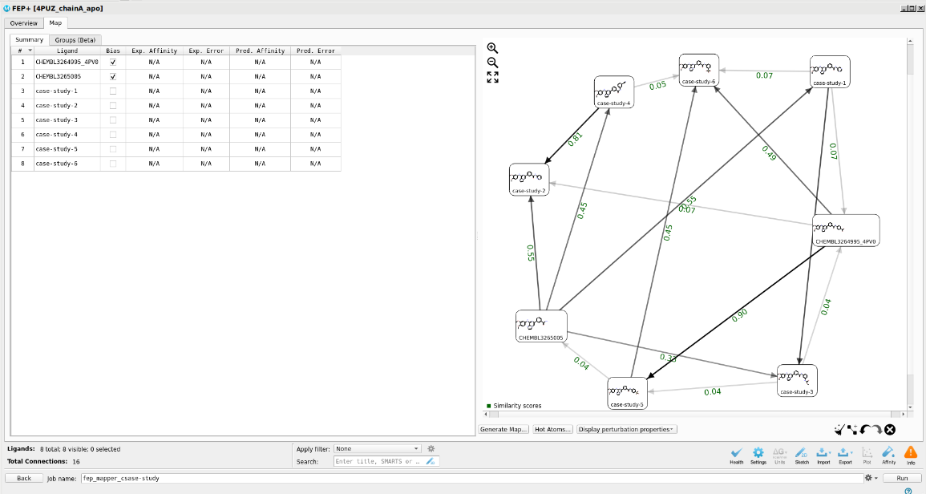**Please paste the Map tab summary FEP+ Panel screenshot of your merged results arranged by Pred. Affinity here:** (see Module 5.2 Section 2 step 5 for instructions)

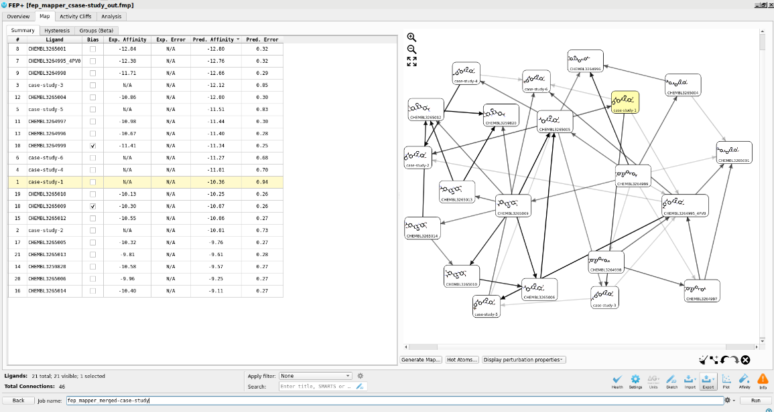

1. **Please write a few sentences summarizing your case study findings and observations. A few questions you could consider are:**
   * Would you move forward with any of your new ligand designs?
   * Would you re-run this map with different settings, such as longer simulation time, more lambda windows, or with additional intermediate compounds?
   * What designs would you try next?