FCC Reactor Simulation App – User Manual
1. Introduction
The FCC (Fluid Catalytic Cracking) Reactor Simulation App is an interactive MATLAB-based application developed to simulate and compare the numerical solutions of coupled ordinary differential equations governing an FCC reactor. It is intended to help students and researchers visualize the effect of kinetic and thermodynamic parameters on hydrocarbon conversion, reactor temperature, and catalyst activity. The app supports RK1 to RK4 methods and highlights the impact of step size on numerical stability.
2. System Requirements
- MATLAB R2024b or later (for `.mlappinstall` use)
- MATLAB Compiler Runtime (for standalone `.exe` use)
- Windows/macOS/Linux
- 4 GB RAM or higher recommended
3. Launching the App
- If using MATLAB: run `FCC_APP.mlapp` from App Designer(preferred) or install `.mlappinstall` file.
- If using compiled version: install using the generated installer or run `FCC_Reactor_Simulator.exe`.
- Ensure MATLAB Runtime is installed (if compiled version is used).

4. Interface Overview
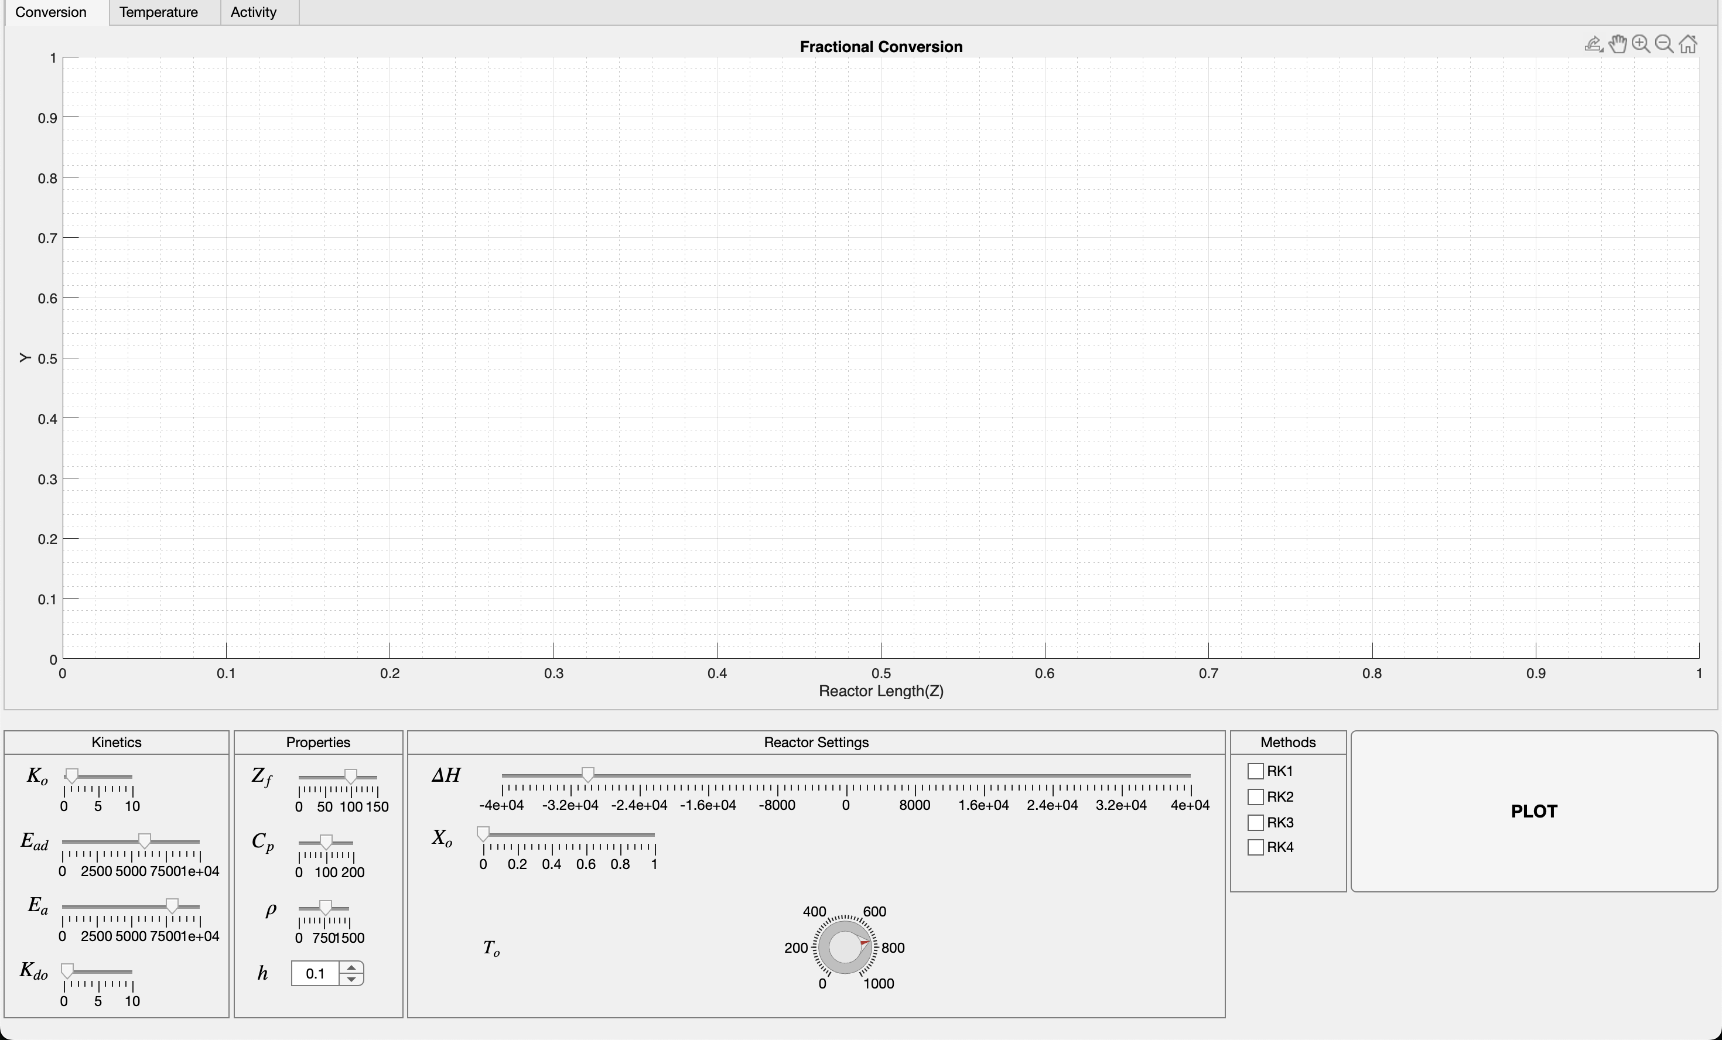
The app consists of the following major sections:
- Kinetics Panel: Sliders for Ko, Ea, Ead, Kdo.
- Reactor Settings Panel: Knob for T0 and slider for X0 and ΔH.
- Properties Panel: Sliders for Cp, ρ, Zf, and spinner for h.
- Methods Panel: Checkboxes for RK1, RK2, RK3, RK4 selection.
- Tabs: Plots for Conversion (X vs Z), Temperature (T vs Z), and Activity (A vs Z).
- Plot Button: Triggers computation.
- Status Label: Displays feedback.
5. Input Parameters
Parameter | Description | Range | Units
Ko | Pre-exponential factor | 0–10 | 1/m
Ea | Activation energy | 0–10000 | J/mol
Kdo | Catalyst deactivation prefactor | 0–10 | 1/m
Ead | Catalyst Deactivation activation energy | 0–10000 | J/mol
ΔH | Heat of reaction | -40000–40000 | J/mol
Cp | Heat capacity | 0–200 | J/kg·K
ρ | Density | 0–1500 | kg/m³
X₀ | Initial mole fraction of Fuel | 0–1 | –
T₀ | Inlet temperature | 0–1000 | K
Zf | Final reactor length | 0–150 | m
h | Step size | 0–10 | m
6. How to Use the App
1. Launch the app.
2. Adjust kinetic and physical parameters using the left-hand sliders.
3. Select numerical methods from RK1–RK4.
4. Set step size h via spinner.
5. Click PLOT.
6. View the three output tabs for Conversion, Temperature, and Activity profiles.
7. Example 1: Small Step Size (High Accuracy)
Inputs: Ko = 1.2, Ea = 8000, Ead = 6000, Kdo = 0.5, ΔH = -30000, Cp = 100, ρ = 800, X₀ = 0, T₀ = 750 K, Zf = 100 m, h = 0.5
Methods: RK1, RK2, RK3, RK4
Expected Behavior:
- Smooth and accurate plots for all of the methods
- Smooth increase in conversion
- Gradual temperature drop
- Moderate deactivation

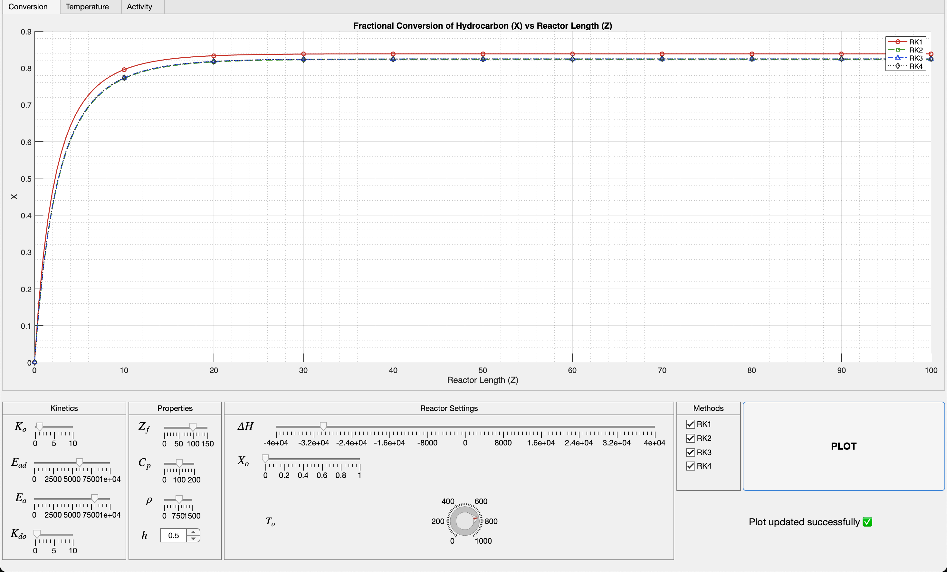Figure 1: Conversion v/s reactor length
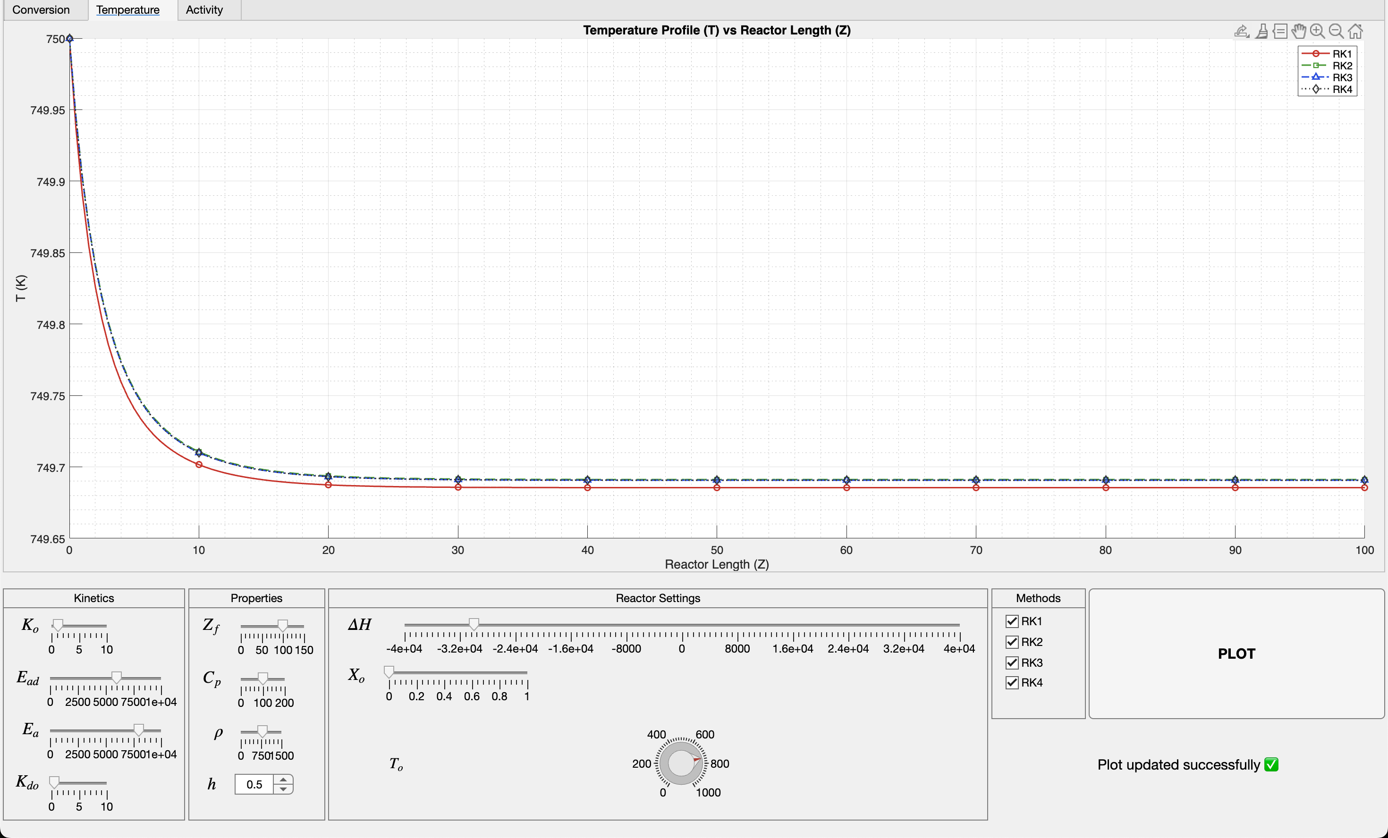Figure 2: Temperature v/s reactor length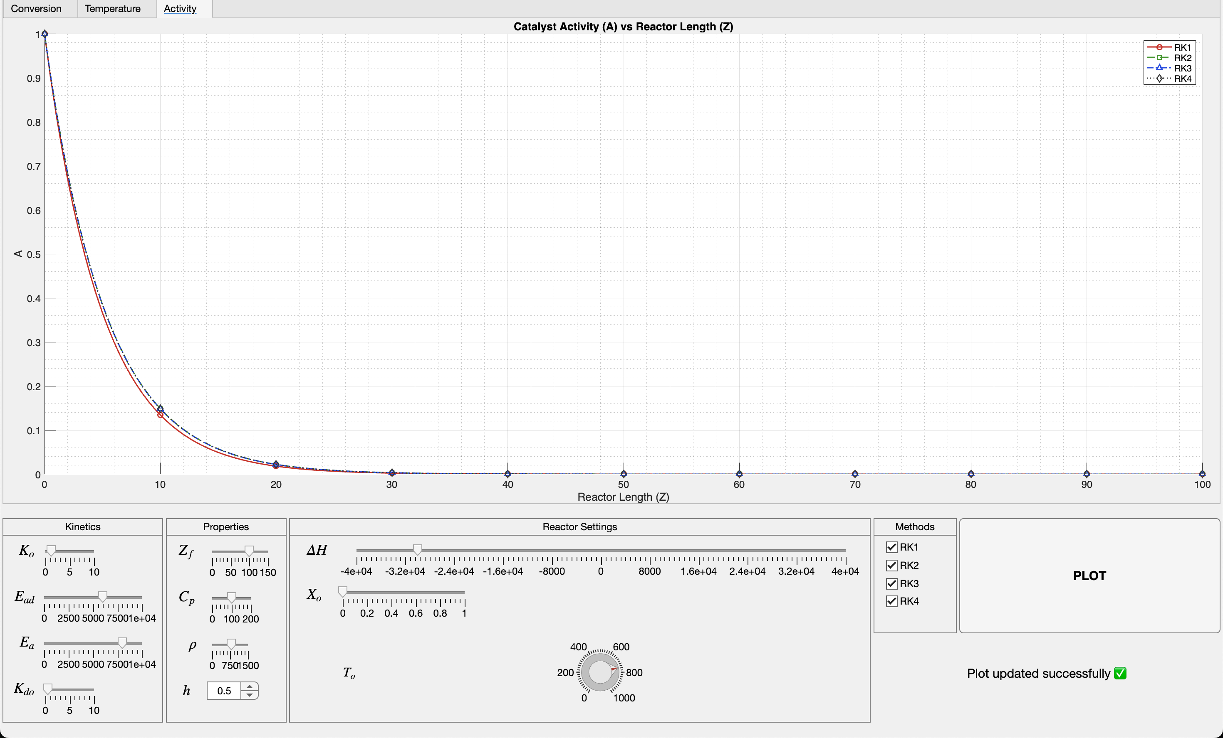Figure 3:Catalyst Activity v/s reactor length
Example 1: Large Step Size (Low Accuracy)
Inputs: Ko = 1.2, Ea = 8000, Ead = 6000, Kdo = 0.5, ΔH = -30000, Cp = 100, ρ = 800, X₀ = 0, T₀ = 750 K, Zf = 100 m, h = 0.5
Methods: RK1, RK2, RK3, RK4
Expected Behavior:
- Less smooth plots for all of the methods
- Lower order RKs deviate largely from true solution.
- Smooth increase in conversion
- Gradual temperature drop
-Moderate deactivation
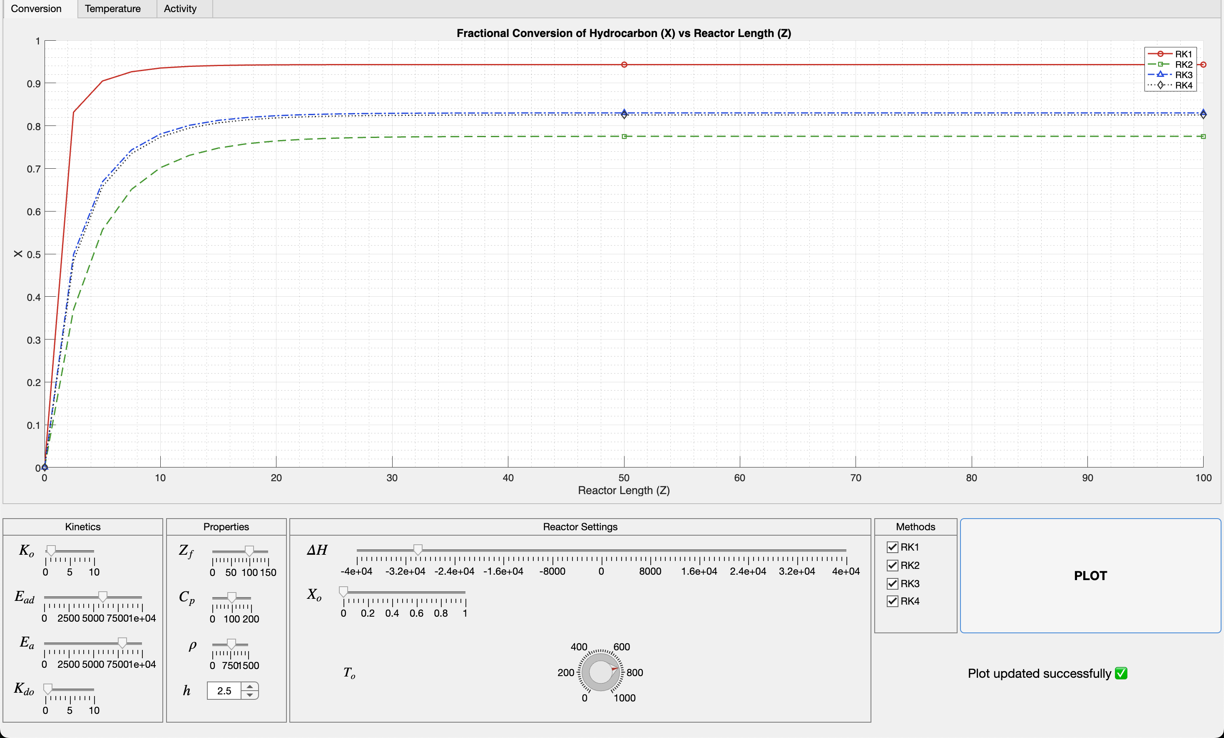Figure 1: Conversion v/s reactor length
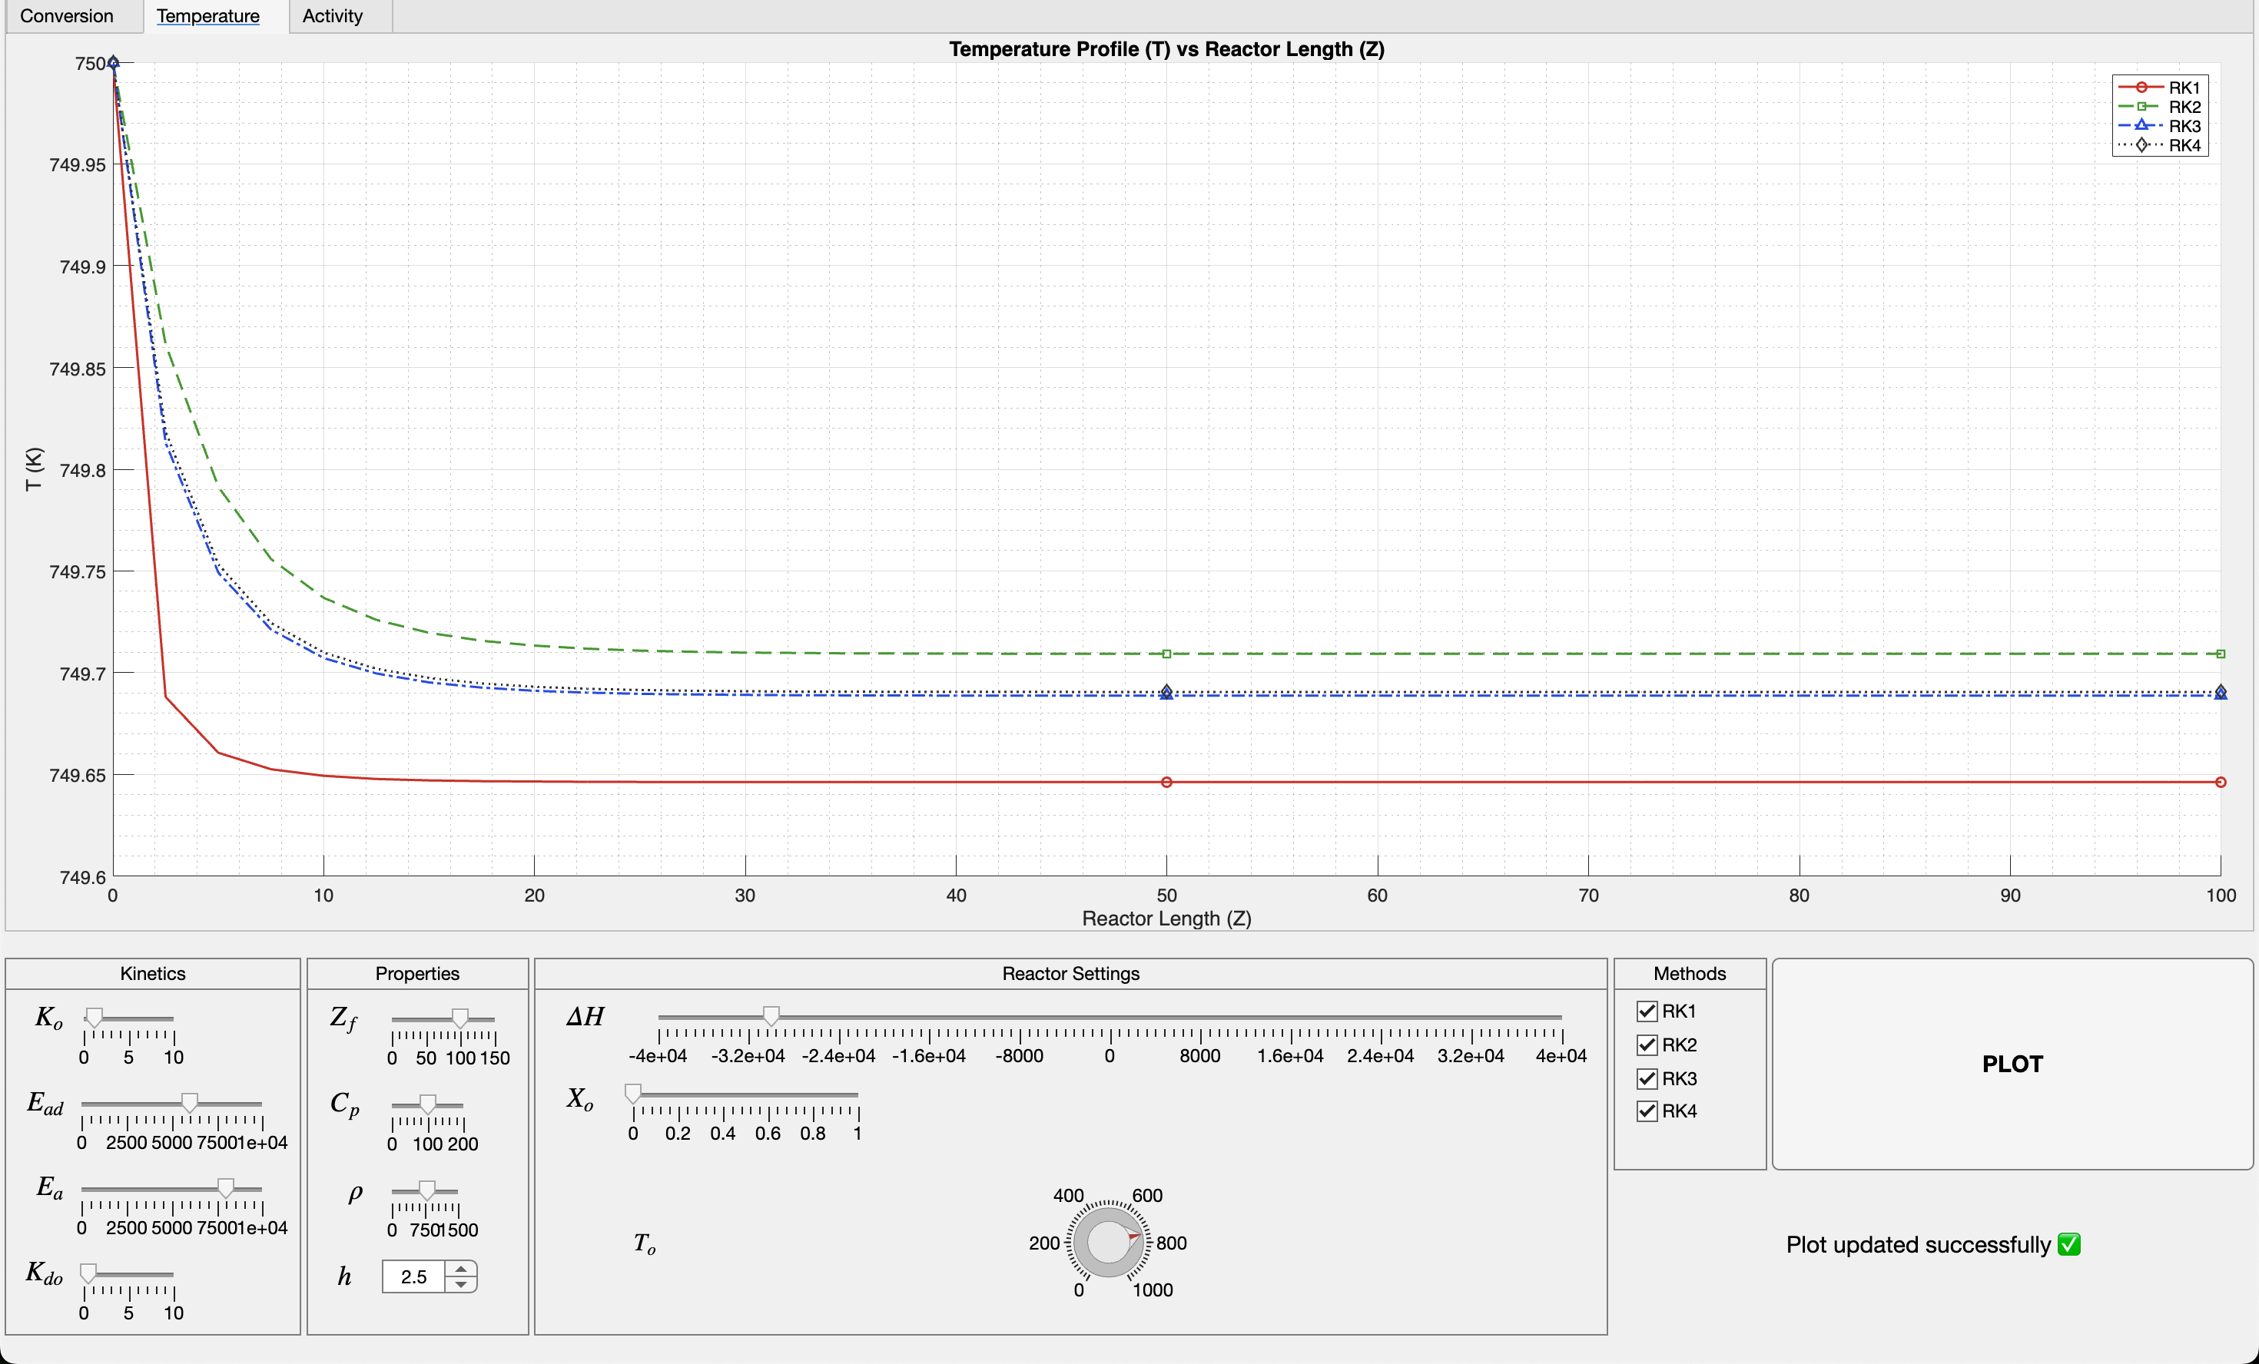
Figure 2:Temperature v/s reactor length

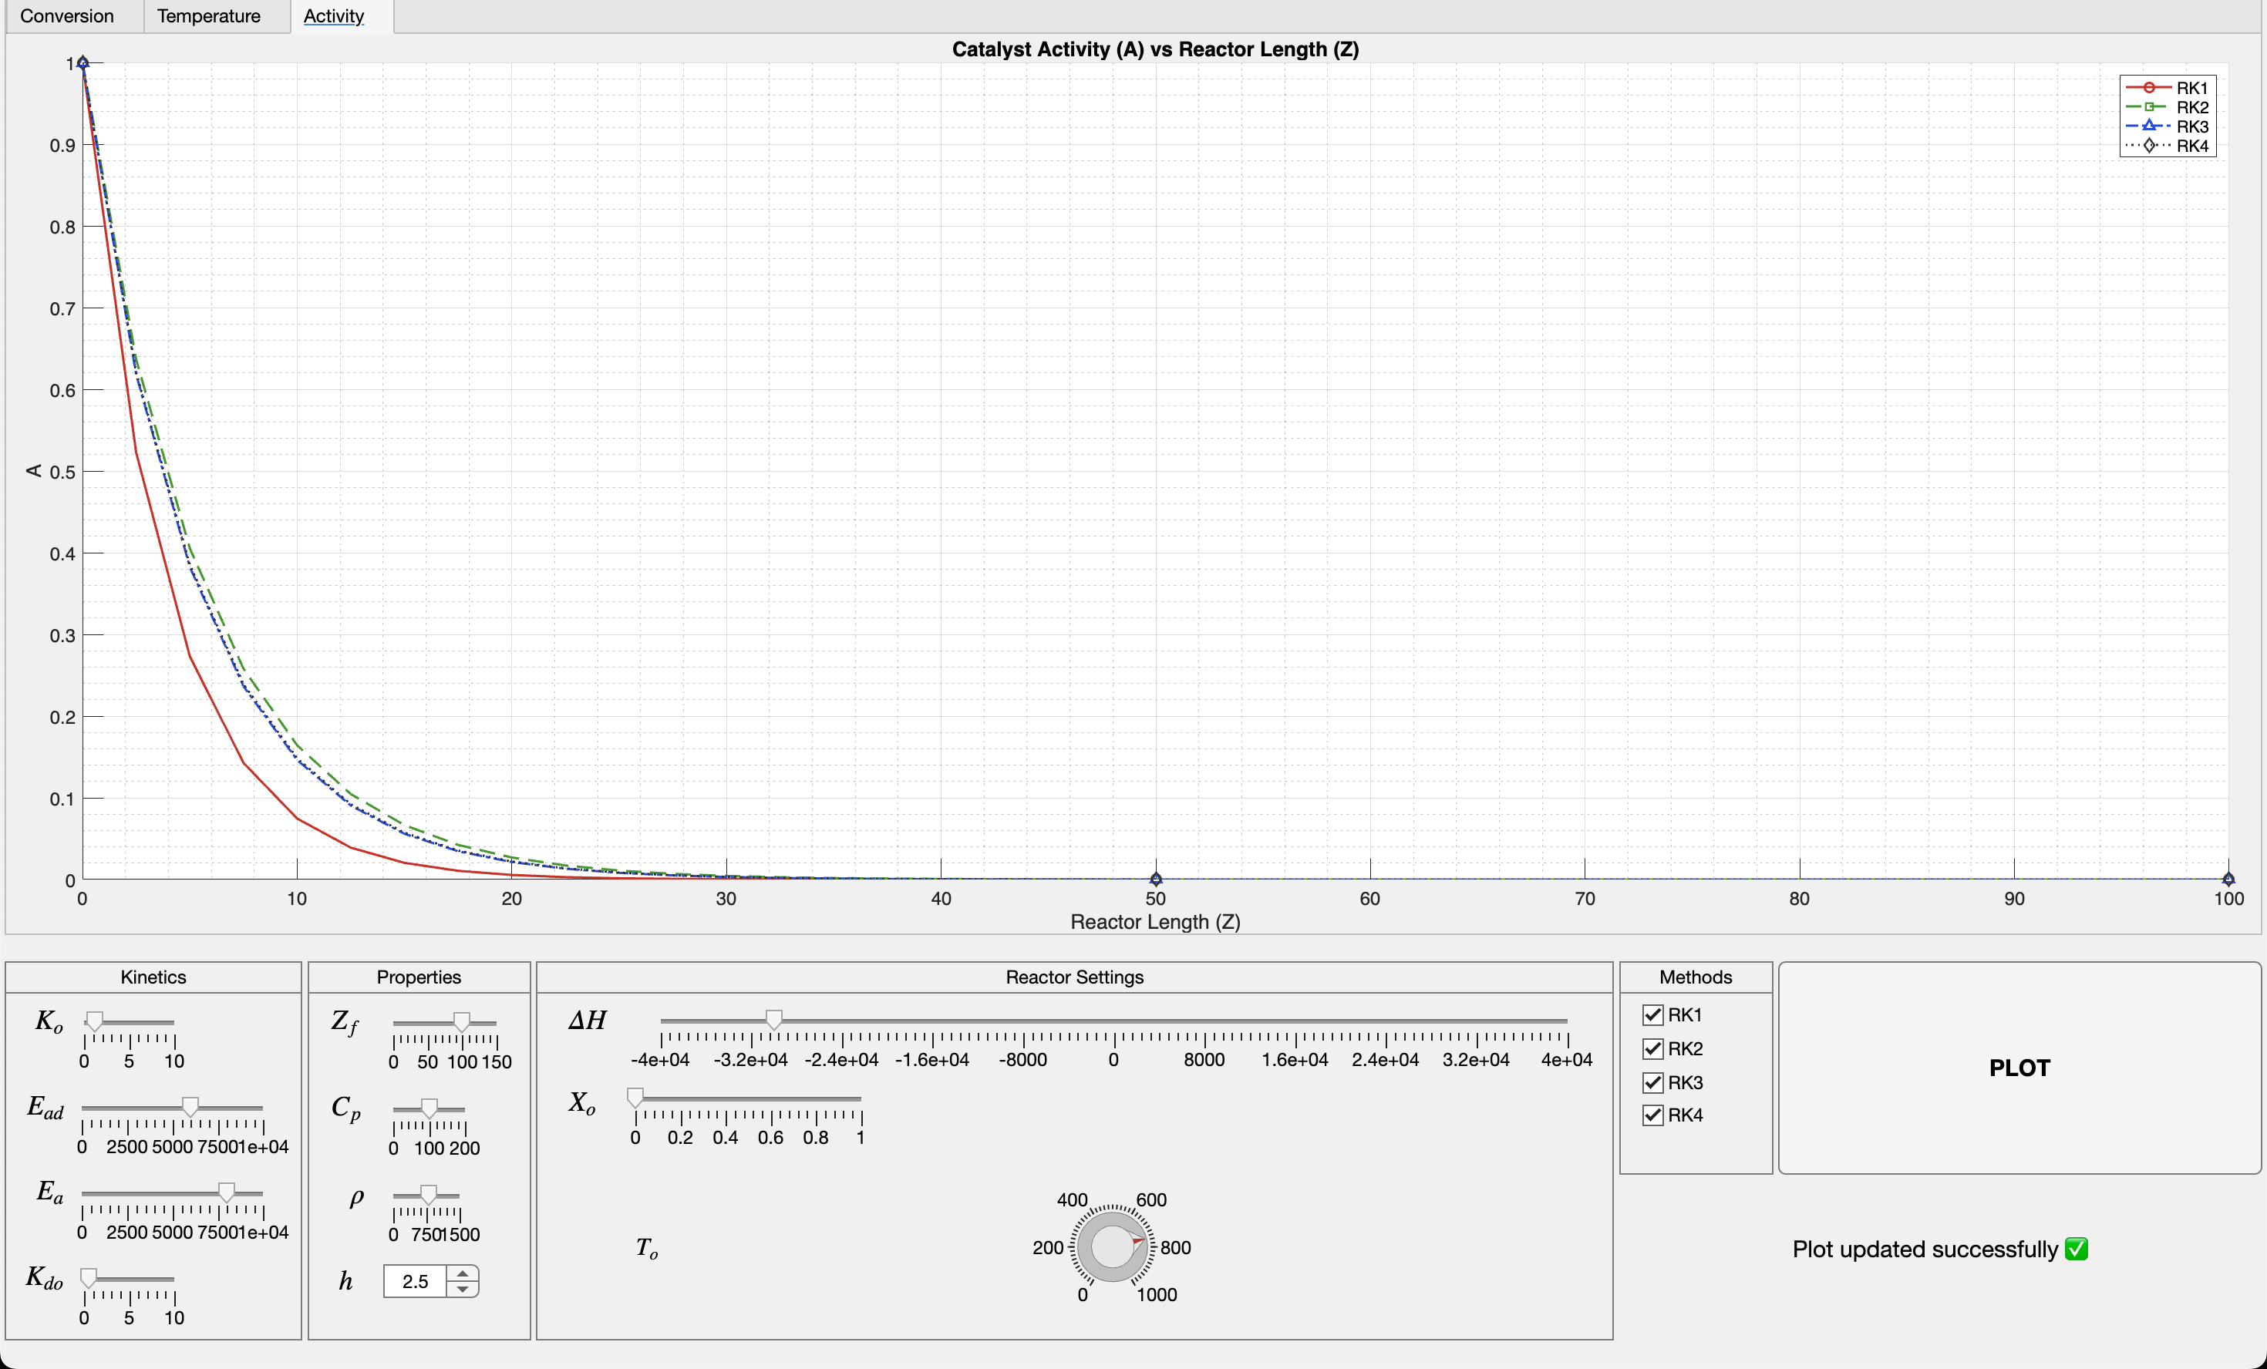
Figure 3:Catalyst Activity v/s reactor length

