“**SNEAKERONOMICS”**

“DATA SCIENCE PROJECT”

C/O **DEVANSH SACHAR**

**SATVIK PANDEY**

SEPTEMBER 2020

MANIPAL UNIVERSITY JAIPUR

DEPARTMENT OF COMPUTER AND COMMUNICATION ENGINEERING

**AIM OF THE PROJECT**

The main aim of this project is to analyze the appreciation and depreciation of sneaker sales to determine whether collab with influential figures and conglomerates has impact on resell values.

The insights in this project will help the individuals who make a living by buying and reselling sneakers. It will help them determine:

1.Which shoes are the most profitable

2.Which region the sales are maximum

3.Which shoe size is the most popular

4.Which shoe model has highest profit margin

5.In which quarter of the year are sales maximum

With more than 500,000 pairs of shoes sold on stock x alone the sneaker industry is growing at a triumphant pace catching the eyes of many investors and resellers.

In the coming years, this data will help the individuals make optimal profits and prove to give them highest profit margins.

In this project, We will perform regression to predict the price of a given sneaker based on several factors such as order date, brand, sneaker name, sale price, and several others. This dataset is directly from StockX and was used for their 2019 data competition. The flipping and reselling business has provided an avenue for hustlers to ethically and ingeniously make a quick buck. And what seemed to be footwear that keeps your feet safe and warm serve a different purpose to other people.

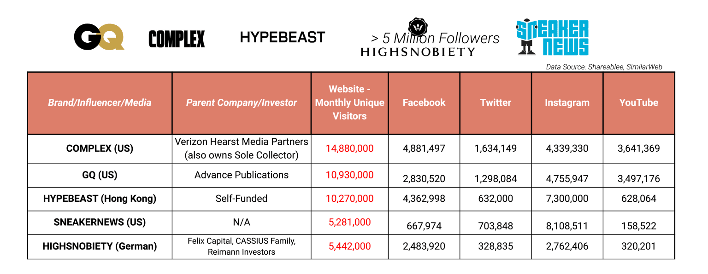

Sneaker culture is far from a fleeting trend. Over the years, collecting sneakers has become a global phenomenon that consumers are willing to bet big on — shelling out upwards of $20,000 on limited-edition shoes. Smart brands may be wise to capitalize on sneaker culture as the industry is poised to grow exponentially in the next decade.

**WHY STOCKX?**

Coming off the heels of a pivotal year for the resale industry as a whole, StockX, the first-ever "Stock Market of Things," announced it surpassed $1B in gross merchandise value (GMV) in 2019 alone and grew global buyer and seller registrations by more than 100%. The two-sided marketplace for sneakers, apparel, accessories and collectibles focused heavily on expanding its global business - specifically in Europe and Asia - and diversifying product categories. To mark the milestone year, the company today issued a report highlighting industry trends and predictions, as well as insights into the company's growth.

* **Customer Momentum:**The company grew its buyer and seller registration base by more than 100% and processed sales in 197 countries and territories. Additionally, StockX powered economic opportunity for hundreds of thousands of sellers around the world. *Fun Fact: In 2019, StockX saw 1,200 sales in Luxembourg alone.*
* **Team Growth:** The company ended 2019 with approximately 1,000 team members globally and expanded the executive team by hiring its first-ever chief financial, chief marketing and chief communications officers. *Fun Fact: More than 5,200 sneakers were purchased by StockX employees in 2019.*
* **Vertical Extension:** StockX saw sales for the luxury and collectibles categories grow by nearly 200%. StockX also officially launched trading cards as part of collectibles, featuring hundreds of cards across all four major American professional sports leagues including the NFL, NBA, NHL and MLB. *Fun Fact: Collectibles is StockX's first category to showcase non-wearable goods.*
* **Global Operations and Expansion:**The company opened offices in Tokyo, NYC and Silicon Valley, and authentication centers in the Netherlands and Atlanta during 2019. Additionally, StockX opened its first permanent brick-and-mortar location in New York City and had pop-up drop-off locations in London, NYC, Los Angeles, Atlanta and Chicago. StockX also leaned into its international growth by localizing in France, Italy and Germany which reduced processing fees and delivery times for its European customers. *Fun Fact: StockX added multiple payment methods including Apple Pay, Google Pay, Alipay and Venmo.*

**DATA DESCRIPTION**

The data we’re giving you consists of a random sample of all Off-White x Nike and Yeezy 350 sales from between 9/1/2017 (the month that Off-White first debuted “The Ten” collection) and the present. There are 99,956 total sales in the data set; 27,794 Off-White sales, and 72,162 Yeezy sales. The sample consists of U.S. sales only.

To create this sample, we took a random, fixed percentage of StockX sales (X%) for each colorway, on each day, since September 2017. So, for each day the Off-White Jordan 1 was on the market, we randomly selected X% of its sale from each day. (It’s not important to know what X is; all that matters is that it’s a random sample, and that the same fixed X% of sales was selected from every day, for every sneaker).

To create this sample, we took a random, fixed percentage of StockX sales (X%) for each colorway, on each day, since September 2017. So, for each day the Off-White Jordan 1 was on the market, we randomly selected X% of its sale from each day. (It’s not important to know what X is; all that matters is that it’s a random sample, and that the same fixed X% of sales was selected from every day, for every sneaker).

We’ve included 8 variables for you to work with: Order Date, Brand, Sneaker Name, Sale Price (),RetailPrice(),RetailPrice(), Release Date, Shoe Size, and Buyer State (the U.S. state the buyer shipped to). You can use whatever variables you want in the analysis; you can use 1 variable, or you can use all 8. And remember, every row in the spreadsheet represents an individual StockX sale. There are no averages or order counts; this is just a random sample of daily sales data.

**WORKFLOW**

1.DATA CLEANING

2.EXPLORATORY DATA ANALYSIS

3.LINEAR REGRESSION

4.INSIGTHS

EDA (Exploratory Data Analysis)

1. Sneaker sales by BuyerRegion

From the above trend we can make the following conclusions

1. California has the highest orders region wise while Wyoming the lowest.
2. Delaware has the highest profit region wise while Wyoming the lowest.

Evidences to back up the same

1. California is the 8th richest state in the United States of America with a median income of $71,805. California’s high-income earners, from film and television celebrities in Los Angeles to tech giants in Silicon Valley, are heavily taxed in the state, which hosts the largest entertainment and fashion industries in the country which makes it the state with the people who can easily afford these hyped sneakers with ease. Sneaker culture in California is also influenced as the most popular basketball teams are from California namely Golden state warriors and Los Angeles Lakers
2. Reason for Delaware to be the state with the highest profit margins as Delaware is a tax-free state resulting in more profit margins. Wyoming it is also the least populous and second most sparsely populated state in the country therefore the least amount of orders.
3. Stadium Goods, KITH and Bodega are the top Sneaker showrooms in the country and with the most hyped shoes. Majority of these showrooms are located in California, New York and Florida thus making these states the top 4 sneaker buying states as people see these shops everyday and are familiar with the sneaker culture.
4. **Sneaker Sales Model-Wise**

In this Insight we will analyse:

1. Number of orders Model-wise
2. Profit Margin Model-wise
3. Average selling price Model-wise

Why these insights?

From these insights it will help us understand which models are best for reselling purposes and can help make you the best profits.

Which Sneakers are safest choice if your sole purpose is only making money off of them.

A. Number of orders Model-wise

Conclusion:

Adidas Yeezy Boost 350 V2 has the most of orders(71209)

Whereas Adidas Yeezy Boost 350 Low has the lowest(455).

Evidences to backup the data

1. A decade-defining sneaker, the Yeezy Boost 350 is Kanye West and Adidas most successful silhouette. Why? Because not only do the sneakers look as fresh with gym gear as they do with date-night attire, they’re also [insanely comfortable](https://www.farfetch.com/style-guide/street-style/yeezy-350-sizing-and-fit-guide/). This is down to the use of Adidas’ innovative materials, a primeknit upper upon a Boost sole. But where did it all begin and where is it heading next? With the help of Fresco Wilson, manager and official Youtube 'unboxer' of [Stadium Goods](https://www.farfetch.com/shopping/men/stadium-goods/items.aspx), we put together a timeline of the history of the Yeezy Boost 350 - a sneaker sure to go down in history as one of the all-time greats.

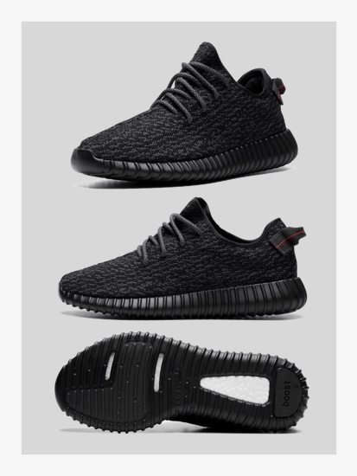

1. The Yeezy boost 350 low is not a common silhouette as most of the colourways in this silhouette are uncommon and those who purchase these shows for dailywear don’t prefer wearing these colors.

b. Profit Margin Model-wise

As clearly seen from the above bar graph the Air Jordan 1 Retro High Off-White has the highest profit margin.

Reason:

1. Virgil Abloh and Nike's "The Ten" collaboration was the biggest sneaker event of 2017, with Highsnobiety readers voting Abloh the most influential person of the year and electing his Nike Air Jordan 1 "Chicago" design the best sneaker of 2017.

2.Limited merchandise was available at "OFF-CAMPUS," including T-shirts and tote bags. Abloh’s Air Jordan 1 design could be considered the flagship of the pack. Speaking about himself and his childhood friends, Abloh said, “We were enamored with Air Jordans. Michael Jordan was larger than life — he was Superman to me. My entire design background and ethos came from the ’90s.” Speaking about the design itself, Abloh noted, “The Jordan 1 was done in one design session. I work in a very dream-like state. I see it and it’s done.”

c. Average selling price Model-Wise

Adidas Yeezy Boost 350 Low has the highest average Selling Price.

**3.Sneaker Sales colour-wise**

For this insight we have used different colourways of the model Adidas Yeezy Boost 350 V2 as it has a great number of varied colourways which will be sufficient to carry out our analysis.

The Colourway History Of the 350 v2’s

27th June 2015

First Yeezy Boost 350 is released

Having worked together on the Yeezy Boost 750 — the first model to come from the collaboration — Adidas and Kanye released the Yeezy Boost 350. The release of the new silhouette, first released in a ‘Turtle Dove' colourway, spearheaded a new-age of sneakers.

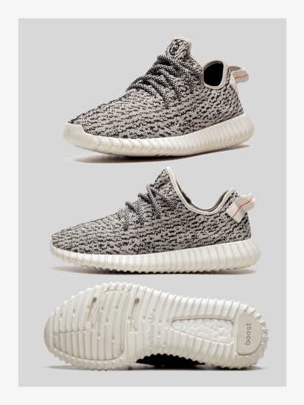

22nd August 2015

## Pirate Black Yeezy Boost 350 is released.

Kanye fans and sneakerheads alike were foaming at the mouth when Adidas announced that the second Yeezy Boost 350 to release would come in an all-black colourway. This subtler take on the shoe, released in summer 2015, was beloved by Ye’s wife, Kim Kardashian West. (They were practically glued to her feet.)



24th September 2016

## First Yeezy Boost 350 V2 released

**“The Yeezy 350 V2 tends to run small so it may best to purchase half a size up from your normal size”**

- Fresco Wilson of Stadium Goods

The first Yeezy Boost 350 V2, dubbed Beluga, made the Yeezy brand a household name. The combination of the gunmetal and safety orange hues makes this a distinctive sneaker that’s still desired today.

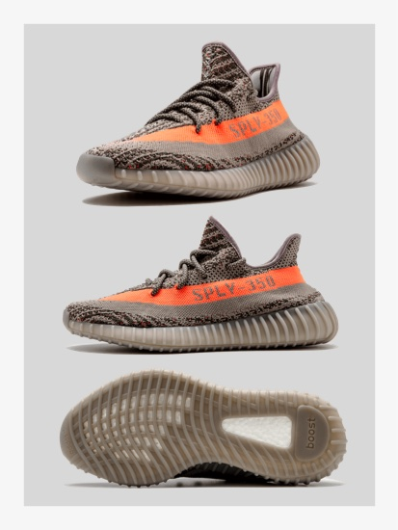

ANALYSIS

30th June 2018

## ‘Butter’ Yeezy Boost 350 V2 is released

After the Blue Tint, the Yeezy 350 took a much-needed hiatus to preserve hype. And then Ye came back with the Butter Boost 350, a pastel-yellow hue that was perfect for summer.

The versitality of this color made it the best siloutte to wear in any season.

**Profit Margin Colour wise**

This will help the resellers decide which colourway to buy in order to gain maximum profits and which colourways are worth the hype

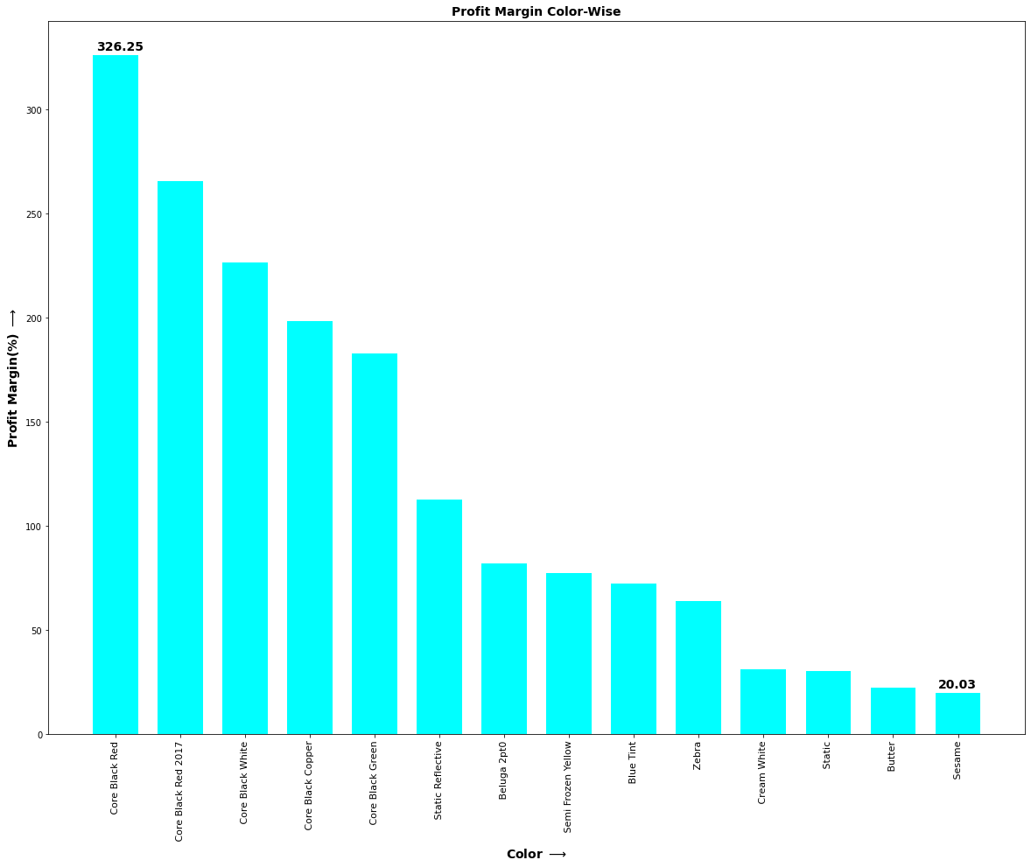

**4. Which Season is best for Resellers**

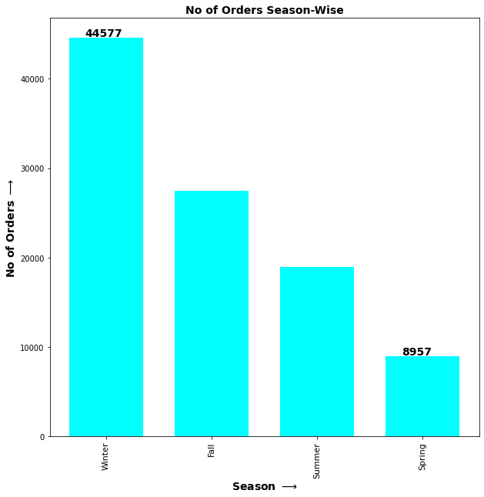

It is quite evident in the graph that people buy sneakers in the Winter Season.

Evidences to backup the same

1. First and the most obvious reason being the temporal conditions people usually prefer wearing flip-flops and sandals in summer and spring season therefore resulting in less orders in this season.
2. The Majority of sales are in the month of Fall and winter as the majority of American festivals lie in these months namely Thanksgiving,Christmas and Easter.
3. The core gist of these holidays is and always will be gift giving and these sneakers make a great gift for the loved ones.
4. The majority of sales like Black Friday and Christmas Bonanzas also occur in these seasons resulting in truckloads of orders.

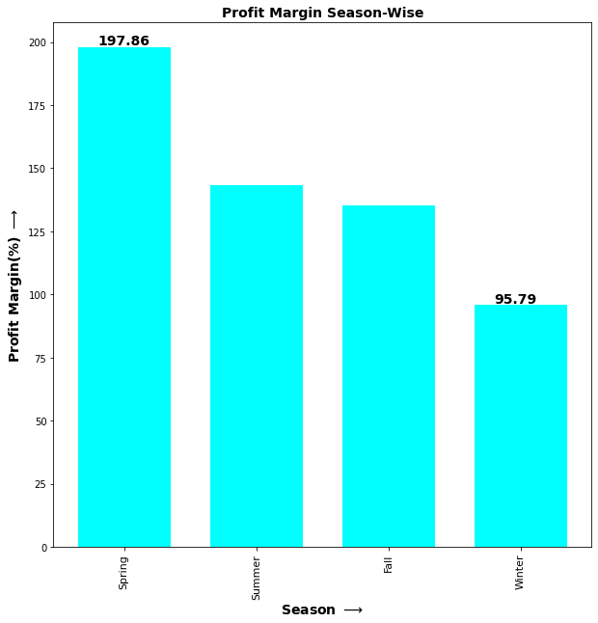

The above observations holds true in this case also as

a. People in Summers are willing to pay more as most sneakers are released in the fall and those couldn’t buy it in the fall have to give more money to buy these now.

b. As a large number of people buy and resell shoes in winter the competition is very and people get a competitive price and profits are comparatively less.

**5. Number of Orders according to Shoe Size**

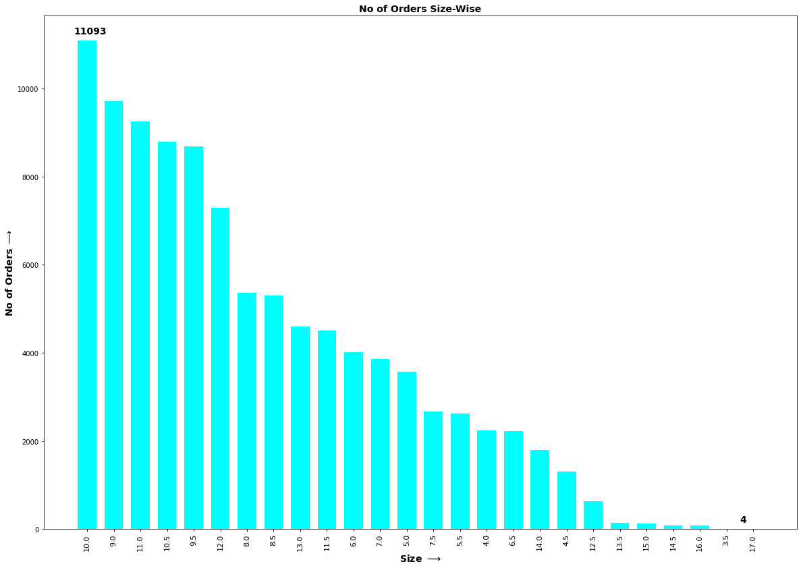

It is clearly evident from the above graph that the shoe size which is the most common is Size 10

Reasons for the Conclusion-

1. In 2014, the **American** Academy of Orthopaedic Surgeons reported that the worldwide average **shoe size** for men is between 9 and 12, while the **American** average male **shoe size** is a 10.
2. The choice to drop down to 10 rather than (logically) up to 11 stems from the “your shoes will stretch” urban legend. No one wants floppy, oversized shoes. Everyone knows that most shoes stretch over time if you need it so they accept slightly uncomfortable footwear. The nerves in their feet in the tight spots go numb/dead/callous so they stop feeling discomfort after a half dozen wearings, so the “shoes stretch theory” seems to the wearer to be true.

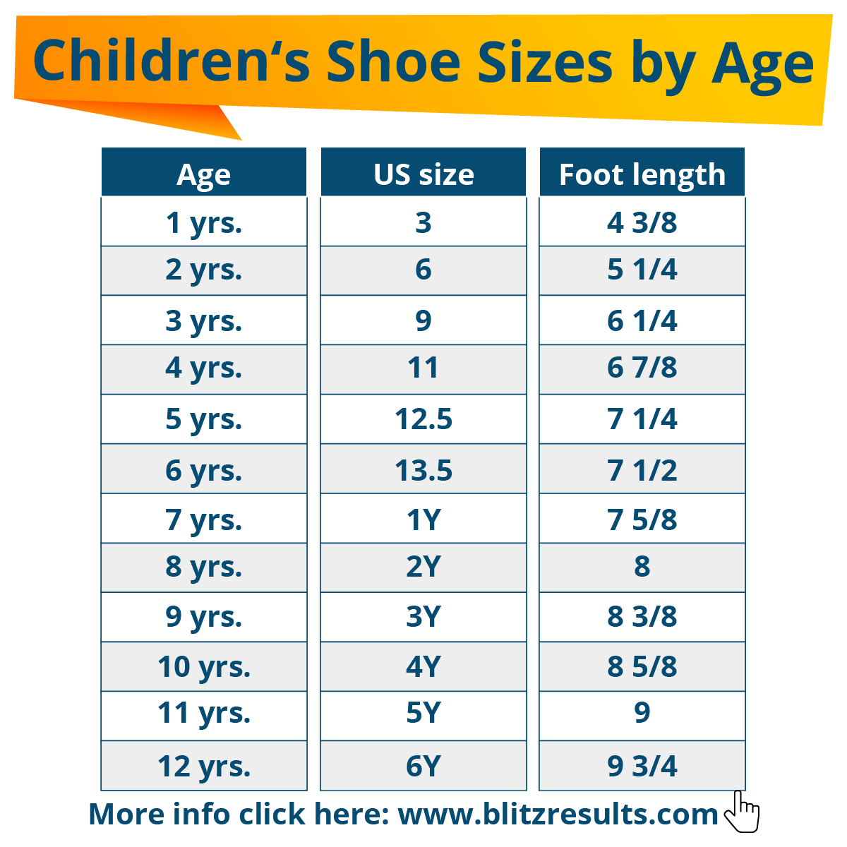

1. Most sneakerheads are usually between the age group 18-24 thus resulting in a shoe size between 9-12 .The sizes below 7 are usually pretty uncommon as parents don’t usually buy their children such expensive shoes.
2. **What is the optimal time to resell your Shoes**

The main conundrum which the resellers face is to figure out the correct time to resell their sneakers.This analysis will help them find the optimal gap between buying and reselling their sneakers in order to make maximum profits.

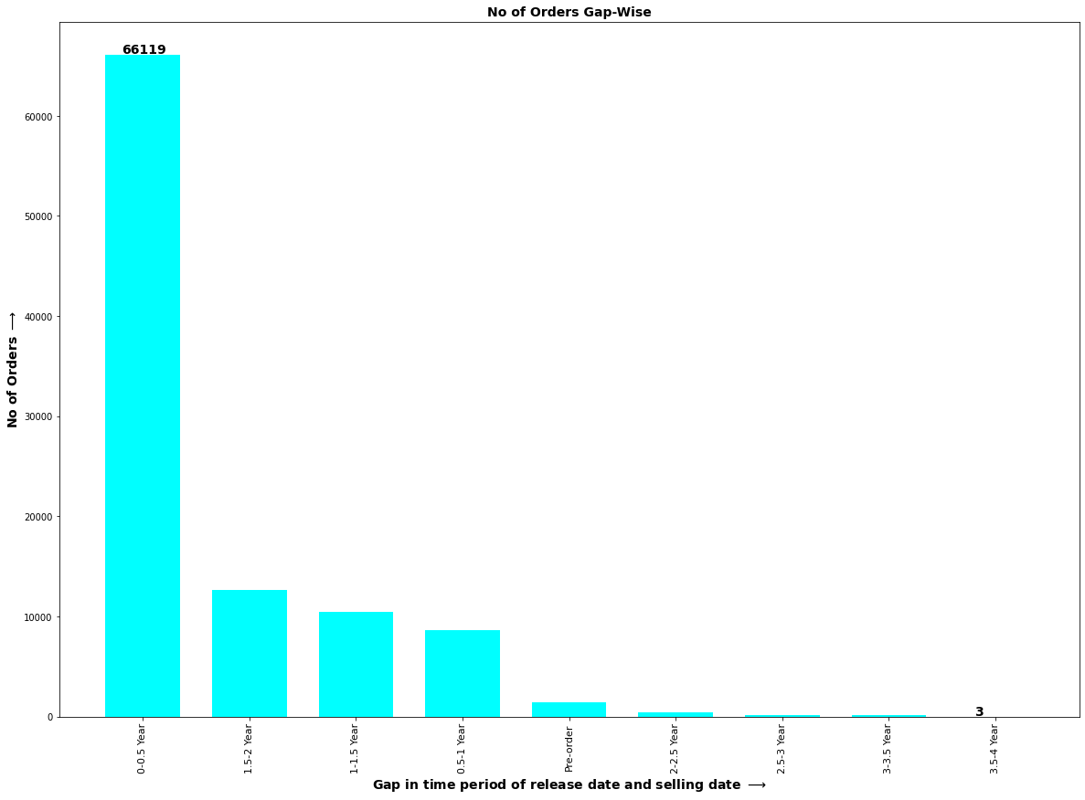

From the above graph it is clearly evident that majority of people prefer to resell their sneakers is within the first 6 months of buying.

Evidences to backup the same-

1. Compared to some other ways of [making money online](https://www.nichepursuits.com/how-to-make-extra-money-online/), the sneaker resale market is very profitable and valued at [around $1 billion](https://www.ft.com/content/b3ea93b2-d48d-11e4-9bfe-00144feab7de#axzz3WBgYkYUg). While only 4% of shoes and sneakers are purchased upon release for resale, the market benefits from side hustlers and entrepreneurs who operate in different channels.
2. Reselling shoes are similar to the stock market. There are pairs of shoes that don’t start out too hot but eventually accumulate value later on. Conversely, some sneakers generate lots of attention only to fizzle out as time goes by.Therefore if you get your hands on a “Hyped” pair it is advised to sell it as soon as possible.

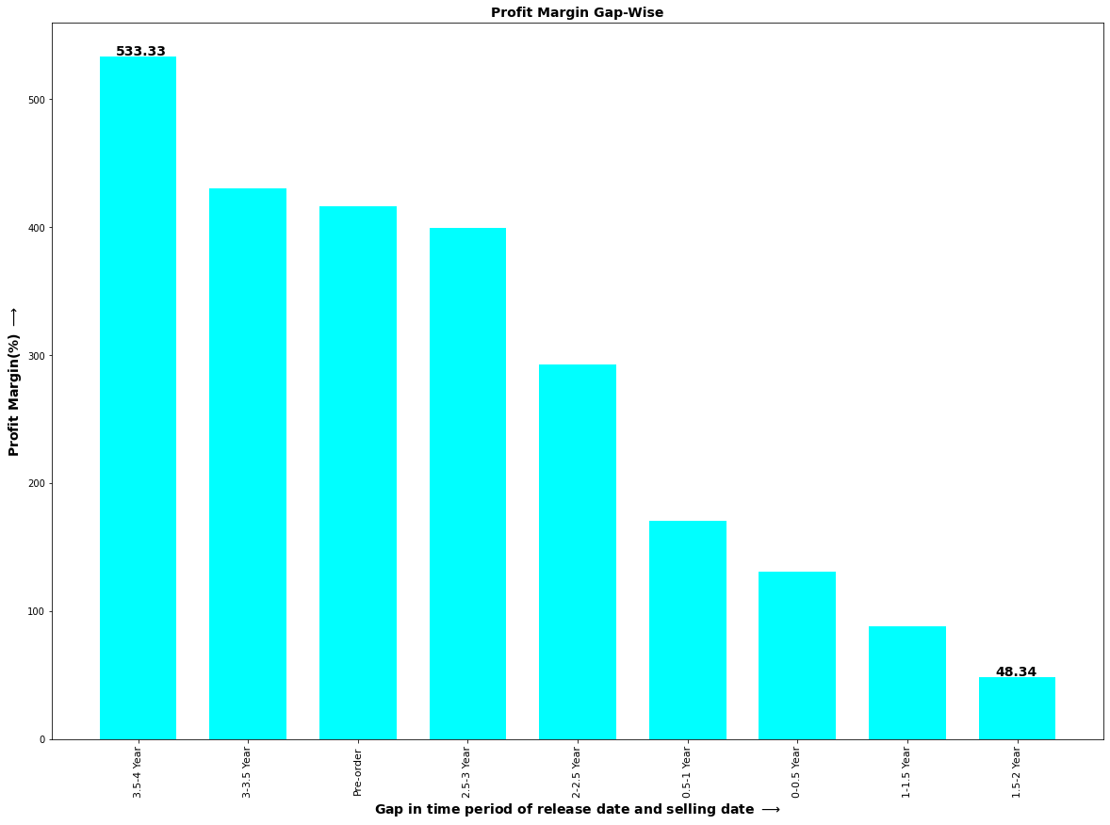

1.The foundation of this industry is to create the “HYPE”. The sneakers in this case can be compared to wine which ages gracefully.The people who can’t cop these sneakers upon release are willing to pay any amount of money to get their desired pairs.

2.This is where [StockX](https://stockx.com/) comes in. The site shows how much the shoes and sneaker cost over a 12-month period. Just like a stock market index graph, you will see the movement of price over time, thus giving you information on which shoes to acquire for reselling. It also serves as a consignment store where people can bid or ask for shoes for resale. If you got a pair of sneakers you want to sale, you could do so through the site.

3.Waiting for a time period of more than 3 years as the fashion may go out of trend but on severe analysis it clearly evident that old sneakers go for a stupendous amount.Most common Examples:

a. **Nike Air Yeezy 2 “Red October” ($6,000)**

**b.** **Nike Air Mag Back to the Future ($10,000+)**

**c.Nike Air Jordan 4 EminemxCarhatt ($15,000+)**