Vision Transformer from Scratch for Multi-Label Chest X-Ray Classification
Project Overview
This project focuses on the end-to-end implementation of a Vision Transformer (ViT) architecture from scratch for a multi-label chest X-ray classification task based on the CheXpert benchmark dataset. CheXpert is a large public chest radiograph dataset containing 224,316 chest radiographs from 65,240 patients, and it is widely used for automated chest X-ray interpretation research.
The objective of the work was to train a transformer-based image classification model directly on chest radiographs and predict multiple disease labels for a single image, rather than restricting the task to a single mutually exclusive diagnosis. This makes the problem more realistic for medical imaging because a single chest X-ray can show multiple co-existing thoracic conditions at the same time.
This report presents the problem formulation, solution design, implementation details, experimental workflow, observed outcomes, and concluding remarks in a structured format so it can be pasted directly into a formal project document.
Problem Statement
Chest X-ray interpretation is one of the most common and clinically important medical imaging tasks. Manual interpretation by radiologists is time-consuming and can be difficult at scale, especially when multiple abnormalities may appear simultaneously in the same image [page:1].
The task addressed in this project is multi-label classification of chest X-ray images using a deep learning model built from scratch. In the selected problem setting, each input image may belong to more than one pathology class, so the model must independently estimate the presence or absence of each disease label instead of assigning only one final class.
The project is based on the CheXpert dataset, which was designed for chest radiograph analysis and includes uncertainty-aware labels for clinically relevant observations. The dataset contains 14 observations in the original benchmark, with labels marked as positive, negative, or uncertain depending on the interpretation extracted from radiology reports.
For this project, the classification setup was adapted to a 15-class multi-label problem of chest X-ray findings. The goal was therefore to develop a custom Vision Transformer pipeline capable of learning meaningful image representations from chest radiographs and producing reliable multi-label predictions across all defined classes.
Core Challenges
Several technical and domain-specific challenges make this problem difficult:
- Chest X-ray images are high-resolution medical images in which disease evidence may be subtle and spatially distributed.
- Multi-label classification is more complex than standard single-label classification because several pathologies may be present in the same image.
- Medical datasets frequently suffer from class imbalance, where some conditions occur much more often than others.
- The CheXpert labeling framework includes uncertain observations, which complicate target processing and loss design.
- Training a Vision Transformer from scratch is computationally demanding because transformer architectures generally require careful design choices, sufficient regularization, and stable optimization.
Proposed Solution
To address the problem, a Vision Transformer (ViT) model was implemented from scratch rather than using a fully pre-trained off-the-shelf backbone. Vision Transformers process an image by dividing it into fixed-size patches, converting those patches into embeddings, and learning relationships among them through self-attention layers instead of convolutional feature extraction.
The proposed system treats each chest X-ray as a sequence of visual tokens. First, the image is resized and partitioned into patches. Each patch is flattened and linearly projected into an embedding space. Positional embeddings are then added so that the model can preserve spatial information while processing the sequence through stacked transformer encoder blocks.
Each encoder block typically contains the following components:
- Layer normalization
- Multi-head self-attention
- Residual connections
- Feed-forward multilayer perceptron layers
- Dropout or other regularization components, depending on implementation
The final learned representation is passed through a classification head that outputs one score per disease label. Since the task is multi-label classification, sigmoid activation is used at the output stage so that each class probability is estimated independently.
Why Vision Transformer
A Vision Transformer was selected because it offers a different representational strategy from conventional convolutional neural networks. Instead of relying primarily on local convolution kernels, ViT uses self-attention to model long-range dependencies between image regions, which can be beneficial when abnormalities are distributed across multiple anatomical regions of a chest radiograph.
This design is especially relevant for chest X-ray analysis because certain findings are not defined by a single compact local pattern alone; rather, they may depend on broader contextual relationships across the lungs, pleural spaces, mediastinum, or cardiac silhouette. Implementing the model from scratch also demonstrates architectural understanding rather than only model reuse.
System Design and Implementation
The implementation pipeline can be described as a sequence of major stages, beginning from dataset preparation and ending with model evaluation.
1. Data Preparation
The dataset images and labels were first organized into a format suitable for supervised learning. Image paths were mapped to their corresponding multi-label targets, and the label vectors were prepared for all 15 classes used in the project.
Typical preprocessing steps in this kind of workflow include:
- Reading chest X-ray images from the dataset directory
- Resizing images to a fixed spatial resolution
- Normalizing pixel intensities
- Converting labels into multi-hot encoded vectors
- Splitting the data into training, validation, and test subsets
- Handling missing or uncertain labels according to the chosen training policy
A consistent preprocessing pipeline is particularly important in medical imaging because model performance can be strongly affected by image scaling, contrast handling, and label construction.
2. Patch Embedding Layer
In the Vision Transformer architecture, the input image is split into non-overlapping patches. If the input image size is denoted by $H×W$ and the patch size is $P×P$, then the number of patches is:
$N=\frac{H×W}{P^{2}}$
Each patch is flattened and projected into a dense embedding vector. This converts a 2D medical image into a 1D token sequence that can be processed by the transformer encoder.
3. Positional Encoding
Because transformers do not inherently encode spatial order, positional embeddings are added to the patch embeddings. These embeddings allow the model to distinguish between patches coming from different anatomical regions of the image.
This step is critical in X-ray analysis because the location of an abnormality often has clinical meaning. For example, disease patterns in the upper lung zone, lower lung zone, pleural boundary, or cardiac region may carry different diagnostic relevance.
4. Transformer Encoder Blocks
The main learning capacity of the model comes from stacked transformer encoder blocks. Each block applies self-attention to model interactions among image patches and then refines the representation through a feed-forward network.
A typical encoder block in the implementation includes:
- Multi-head self-attention for contextual feature interaction
- Skip connections to stabilize deep learning
- Layer normalization for training stability
- A feed-forward network for nonlinear transformation
- Dropout for regularization
By stacking several such blocks, the model learns hierarchical contextual relationships among patches while preserving global receptive fields.
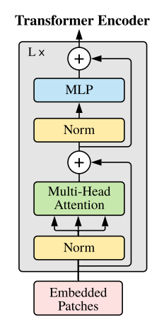
5. Classification Head
The learned representation at the output of the transformer is passed into a dense classification head. Because the task is multi-label, the output dimension equals the number of pathology classes.
Instead of softmax, a sigmoid activation function is applied independently to each class output. This enables the network to assign high probability to multiple disease categories for the same chest X-ray whenever appropriate.

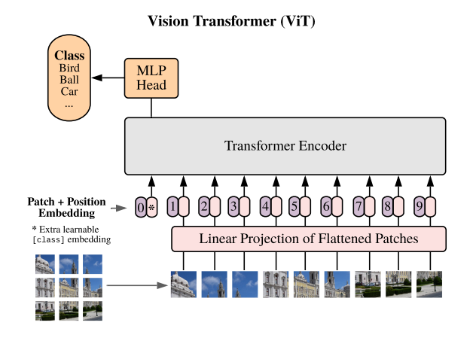

6. Loss Function and Optimization
For multi-label classification, binary cross-entropy or binary cross-entropy with logits is typically the appropriate loss function because each label is treated as an independent binary decision. The optimizer, learning rate schedule, batch size, regularization settings, and number of epochs were tuned as part of the training process to obtain stable convergence.
Training Hyperparameters:
- Image size: (3,224,224)
- Patch size:(3,16,16)
- Embedding dimension: 512
- Number of transformer blocks: 3
- Number of attention heads: 8
- MLP hidden dimension: 1024
- Batch size: 32
- Number of epochs: 33
- Optimizer: Adam
- Learning rate: 0.0001
- Loss function: BCEWithLogitsLoss
_

Model Architecture

One Encoder Block:
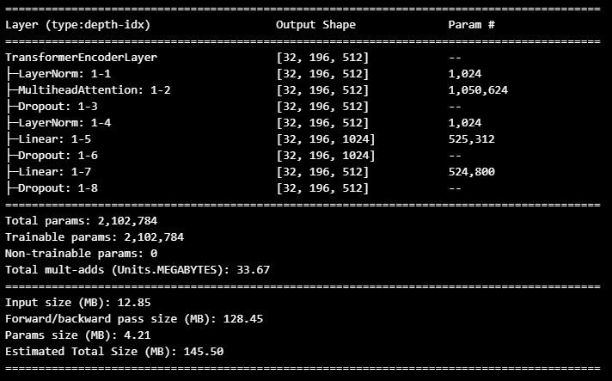

Stacked Encoder Blocks:
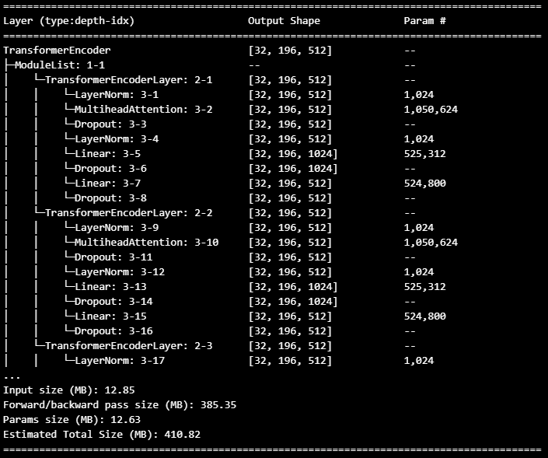
ViT:
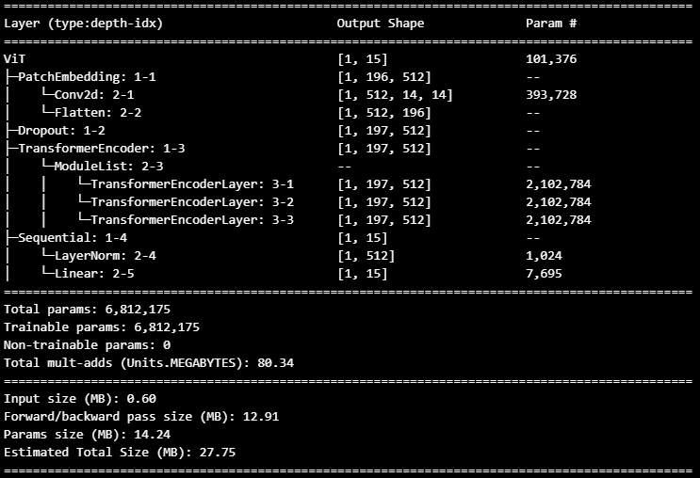

Training Workflow
The overall training workflow followed a standard deep learning pipeline adapted to the transformer architecture and the medical multi-label setting.
- Load and preprocess chest X-ray images.
- Generate multi-label target vectors for all classes.
- Build the Vision Transformer architecture from scratch.
- Compile the model using a multi-label loss function and suitable optimizer.
- Train the model on the training set while monitoring validation performance.
- Evaluate the trained model using multi-label classification metrics.
- Analyze class-wise and aggregate performance trends.
During training, the model learns to map patch-level image features to disease probabilities. Validation monitoring is important because a model trained from scratch on medical data can overfit, especially when classes are imbalanced or when some pathologies have relatively few positive examples.

Experimental Setup
The experiments were designed to assess whether a transformer-based model implemented from scratch can effectively learn discriminative patterns from chest X-ray images for multi-label disease prediction.
The evaluation should ideally include both aggregate and class-specific metrics, since overall performance alone may hide poor behavior on minority classes. In multi-label medical classification, common evaluation measures include:
- Training loss and validation loss
- Training accuracy and validation accuracy, if tracked
- Per-class AUC-ROC
- Macro and micro averaged precision
- Macro and micro averaged recall
- F1-score
- Hamming loss
- Exact match ratio, if computed
- Confusion behavior or threshold-based class-wise analysis

Metrics
Epoch_1:
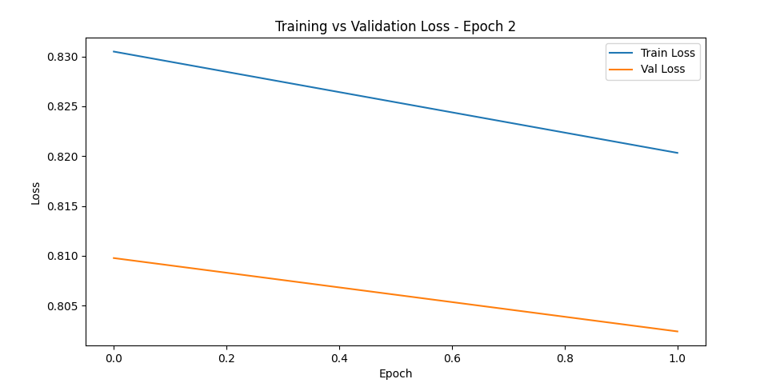
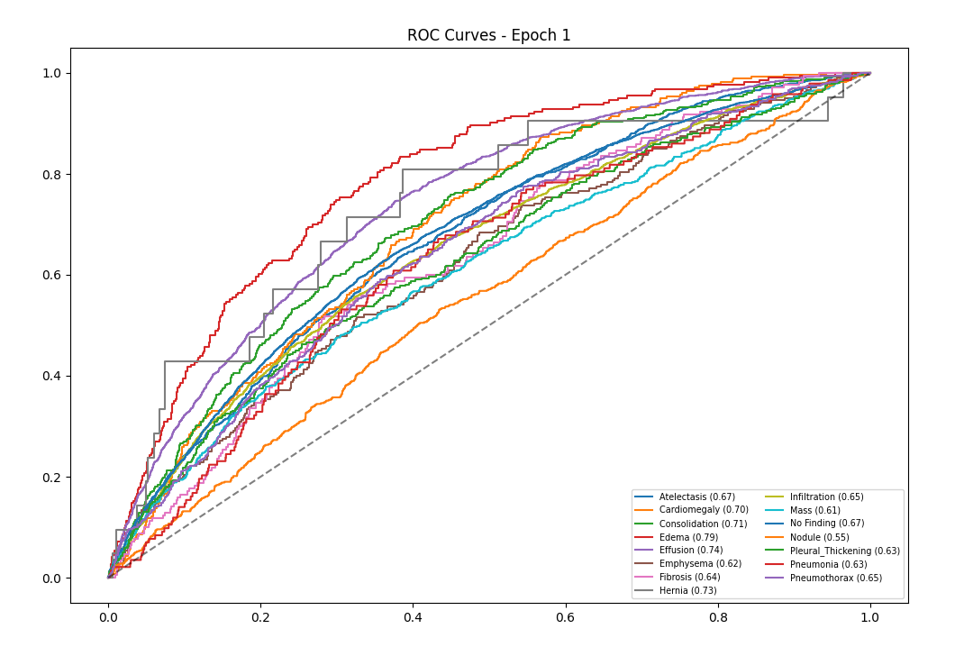
Epoch_33(Last Epoch):
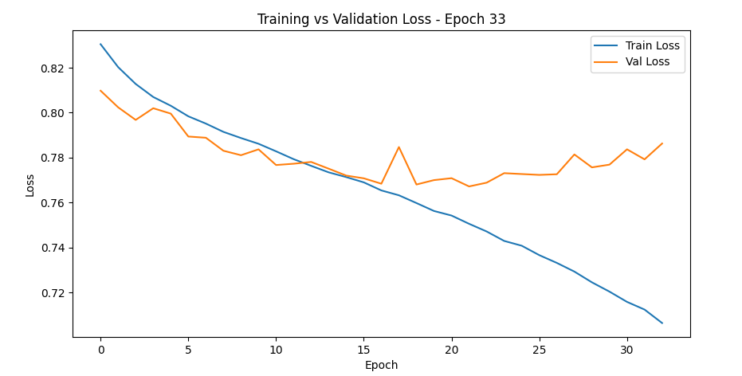

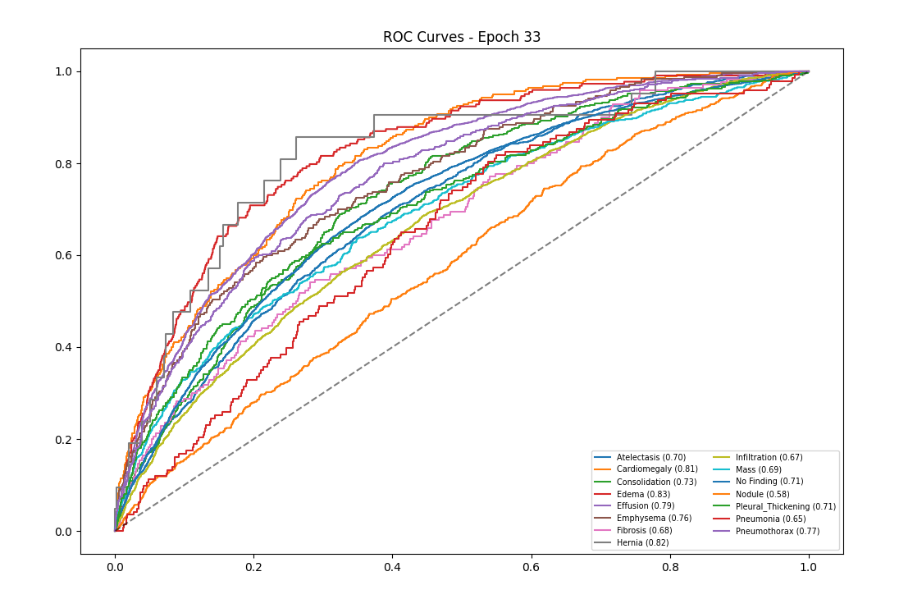
Epoch_17(Most Optimal Model State):
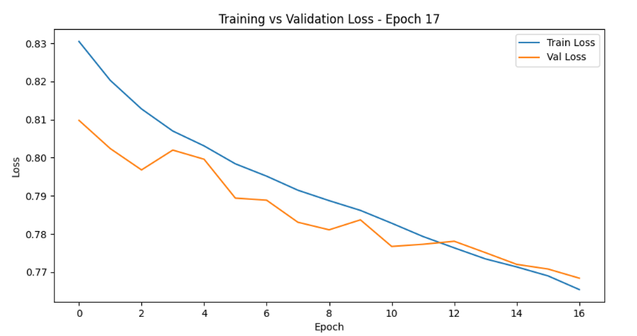
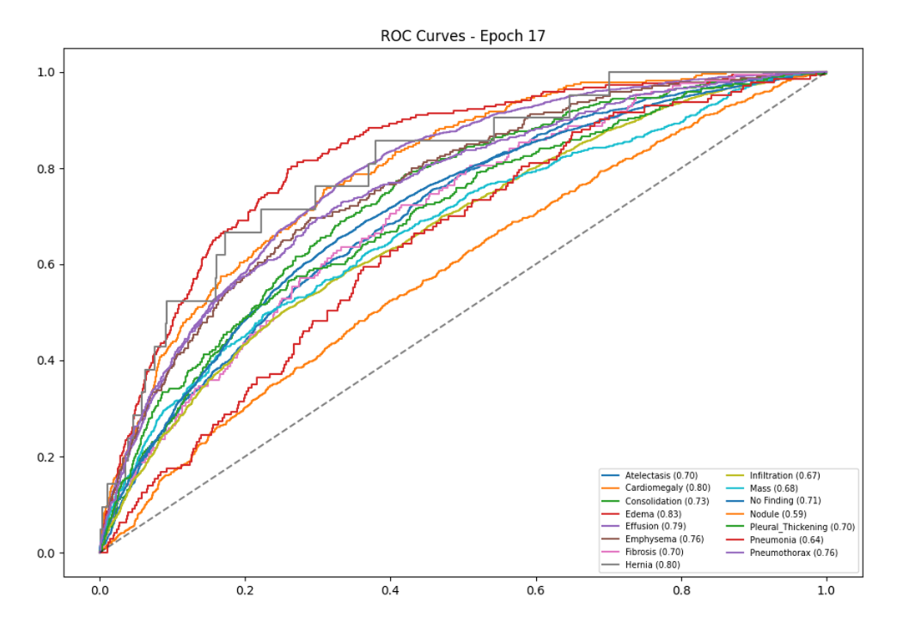

Results and Discussion
The experimental results indicate a clear improvement in model learning behavior from the initial training stage to the optimal checkpoint. In the early epoch, both training and validation loss are relatively high, showing that the model is still in the process of learning meaningful feature representations from the chest X-ray images. At this stage, the ROC curves are already above the diagonal baseline for most classes, which means the model has begun to capture disease-related patterns, but the discriminative performance is still limited and inconsistent across classes.
By the optimal epoch, the model demonstrates its strongest balance between learning and generalization. The training and validation loss curves both decrease noticeably, and the gap between them remains small, indicating that the model is improving without severe overfitting at this point. The ROC curves at the optimal epoch are visibly stronger across most classes than in the initial stage, showing that the model has learned more reliable multi-label representations and is better able to distinguish between the presence and absence of thoracic abnormalities.
At the final epoch, the training loss continues to decrease, but the validation loss stops improving and begins to fluctuate upward slightly, which is a common sign that the model has started fitting the training data more strongly than the validation distribution. Although the ROC curves at the last epoch remain competitive and still show good class separation for several labels, the gains over the optimal epoch appear limited, and some classes do not improve meaningfully enough to justify selecting the final checkpoint over the middle one. This pattern suggests that the best model for reporting and deployment purposes is the optimal epoch rather than the last epoch.
The class-wise ROC behavior also reflects the difficulty of the medical multi-label setting. Some classes achieve comparatively stronger ROC performance across epochs, indicating that their radiographic patterns are easier for the model to learn, while others remain weaker and closer to the diagonal, which is expected in chest X-ray classification because certain abnormalities are subtle, infrequent, or visually overlapping with other conditions. This uneven class-wise behavior is typical in CheXpert-style problems, where label imbalance and visual ambiguity can affect performance across disease categories.
Overall, the results support the effectiveness of the custom Vision Transformer implementation for multi-label chest X-ray classification. The model successfully learns from scratch, improves substantially during training, and reaches its best trade-off between representation quality and generalization around the optimal epoch, while the last epoch shows early signs of overfitting rather than a clear improvement in validation performance.

Conclusion
This project successfully demonstrates the implementation of a Vision Transformer from scratch for multi-label chest X-ray classification. The training and ROC trends show that the model was able to learn useful visual representations for multiple thoracic disease classes and achieve progressively stronger predictive performance as training advanced.
The most important finding is that the optimal checkpoint provides the best overall model state, since it combines lower validation loss with stronger and more balanced ROC behavior across classes. Although the final epoch achieves lower training loss, the slight rise and fluctuation in validation loss suggest mild overfitting, making the middle checkpoint more suitable as the final selected model for evaluation and reporting.
These results confirm that a transformer-based architecture can be effectively adapted to a medical multi-label classification task even when implemented from scratch. At the same time, the observed gap between continued training improvement and validation stability indicates that future gains may come from better regularization, threshold tuning, class-balancing strategies, and possibly pretrained initialization rather than simply extending training for more epochs.

