1. Create RESOURCE GROUP.

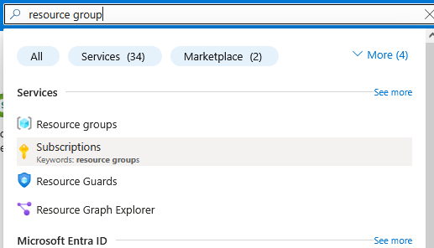

1. Give name and region

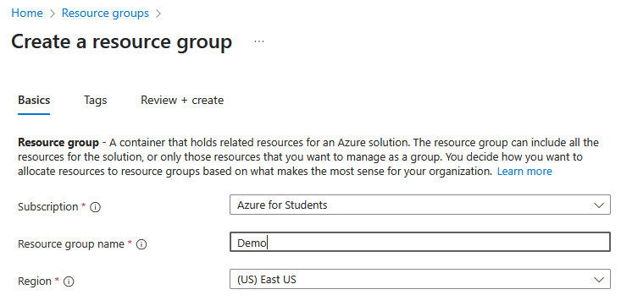

1. Resource Group created

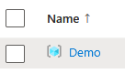

1. Check Virtual machines in search.

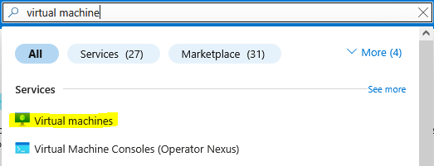

6. Select the following.

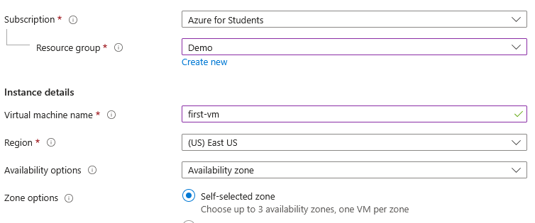

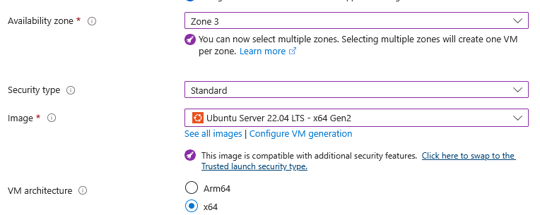

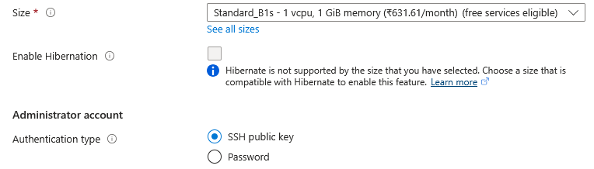

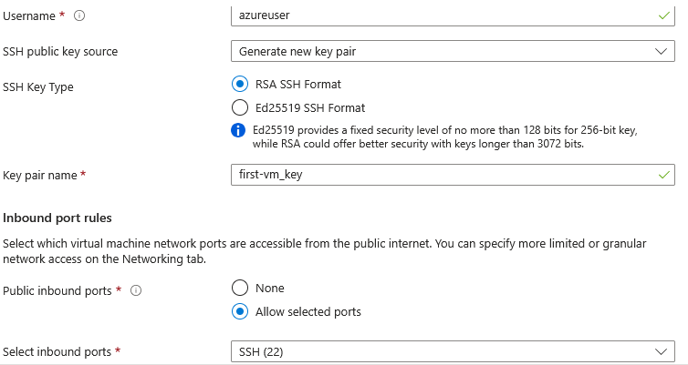

7. Click Review + Create

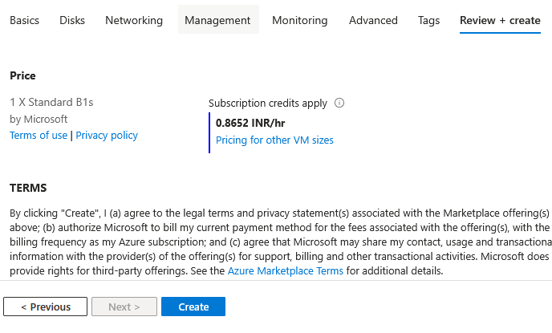

8. Download the key pair.

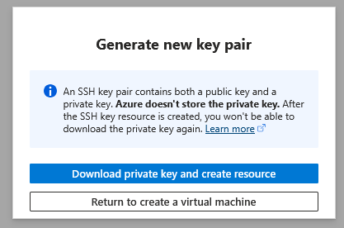

9. SSH key is downloaded now.

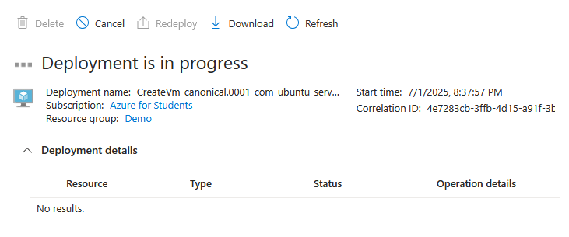

10. VM is created and placed in ResourceGroup.

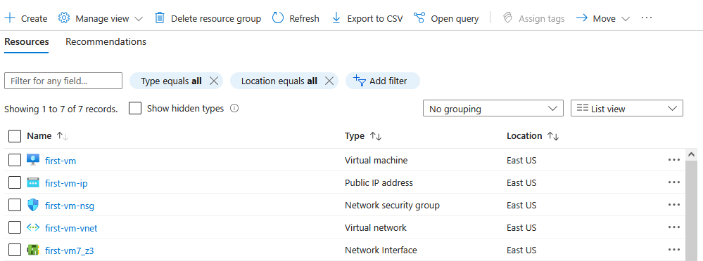

**To Run Jenkins on Ubuntu VM:**

1. Download and Install Gitbash from this link - <https://git-scm.com/downloads/win>
2. 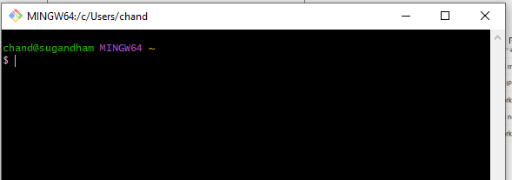

$ ssh -i C:/Users/chand/Downloads/first-vm_key.pem [azureuser@48.216.244.158](mailto:azureuser@48.216.244.158)

Ssh -I (identity) folderwherepemfileisthere username@publicip

username - azureuser

keypair name - first-vm_key

public ip - 48.216.244.158

1. 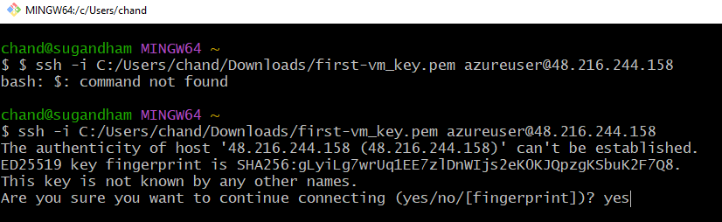

$ ssh -i C:/Users/chand/Downloads/first-vm_key.pem [azureuser@48.216.244.158](mailto:azureuser@48.216.244.158)

**sudo apt update**

**sudo apt install openjdk-17-jre**

**java -version**

**curl -fsSL https://pkg.jenkins.io/debian/jenkins.io-2023.key | sudo tee \**

**/usr/share/keyrings/jenkins-keyring.asc > /dev/null**

**echo deb [signed-by=/usr/share/keyrings/jenkins-keyring.asc] \**

**https://pkg.jenkins.io/debian binary/ | sudo tee \**

**/etc/apt/sources.list.d/jenkins.list > /dev/null**

**sudo apt-get update**

**sudo apt-get install jenkins**

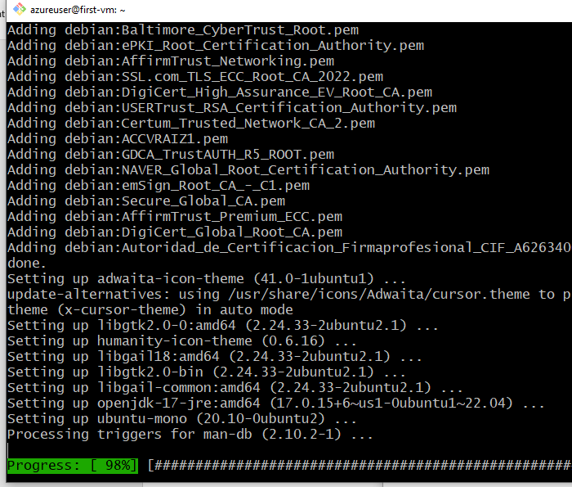

ps -ef | grep jenkins

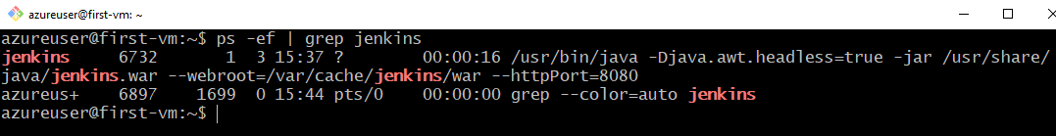

**http://Publicip:8080 – to use Jenkins application**

By Default, we wont be able to access application because by default due to security settings in any cloud the ports are closed. We need to open them. To open them go to network settings configured on the VM.

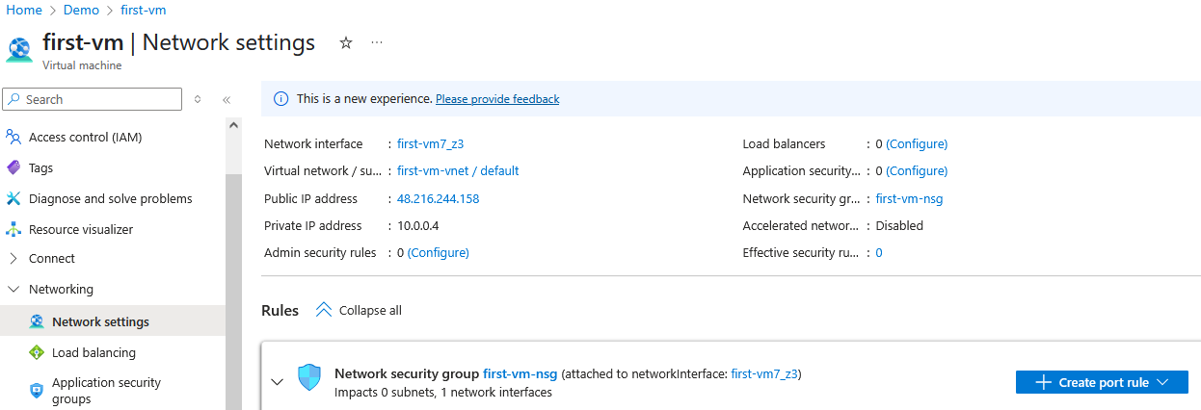

Click Create Port Rule – Inbound, give all details and click Add.

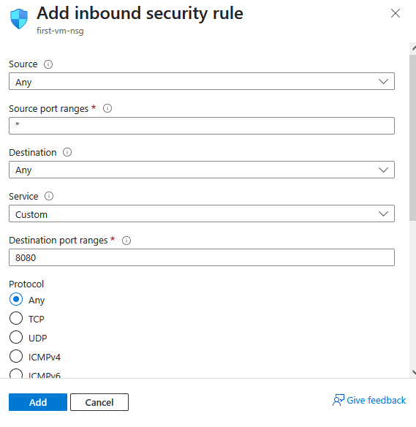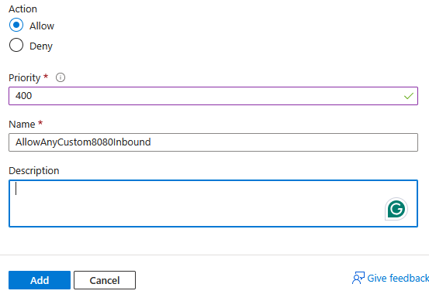

Jenkins is now inside the VM.

