Petro-Intelligence

Satvinder Singh Panesar

[panesar.satvindersingh@gmail.com](mailto:panesar.satvindersingh@gmail.com)

<https://www.linkedin.com/in/panesarsatvinder/>

<https://github.com/satvinder-panesar>

**Project summary:**

A real-time listing service that provides petrol station owners a User Interface to make data entry of daily petrol prices.

All data entries are stored in an Oracle Database.

These details are exposed as a web service where consumers over any platform can access and get JSON data.

Details can also be viewed by navigating the website.

Data gathered over the service can be used to find the cheapest prices, analyze current trends and also meet future demand-supply by estimations.

**Technology Stack:**

**Application Layer:** Node JS

**Packages:** express, ejs, body-parser

**Front End:** HTML, Bootstrap (CSS)

**Database:** Oracle 11g

**Data Parsing Scheme:** JSON

**Screenshots**

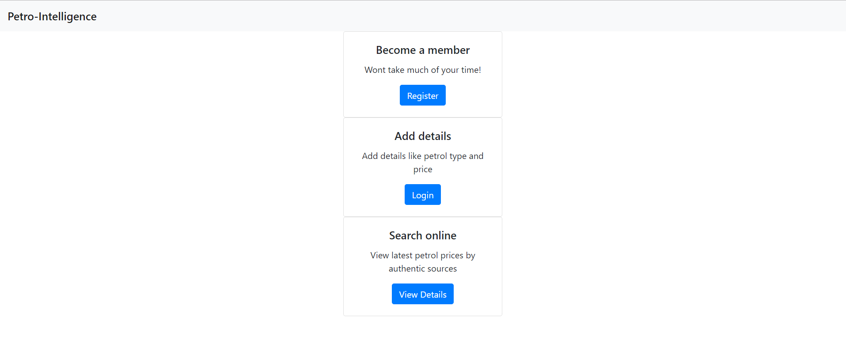

**Fig: Homepage**

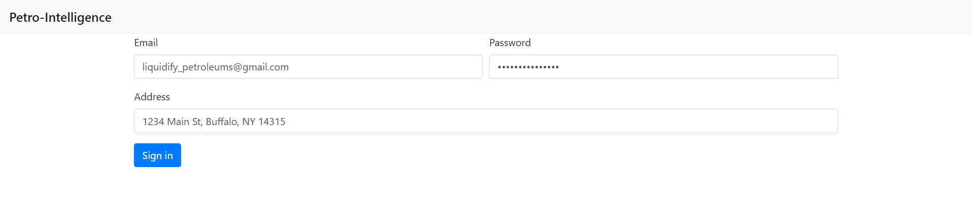

**Fig: Registration**

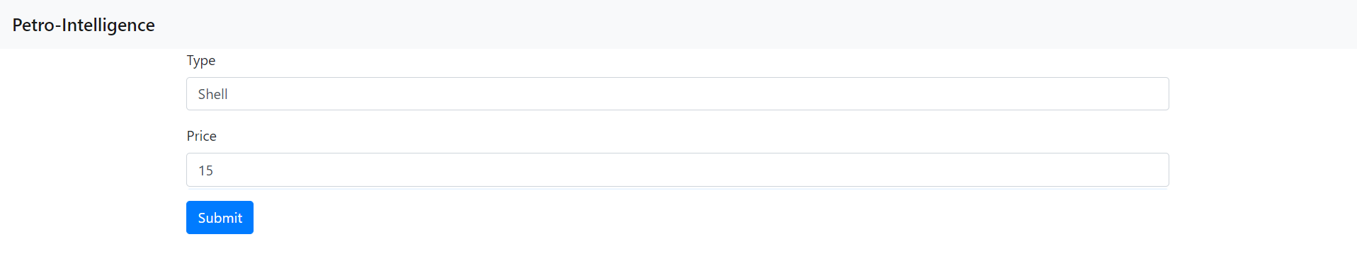

**Fig: Data entry**

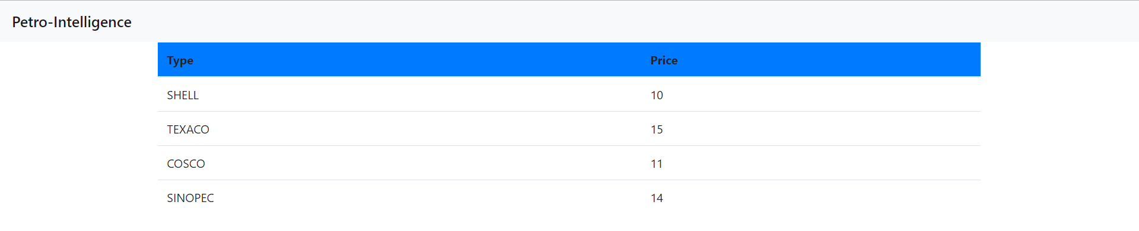

**Fig: Listing**