12.1

1. a. Perform ANOVA test on the discriminant analysis scores of nuclear localization signals of both nuclear and non-nuclear proteins by class variables (Target).

1. > summary(anv)
2. Df Sum Sq Mean Sq F value Pr(>F)
3. yeast$nuc 1 0.084 0.08370 4.463 0.0348 *
4. Residuals 1482 27.790 0.01875
5. ---
6. Signif. codes: 0 ‘***’ 0.001 ‘**’ 0.01 ‘*’ 0.05 ‘.’ 0.1 ‘ ’ 1

b. Which class is significantly different from others?

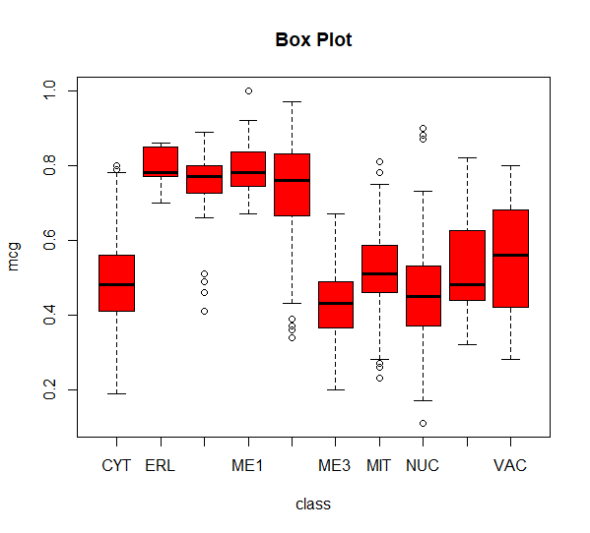

> anv1<-aov(yeast$gvh~yeast$class)

> summary(anv1)

Df Sum Sq Mean Sq F value Pr(>F)

yeast$class 9 7.021 0.7801 72.98 <2e-16 ***

Residuals 1474 15.754 0.0107

---

Signif. codes: 0 ‘***’ 0.001 ‘**’ 0.01 ‘*’ 0.05 ‘.’ 0.1 ‘ ’ 1

**The pink colour highlighted groups are significantly different from others**

> TukeyHSD(anv1)

Tukey multiple comparisons of means

95% family-wise confidence level

Fit: aov(formula = yeast$gvh ~ yeast$class)

$`yeast$class`

diff lwr upr p adj

ERL-CYT 0.302496760 0.155211318 0.449782203 0.0000000

EXC-CYT 0.247353903 0.189928699 0.304779107 0.0000000

ME1-CYT 0.287087669 0.235410402 0.338764937 0.0000000

ME2-CYT 0.133634015 0.085303840 0.181964191 0.0000000

ME3-CYT 0.020005963 -0.009828297 0.049840222 0.5101062

MIT-CYT 0.063734465 0.037820332 0.089648599 0.0000000

NUC-CYT -0.013372704 -0.035324784 0.008579377 0.6482966

POX-CYT 0.038496760 -0.036316825 0.113310346 0.8332070

VAC-CYT 0.056496760 -0.005217387 0.118210908 0.1061882

EXC-ERL -0.055142857 -0.211754255 0.101468541 0.9831874

ME1-ERL -0.015409091 -0.170005391 0.139187209 0.9999995

ME2-ERL -0.168862745 -0.322372620 -0.015352870 0.0181028

ME3-ERL -0.282490798 -0.431217255 -0.133764341 0.0000001

MIT-ERL -0.238762295 -0.386752221 -0.090772369 0.0000159

NUC-ERL -0.315869464 -0.463217249 -0.168521679 0.0000000

POX-ERL -0.264000000 -0.427788121 -0.100211879 0.0000163

VAC-ERL -0.246000000 -0.404234358 -0.087765642 0.0000409

ME1-EXC 0.039733766 -0.034459686 0.113927219 0.7974178

ME2-EXC -0.113719888 -0.185622143 -0.041817633 0.0000266

ME3-EXC -0.227347940 -0.288374258 -0.166321623 0.0000000

MIT-EXC -0.183619438 -0.242828143 -0.124410733 0.0000000

NUC-EXC -0.260726607 -0.318311520 -0.203141693 0.0000000

POX-EXC -0.208857143 -0.300678714 -0.117035572 0.0000000

VAC-EXC -0.190857143 -0.272360299 -0.109353987 0.0000000

ME2-ME1 -0.153453654 -0.220854100 -0.086053208 0.0000000

ME3-ME1 -0.267081707 -0.322733278 -0.211430136 0.0000000

MIT-ME1 -0.223353204 -0.277005386 -0.169701022 0.0000000

NUC-ME1 -0.300460373 -0.352315056 -0.248605690 0.0000000

POX-ME1 -0.248590909 -0.336931652 -0.160250166 0.0000000

VAC-ME1 -0.230590909 -0.308151532 -0.153030286 0.0000000

ME3-ME2 -0.113628052 -0.166186241 -0.061069863 0.0000000

MIT-ME2 -0.069899550 -0.120335871 -0.019463229 0.0005098

NUC-ME2 -0.147006719 -0.195526550 -0.098486888 0.0000000

POX-ME2 -0.095137255 -0.181562672 -0.008711838 0.0179490

VAC-ME2 -0.077137255 -0.152509107 -0.001765402 0.0398801

MIT-ME3 0.043728502 0.010590915 0.076866090 0.0012662

NUC-ME3 -0.033378666 -0.063519190 -0.003238142 0.0167022

POX-ME3 0.018490798 -0.059121250 0.096102845 0.9991117

VAC-ME3 0.036490798 -0.028587566 0.101569161 0.7500198

NUC-MIT -0.077107169 -0.103373316 -0.050841022 0.0000000

POX-MIT -0.025237705 -0.101428841 0.050953431 0.9890620

VAC-MIT -0.007237705 -0.070614772 0.056139362 0.9999983

POX-NUC 0.051869464 -0.023066780 0.126805708 0.4618685

VAC-NUC 0.069869464 0.008006679 0.131732248 0.0131041

VAC-POX 0.018000000 -0.076563116 0.112563116 0.9998588