12.2

1. a. What are the assumptions of ANOVA, test it out?

* Independence of cases – Its an assumption of the model that simplifies the statistical analysis.
* Normality – the distributions of the residuals are normal.
* Equality (or "homogeneity") of variances, called homoscedasticity...

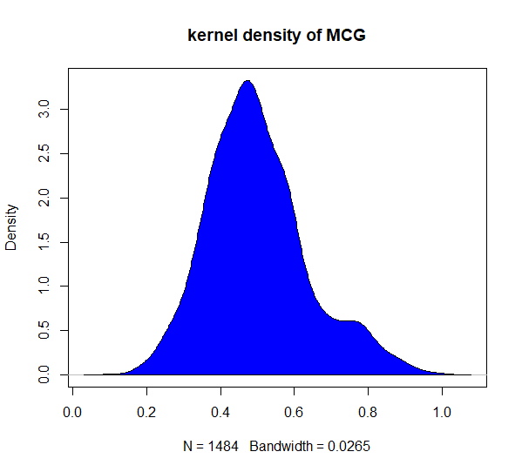

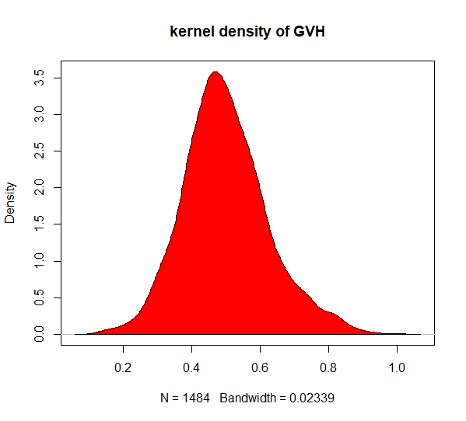

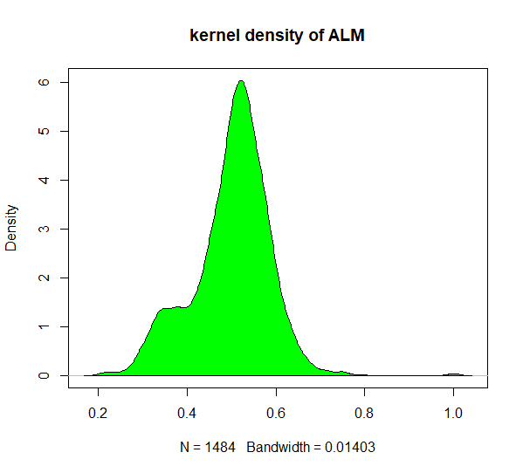

b. Why ANOVA test? Is there any other way to answer the above question?

**t-test is** a special type of ANOVA that can be used when we have only two populations

to compare their means. Although the chances of errors might increase if t-test is used when we have to compare more than two means of the populations concurrently, that is why ANOVA is used.