18

1. Use the below given data set

2. Perform the below given activities:

a. Create classification model using different decision trees.

Classification based on Decision Tree method

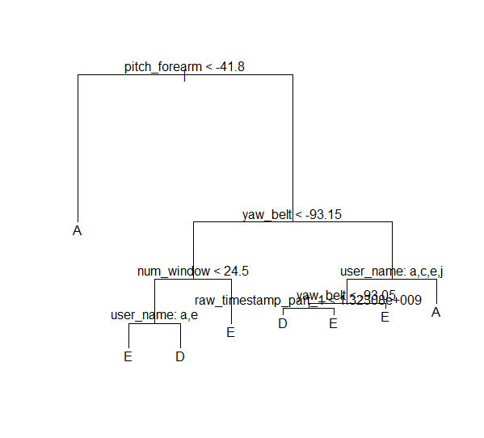’’’’’

> summary(tree)

Classification tree:

tree(formula = classe ~ ., data = weightTrain)

Variables actually used in tree construction:

[1] "pitch_forearm" "yaw_belt" "num_window" "user_name" "raw_timestamp_part_1"

Number of terminal nodes: 8

Residual mean deviance: 0.003518 = 7.051 / 2004

Misclassification error rate: 0.000497 = 1 / 2012

> table(weightTest$classe,pred)

pred

A B C D E

A 337 0 0 248 414

B 0 0 0 17 884

C 29 0 0 0 83

D 0 0 0 0 0

E 0 0 0 0 0

Classification based on Decision Tree method

b. Verify model goodness of fit.

> table(weightTest$classe,pred)

pred

A B C D E

A 337 0 0 248 414

B 0 0 0 17 884

C 29 0 0 0 83

D 0 0 0 0 0

E 0 0 0 0 0

c. Apply all the model validation techniques.

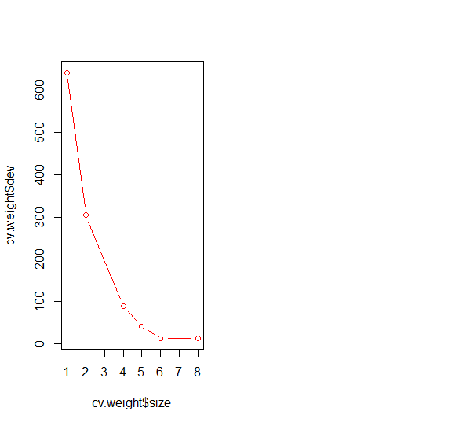

d. Make conclusions.

Model having best classification accuracy is selected