27.1

1. Return the categories (names) of the longest film. NOTE that there may be several "longest"

films (i.e. with the same length), so you might need to return more than one category. Return

the duration as well.

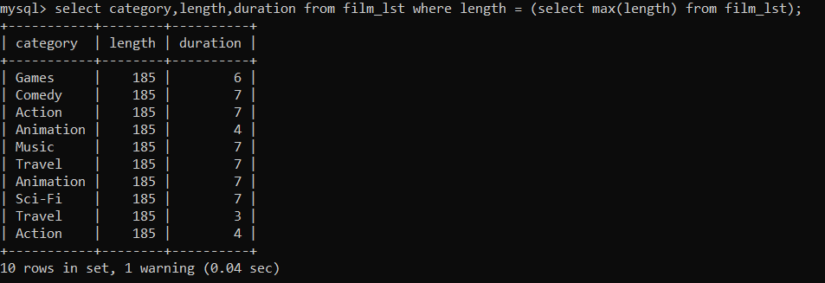

2. Find the movies whose total number of actors is above the average. Return the movie names

And its number of actors ordered by the title. IMPORTANT NOTE: this query should return many

Movies. Please write in your submission only the first TOP-10 results.

Ans: In the tables there is no column with number of actors. Hence average cannot be found. Hence movie names and its number of actors ordered by the title cannot be found.