28.2

While trying to open the assignment shows message “preview not available”.

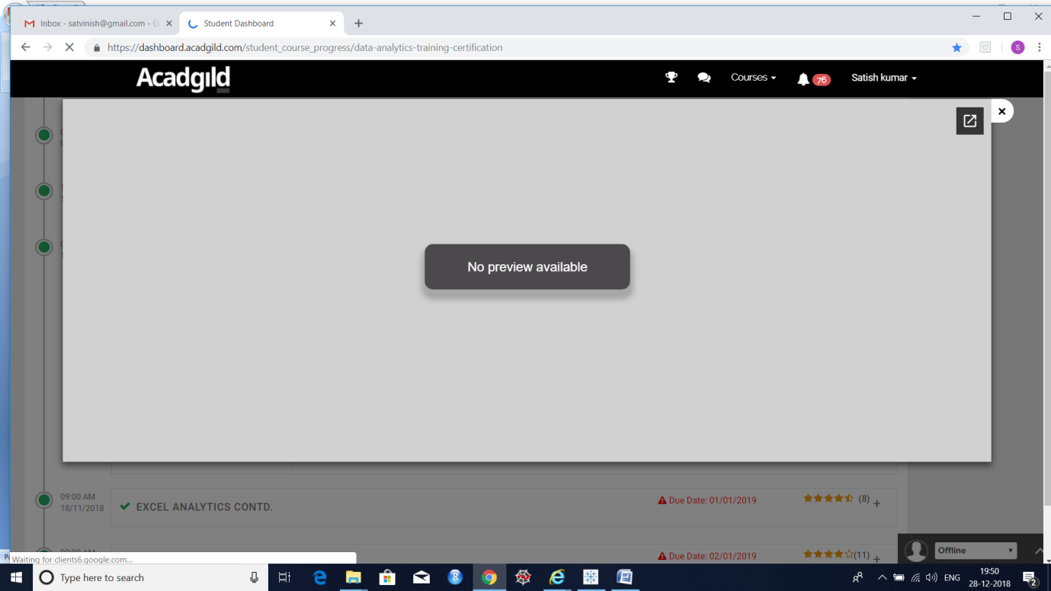

Hence not able to see the questions.

So not able to provide answers .

Note: sent numerous mails to Acadgild support and Nawazia, but no reply.