**34.1** 5. Problem Statement

1. Create a Waterfall chart which would show running total profit over a period of time.

2. The color of the mark should be red if the profit recorded for that Month is less than the

profit recorded compared to previous month, else Green

3. Adjust the tooltip to show as given in the picture below.

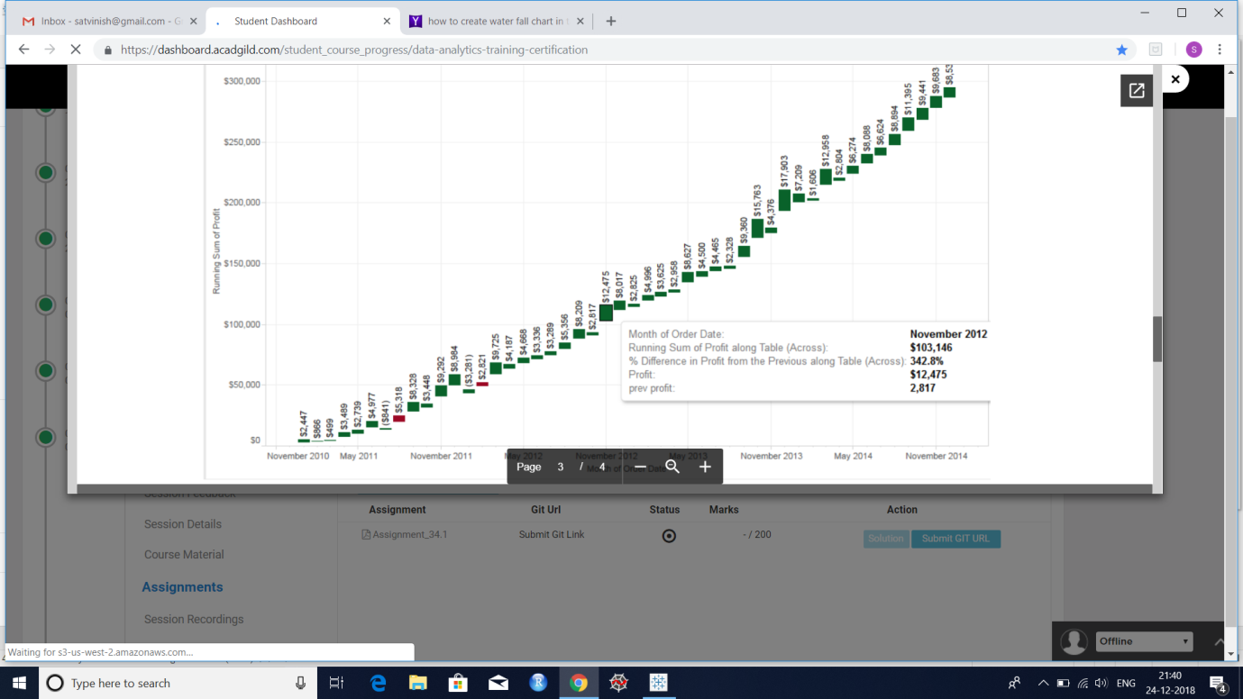

**Answer:**

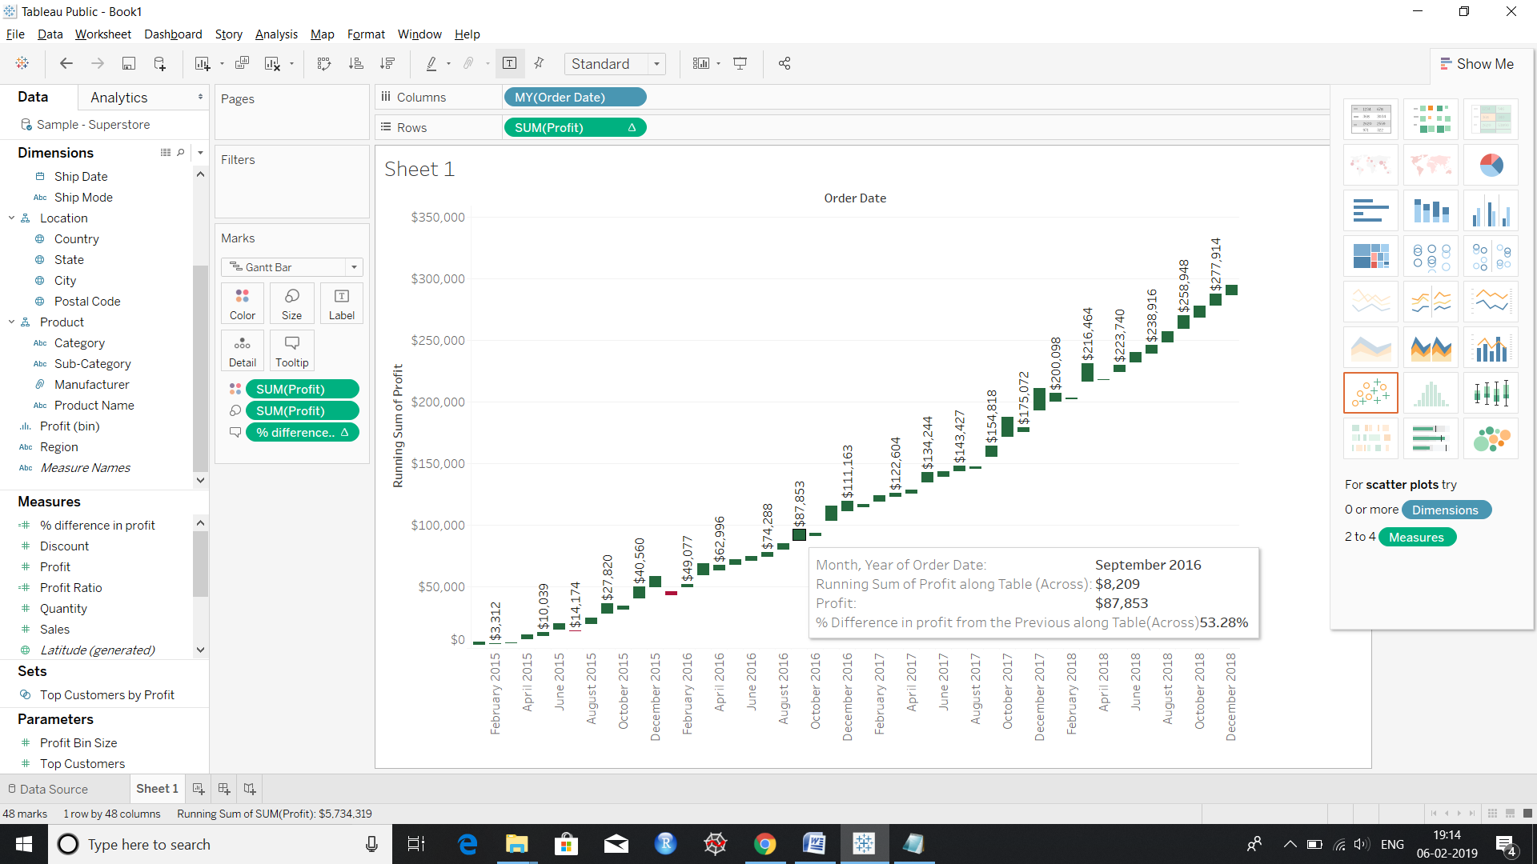

Tooltip to show previous profit-not discussed in class.