7.1

1. Histogram for all variables in a dataset mtcars. Write a program to create histograms for all columns.

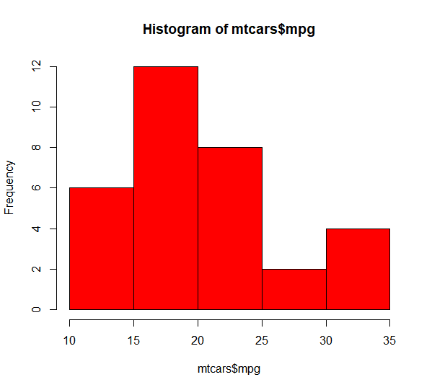

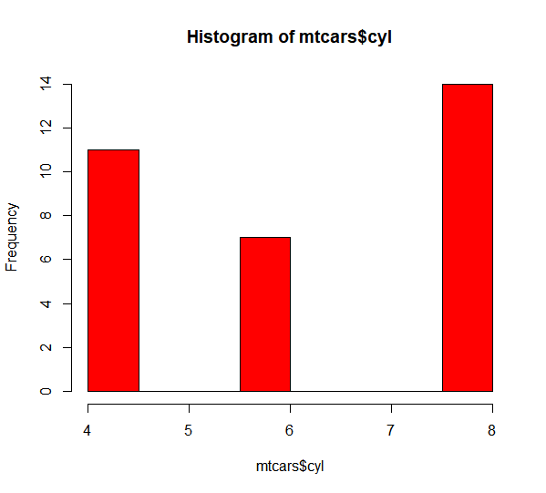

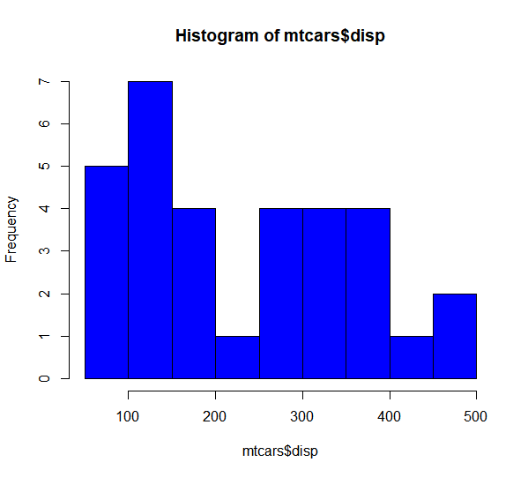

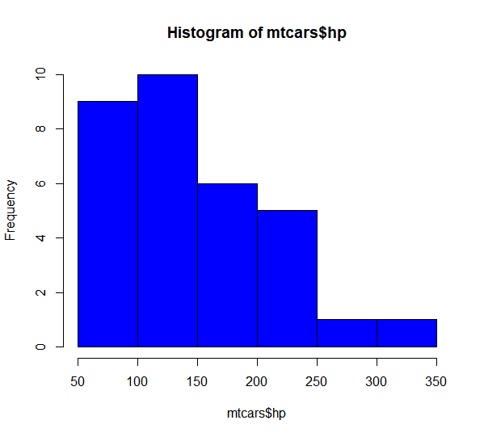

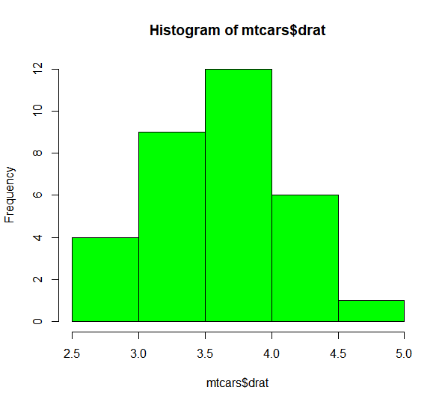

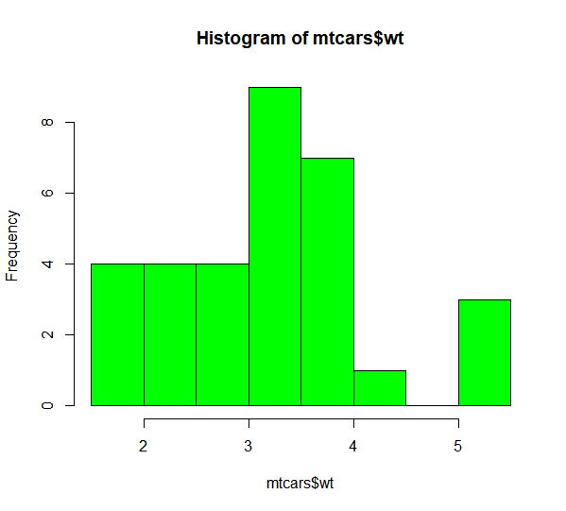

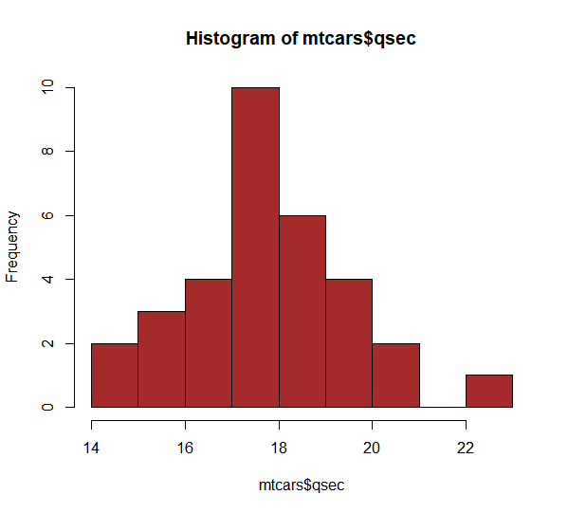

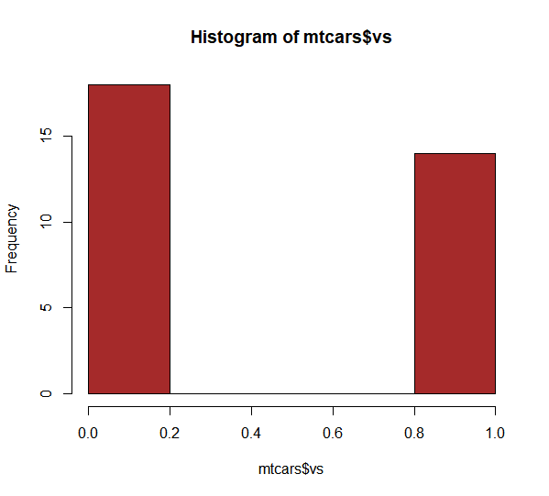

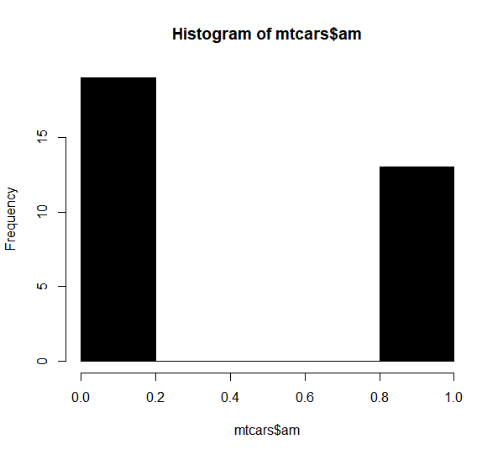

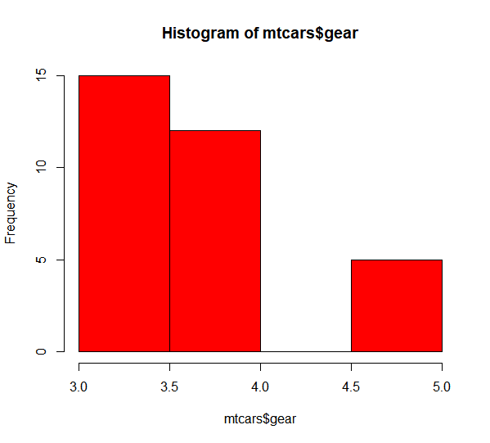

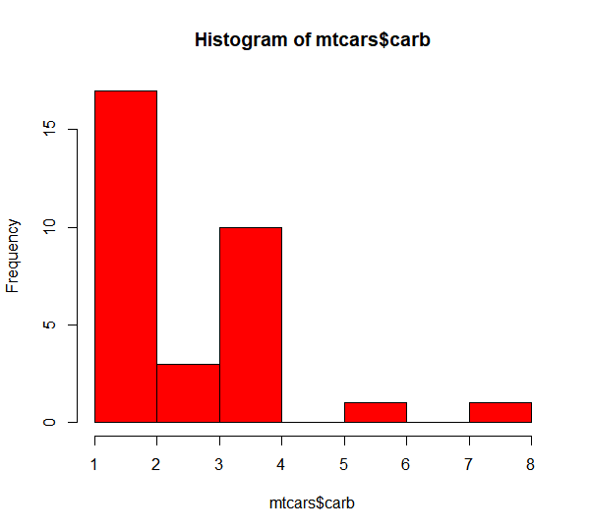

2. Check the probability distribution of all variables in mtcars

> cars_auto = subset(mtcars, am == 0)

> cars_gear = subset(mtcars, am == 1)

> dim(mtcars)

[1] 32 12

> dim(cars_auto) ; dim(cars_gear)

[1] 19 12

[1] 13 12

> mean(cars_auto$mpg); mean(cars_gear$mpg)

[1] 17.14737

[1] 24.39231

> sd(cars_auto$mpg) ; sd(cars_gear$mpg)

[1] 3.833966

[1] 6.166504

> t.test(cars_gear$mpg, cars_auto$mpg, paired = F, var.equal = F)

Welch Two Sample t-test

data: cars_gear$mpg and cars_auto$mpg

t = 3.7671, df = 18.332, p-value = 0.001374

alternative hypothesis: true difference in means is not equal to 0

95 percent confidence interval:

3.209684 11.280194

sample estimates:

mean of x mean of y

24.39231 17.14737

3. Write a program to create boxplot for all variables.

