7.2

1.Write a program to create barplots for all the categorical columns in mtcars.

barplot(mtcars$cyl, xlab = "frequency", ylab="cyl", main = "barplot for cylinder", col = "red")

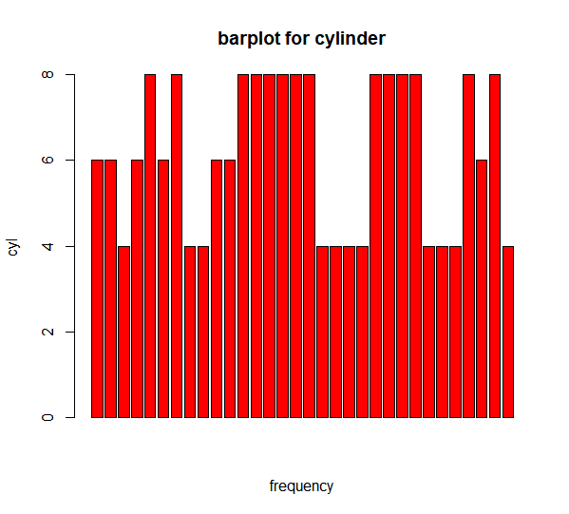

barplot(mtcars$vs, xlab = "frequency", ylab="vs", main = "barplot for vs", col = "blue")

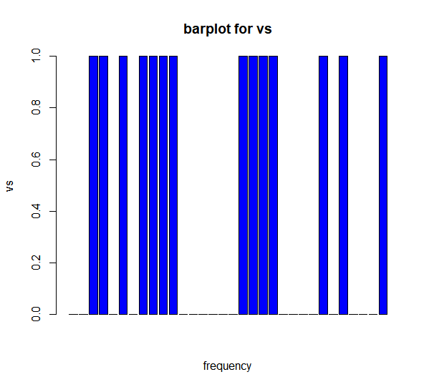

|  |
| --- |
| barplot(mtcars$am, xlab = "frequency", ylab="am", main = "barplot for am", col = "green") |
|  |
| |  | | --- | | > | |

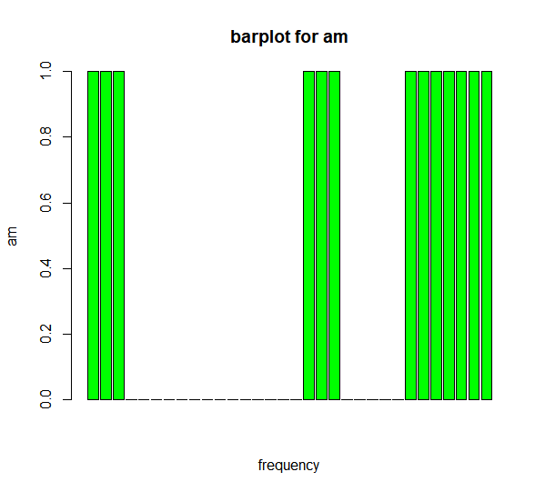

barplot(mtcars$gear, xlab = "frequency", ylab="gear", main = "barplot for gear", col = "red")

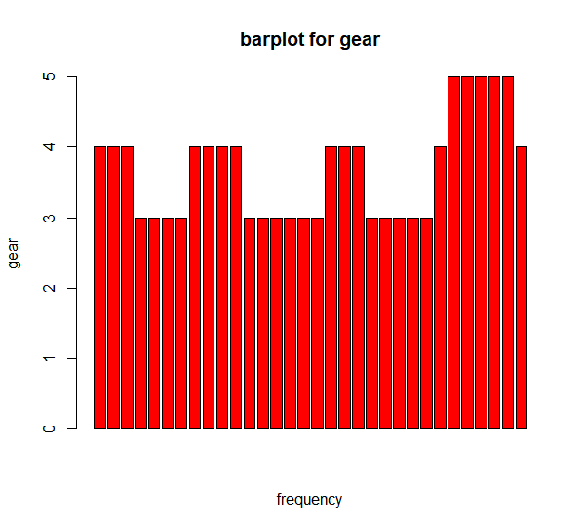

barplot(mtcars$carb, xlab = "frequency", ylab="carb", main = "barplot for gear", col = "brown")

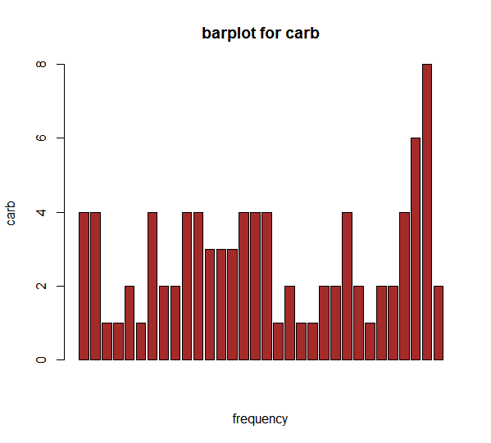

2. Create a scatterplot matrix by gear types in mtcars dataset.

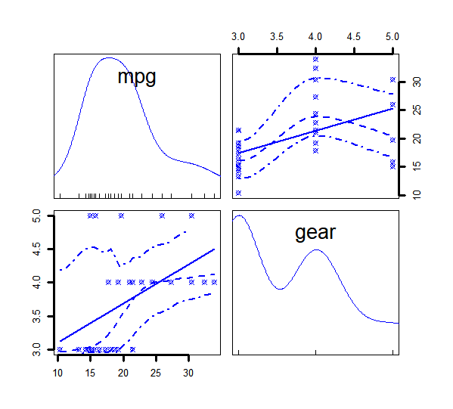

3. Write a program to create a plot density by class variable

d <- density(mtcars$mpg)

> plot(d)

> plot(d, main = "kernel density of mpg")

> polygon(d, col = "blue", border = "black")

