**31.1 & 31.2**

5. Problem Statement

• Create and execute a macro (show a button), to sum of “Sales” where the

“attractiveness” rating is more than 5.

• Do it by recording a Macro.

• Try it using writing a VBA code in Macro.

• Use http://www.excel-easy.com/vba.html for reference to write VBA script.

• Protect the Workbook and save version and upload as a first part of assignment

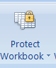

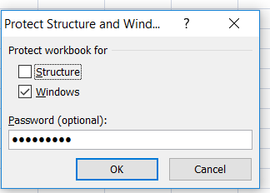

(**Password is vinish123)**

• Share the protected workbook, by giving edit access and implement track change. Upload this workbook as second part of your assignment.



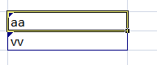

Note: Both upload should contain macros (two types as mentioned above).