13.2

1. Use the given link Data Set.

Answer the below questions:

1. Visualize the correlation between all variables in a meaningful and clear way of representing. Find out top 3 reasons for having more crime in a city.

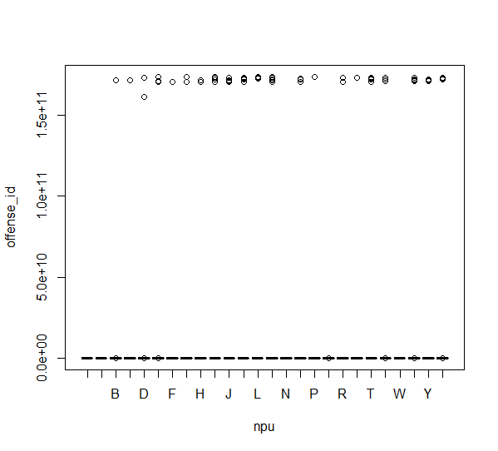

1. Find out top 3 reasons for having more crime in a city.
2. LARCENY-NON VEHICLE
3. LARCENY-VEHICLE
4. AUTO THEFT
5. What is the difference between co-variance and correlation? Take an example from this dataset and show the difference if any?

The following points are noteworthy so far as the difference between covariance and correlation is concerned:

1. A measure used to indicate the extent to which two random variables change in tandem is known as covariance. A measure used to represent how strongly two random variables are related known as correlation.
2. Covariance is nothing but a measure of correlation. On the contrary, correlation refers to the scaled form of covariance.
3. The value of correlation takes place between -1 and +1. Conversely, the value of covariance lies between -∞ and +∞.
4. Covariance is affected by the change in scale, i.e. if all the value of one variable is multiplied by a constant and all the value of another variable are multiplied, by a similar or different constant, then the covariance is changed. As against this, correlation is not influenced by the change in scale.
5. Correlation is dimensionless, i.e. it is a unit-free measure of the relationship between variables. Unlike covariance, where the value is obtained by the product of the units of the two variables.