sample the more numerous class Churn=0

1. Use R to do the preprocessing and training. Your final submission should have all the R code and results coming from Training Model. Show all the accuracy measures and ROC curve for different probability cut-off. Find the optimal Threshold.

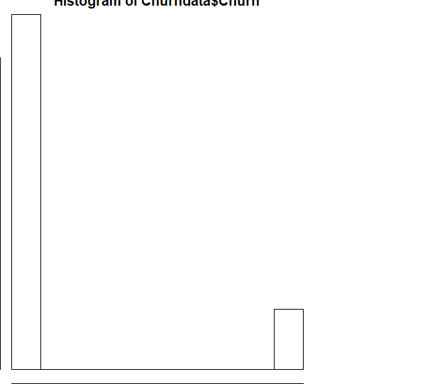

2. Use R for giving all the results and statistics of the Trained Model performance on the Test Dataset. Your final report should contain all these results.

3. Use Tableau for Visualization Reporting.

a. Perform the training and threshold optimization in tableau. Prepare required worksheet to perform the same. You should be able to change the probability threshold using a slider. When changing the threshold, you must show the accuracy measures accordingly.

Ans: As our Tableau Desktop free 14 days trail got over. Entering the steps manually as instructed by Pratek for during Assignmnet 32.

1. Install.package(Rserve)
2. library("Rserve")
3. Rserve()

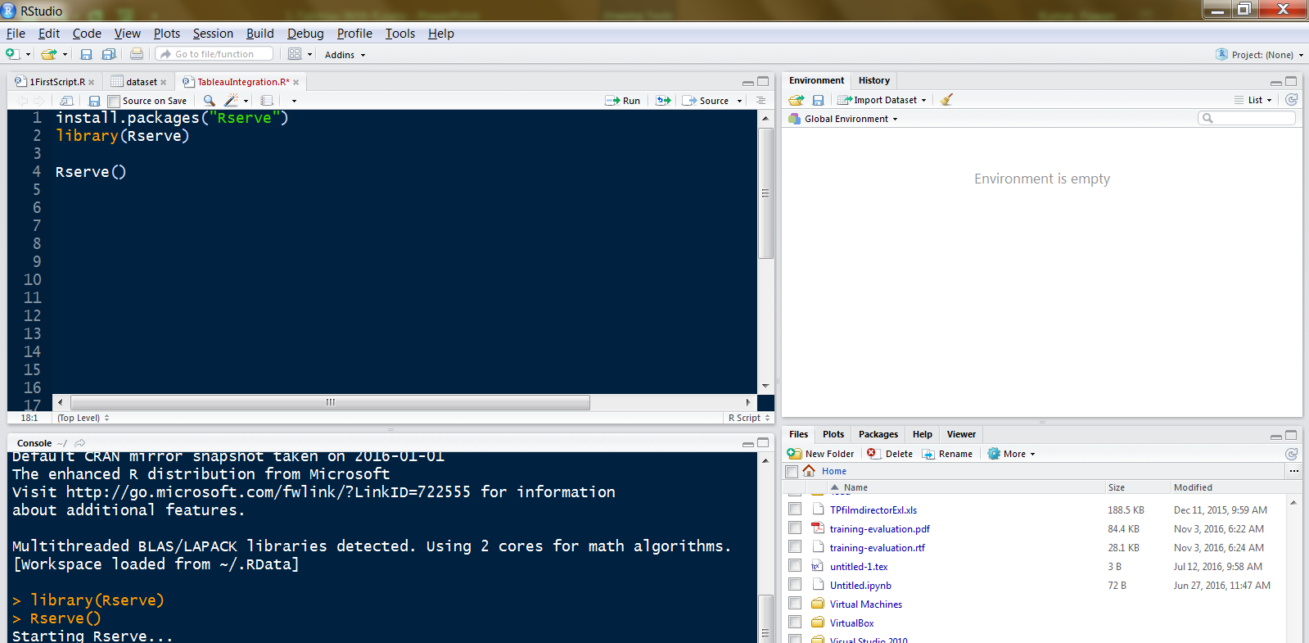

1. The below screen opens [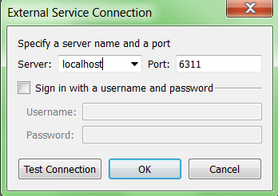](https://lh5.googleusercontent.com/LqgKnNdSe0le8yG9LvWbP0kNAwBelXk5RJDW7uZU0f_eJx6rqKvmubKdvSXN8Yt93XLvsl1Vgw9g83dY9l0aywMn408WkTTMC6DC4mzXaDVTQLWVRMpvuBHJLAh0jcs4FJBF2_fk-u3JufFc2A)  
   Enter or select a server name using a domain or an IP address. The drop-down list includes localhost and the server you most recently connected to.   
   Specify a port. Port 6311 is the default port for Rserve servers. If the server requires credentials, specify a Username and Password.   
   Click Test Connection. Click OK.
2. In Tableau Desktop under Help menu-> choose settings and performance->Manage R connection to open the Rserve connection dialog box
3. In Tableau create calculated field as below Script _real (“write the code you want to write”)’ {write within double codes)
4. Need to find accuracy measures when threshold is 0.1.
5. Need to find accuracy measures when threshold is 0.2.
6. Need to find accuracy measures when threshold is 0.3.
7. Need to find accuracy measures when threshold is 0.4.
8. Need to find accuracy measures when threshold is 0.5.
9. Need to find accuracy measures when threshold is 0.6.
10. Need to find accuracy measures when threshold is 0.7.
11. Need to find accuracy measures when threshold is 0.8.
12. Need to find accuracy measures when threshold is 0.9.
13. Need to find accuracy measures when threshold is 1. **(Find the optimal accuracy.)**
14. Draw a plot ie slider for probability threshold. So when probability threshold changes correspondingly accuracy will change

b. Once fixed on a particular threshold, you should use R_script to run the testing on the test data from Tableau.

1. In Tableau create calculated field as below Script _real (“write the code you want to write”)’ {write within double codes) with optimal threshold accuracy

c. One you get the test result. Show the accuracy measure as well.

1. Data will be taken from tableau thru R, result will be calculated and the final result will be displayed in Tableau in calculated field.
2. Drag ad drop the value to “Text” under Marks
3. Then drag and drop the calculated field where ever you want ie under “Row” or “Column”

d. How the odds ratio on the viz, i.e. show the effect of change of input variables to probability/chances of churn. You should provide option such that, we can choose any input variable and change the value to see the effect. Change on numerical variable would be offset change (some unit change), and categorical variable would be change from one category to other (Example: If binary then change from 0 to 1).

1. When we change any value in the table the accuracy will change.

a. we change any variable then run the R-script it will show the change in accuracy