11.1

1. Use the given link and locate the bank marketing dataset. Data Set Link

Perform the below operations:

1. Create a visual for representing missing values in the dataset. – **no missing values**
2. > summary(bank)
3. age job marital education default housing loan contact
4. Min. :17.00 admin. :10422 divorced: 4612 university.degree :12168 no :32588 no :18622 no :33950 cellular :26144
5. 1st Qu.:32.00 blue-collar: 9254 married :24928 high.school : 9515 unknown: 8597 unknown: 990 unknown: 990 telephone:15044
6. Median :38.00 technician : 6743 single :11568 basic.9y : 6045 yes : 3 yes :21576 yes : 6248
7. Mean :40.02 services : 3969 unknown : 80 professional.course: 5243
8. 3rd Qu.:47.00 management : 2924 basic.4y : 4176
9. Max. :98.00 retired : 1720 basic.6y : 2292
10. (Other) : 6156 (Other) : 1749
11. month day_of_week duration campaign pdays previous poutcome emp.var.rate cons.price.idx
12. may :13769 fri:7827 Min. : 0.0 Min. : 1.000 Min. : 0.0 Min. :0.000 failure : 4252 Min. :-3.40000 Min. :92.20
13. jul : 7174 mon:8514 1st Qu.: 102.0 1st Qu.: 1.000 1st Qu.:999.0 1st Qu.:0.000 nonexistent:35563 1st Qu.:-1.80000 1st Qu.:93.08
14. aug : 6178 thu:8623 Median : 180.0 Median : 2.000 Median :999.0 Median :0.000 success : 1373 Median : 1.10000 Median :93.75
15. jun : 5318 tue:8090 Mean : 258.3 Mean : 2.568 Mean :962.5 Mean :0.173 Mean : 0.08189 Mean :93.58
16. nov : 4101 wed:8134 3rd Qu.: 319.0 3rd Qu.: 3.000 3rd Qu.:999.0 3rd Qu.:0.000 3rd Qu.: 1.40000 3rd Qu.:93.99
17. apr : 2632 Max. :4918.0 Max. :56.000 Max. :999.0 Max. :7.000 Max. : 1.40000 Max. :94.77
18. (Other): 2016
19. cons.conf.idx euribor3m nr.employed y
20. Min. :-50.8 Min. :0.634 Min. :4964 no :36548
21. 1st Qu.:-42.7 1st Qu.:1.344 1st Qu.:5099 yes: 4640
22. Median :-41.8 Median :4.857 Median :5191
23. Mean :-40.5 Mean :3.621 Mean :5167
24. 3rd Qu.:-36.4 3rd Qu.:4.961 3rd Qu.:5228
25. Max. :-26.9 Max. :5.045 Max. :5228

b. Show a distribution of clients based on a Job.

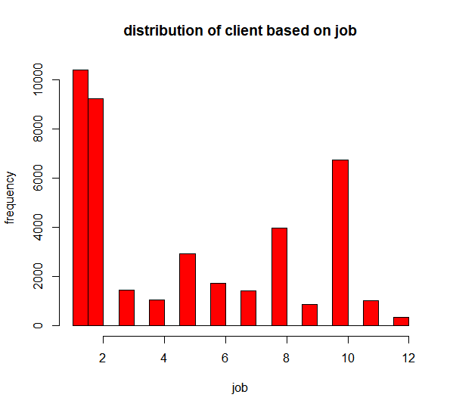

c. Check whether is there any relation between Job and Marital Status?

> cor.test(bank$job, bank$martial, method = "pearson")

Pearson's product-moment correlation

data: bank$job and bank$martial

t = 5.6638, df = 41186, p-value = 1.49e-08

alternative hypothesis: true correlation is not equal to 0

95 percent confidence interval:

0.01824490 0.03754489

sample estimates:

cor

0.0278975

d. Check whether is there any association between Job and Education?

> cor.test(bank$job, bank$education, method = "pearson")

Pearson's product-moment correlation

data: bank$job and bank$education

t = 27.467, df = 41186, p-value < 2.2e-16

alternative hypothesis: true correlation is not equal to 0

95 percent confidence interval:

0.1246249 0.1435925

sample estimates:

cor

0.134121