<https://docs.aws.amazon.com/eventbridge/latest/userguide/eb-log-ec2-instance-state.html>

**Domain: Observability Services**

**Topic: AWS EventBridge**

**Task: Log the State of an Amazon EC2 Instance Using EventBridge**

**Problem to Be Solved**

*In this task we will create an AWS Lambda function that logs the launch of any Amazon EC2 instance in account.*

**Explanation of the Solution**

*Theory explanation with links to official docs*

**Implementation Details**

*Step 1: Create an AWS Lambda Function*

*Create a Lambda function to log the state change events. You specify this function when you create your rule.*

*To create a Lambda function*

1. *Open the AWS Lambda console at* [*https://console.aws.amazon.com/lambda/*](https://console.aws.amazon.com/lambda/)
2. *Choose****Create a Lambda function***

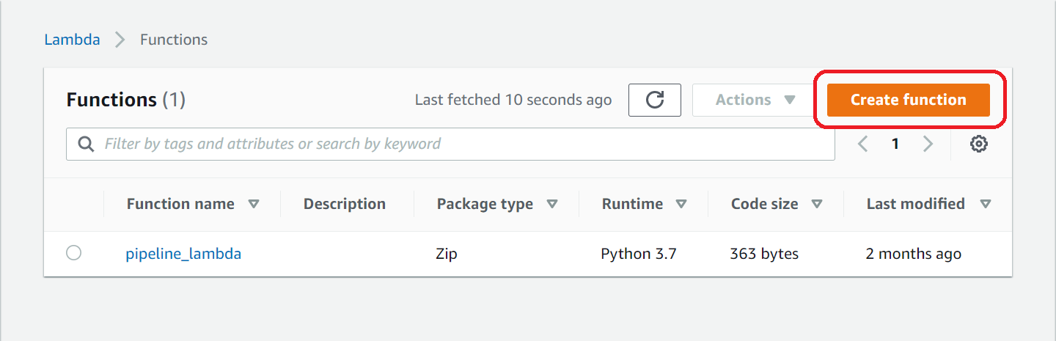

1. *On the* ***Select blueprint*** *page, enter* ***hello*** *for the filter and choose the* ***hello-world*** *blueprint.*

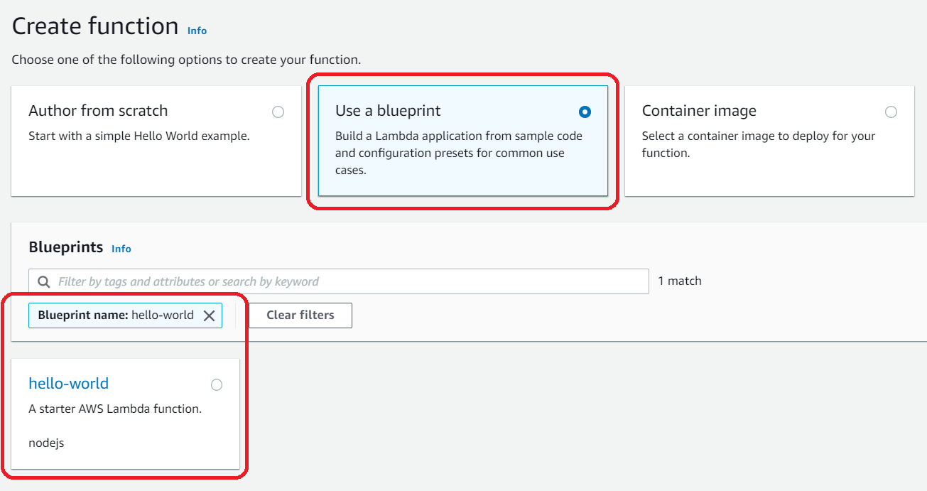

1. *Press* ***Configure***
2. *On the Configure function page, do the following:*
   1. *Enter a name and description for the Lambda function. For example, name the function* ***LogEC2InstanceStateChange****.*
   2. *For* ***Role****, choose* ***Create a new role with basic Lambda permissions***

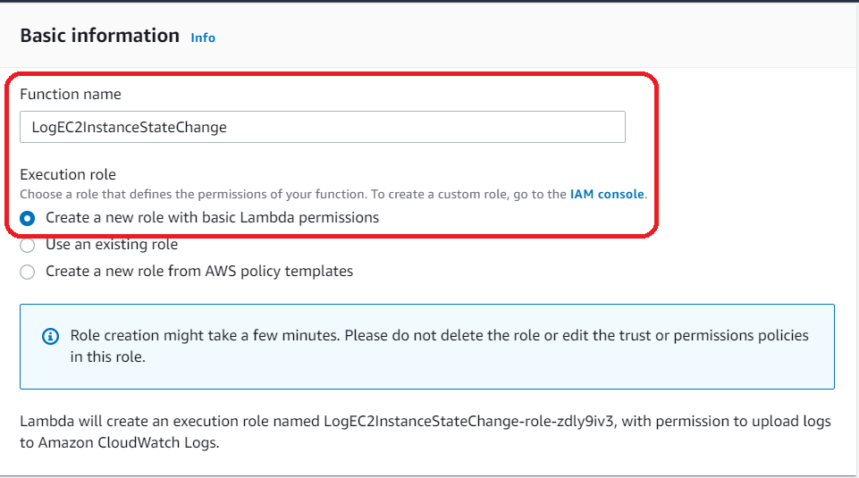

* 1. *Choose* ***Create function****.*

1. *Edit the sample code for the Lambda function:*

'use strict';

exports.handler = (event, context, callback) => {

console.log('LogEC2InstanceStateChange');

console.log('Received event:', JSON.stringify(event, null, 2));

callback(null, 'Finished');

};

1. *Press* ***Deploy****, to deploy new version*

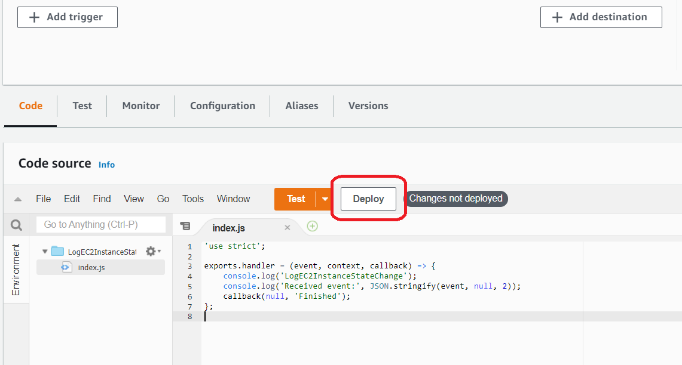

*Step 2: Create a Rule*

*Create a rule to run your Lambda function whenever you launch an Amazon EC2 instance.*

*To create the EventBridge rule:*

1. *Open the Amazon EventBridge console at* [*https://console.aws.amazon.com/events/*](https://console.aws.amazon.com/events/)
2. *In the navigation pane, choose* ***Rules****.*

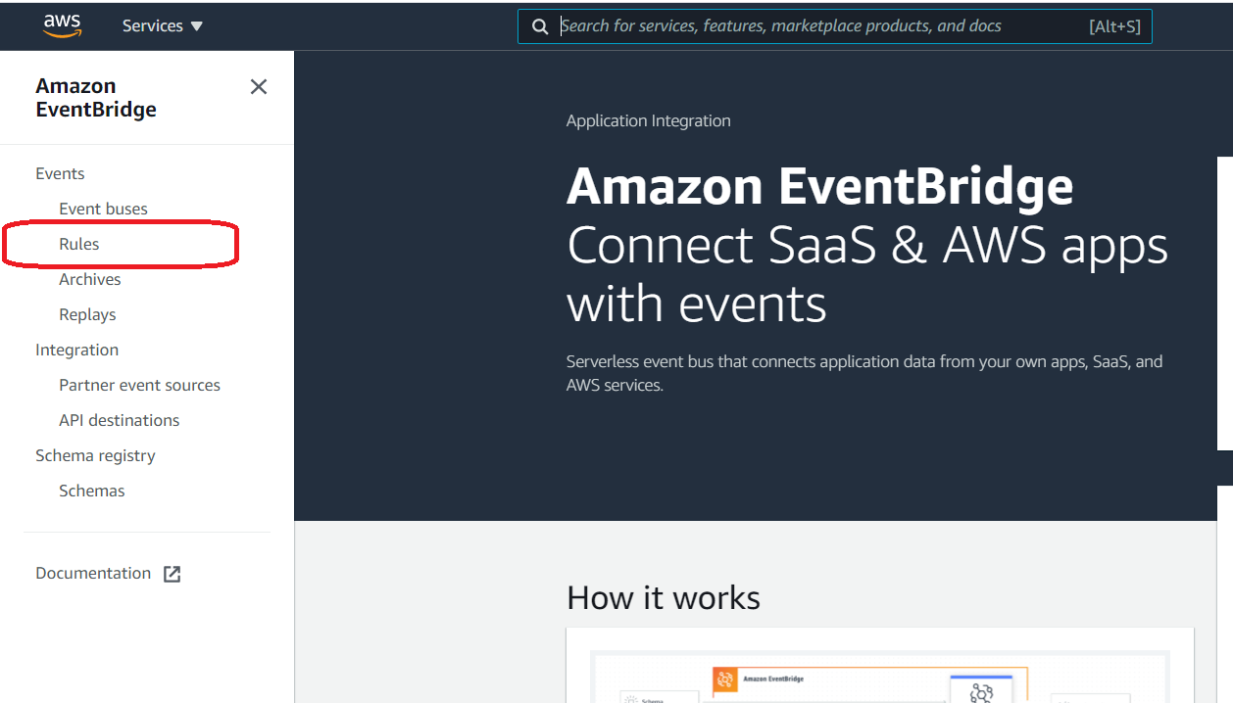

1. *Choose* ***Create rule****.*

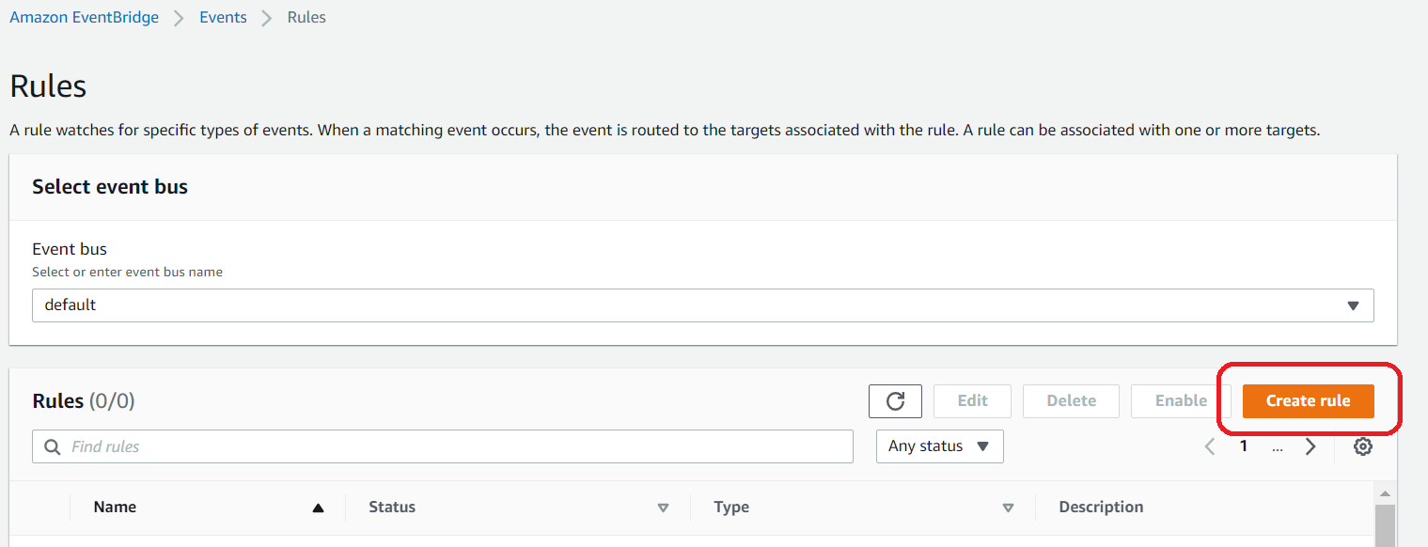

1. *Enter a name and description for the rule.*

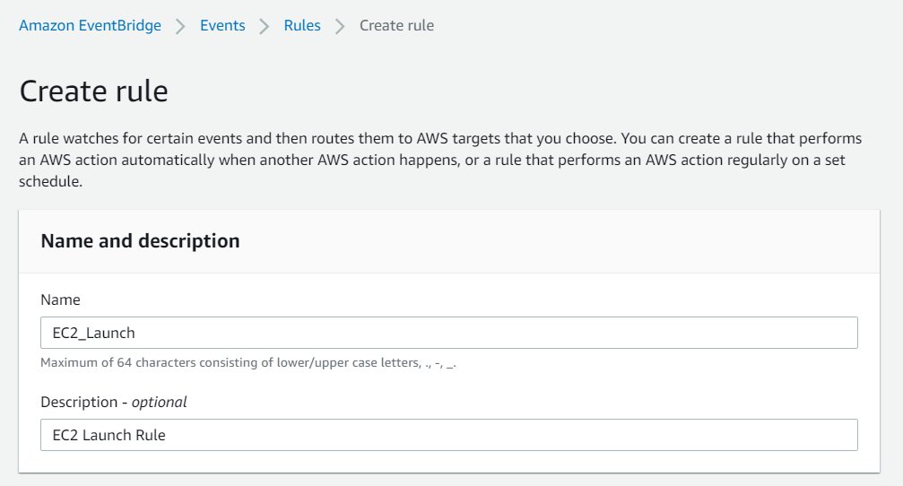

1. *For Define pattern, do the following:*
   1. *Choose* ***Event pattern****.*
   2. *Choose* ***Pre-defined pattern by service****.*
   3. *For* ***Service provider****, choose* ***AWS****.*
   4. *For* ***Service Name****, choose* ***EC2****.*
   5. *For* ***Event type****, choose* ***EC2 Instance State-change Notification****.*
   6. *Choose* ***Specific state(s), running****.*
   7. *By default, the rule matches any instance group in the Region.*

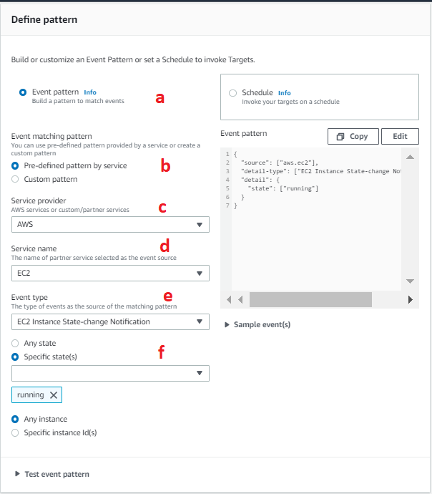

1. *For****Select event bus****, choose****AWS default event bus****.*

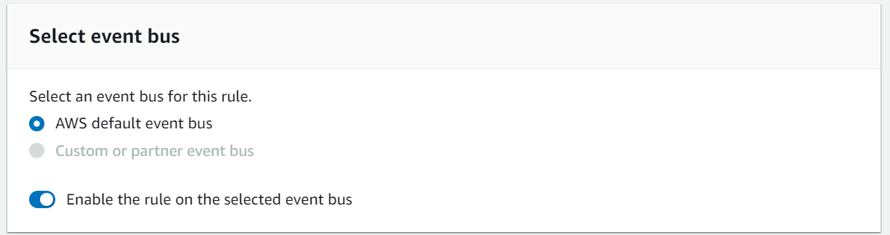

1. *For* ***Target****, choose* ***Lambda function****.*

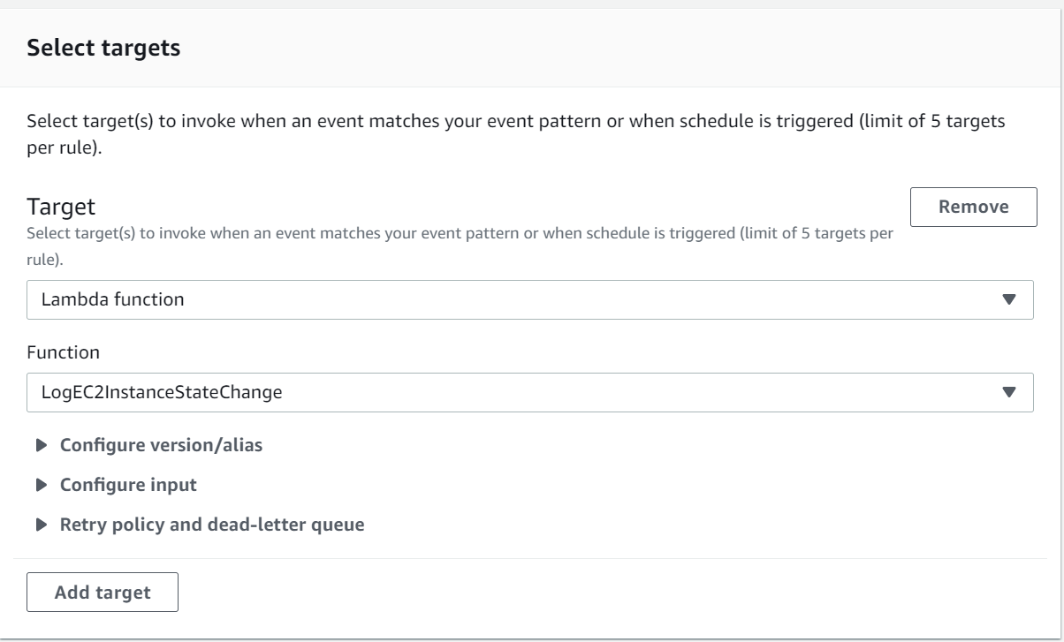

1. For **Function**, select the Lambda function that you created.
2. *Choose****Create****.*

Step 3: Test the Rule

To test your rule, launch an Amazon EC2 instance. After waiting a few minutes for the instance to launch and initialize, verify that your Lambda function was invoked.

**Benefits / Outcomes / Pros and Cons / Summary**

*Now we will log each event of creating new instance in our AWS account.*

**Tearing down**

1. *Delete EventBridge Rule*
2. *Delete created AWS Lambda function*