Practice Problem:

## Oracle On premise DB to Aws RDS

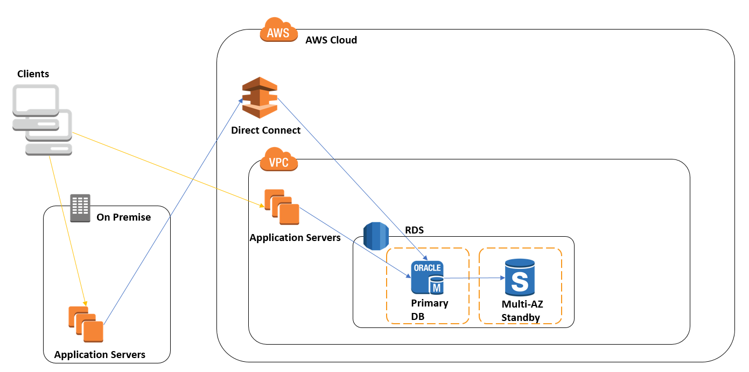

## Related imageMigrate from Oracle to Amazon Redshift