**Use case#1:  Implement AWS pipeline along with ETL process.**

Solution:

             Using AWS Glue ->

                             Stage 1#:

1. Prepare raw data and uploaded into S3
2. Using Glue crawler and loaded into DynamoDB.
3. Verify in DynamoDB

Stage 2#:

1. Prepare raw data and uploaded into S3
2. Implement custom Glue classifier via Python spark and loaded into DynamoDB.

Stage 3#:

1. Scheduled the above process via Glue job.
2. Monitor above process via cloud watch.

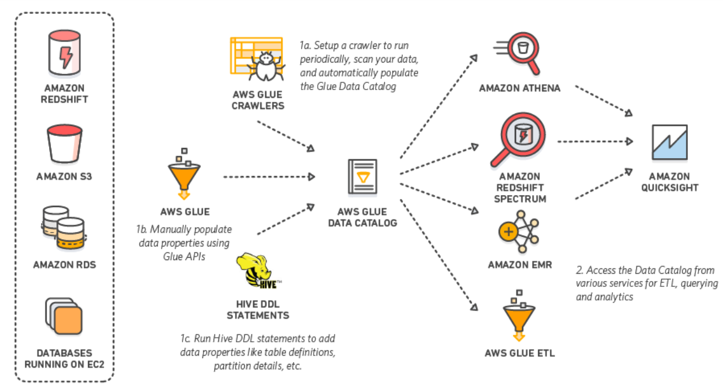

**Use case#2:  Implement AWS pipeline via Redshift.**

Solution:

             Using AWS Redshift ->

1. Extract data from Data base
2. Transfer to S3
3. Perform some ETL operations in Redshift
4. Save aggregated reports in S3.

