**#1. Serverless Image Recognition Engine**

Imagine you have a website where people can upload images. As soon as the images are uploaded, you want the images to go through a set of workflow actions.

For example, a workflow where a user uploads an image which is stored in the S3 bucket triggers a Lambda function 1. This function invokes the state function workflow, as shown in the image.

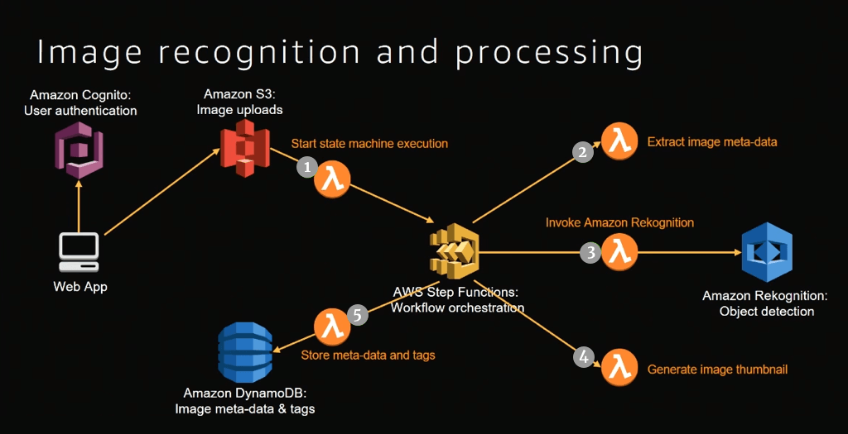

This step function workflow orchestrates the job of multiple Lambda functions. The first thing it does it to extract the metadata from the image, for example, image type information. Meanwhile, another three lambda functions are invoked in parallel.

* Lambda function 2 is invoked to extract the image metadata
* Lambda function 3 invokes the Rekognition which finds out the object in the image
* Lambda function 4 is invoked to generate an image thumbnail
* Lambda function 5 writes all this information back into the DynamoDB

End result: Whenever the page refreshes after the user has uploaded the image, they see all the metadata, thumbnail and the object tagged that are evident in the image. This is an example of an image processing pattern and can extend it as per your custom requirements.