*Use Case 1: Build a Serverless Web Application:*

Overview

In this tutorial, you'll create a simple serverless web application that enables users to request unicorn rides from the [Wild Rydes](http://www.wildrydes.com/) fleet. The application will present users with an HTML based user interface for indicating the location where they would like to be picked up and will interface on the backend with a RESTful web service to submit the request and dispatch a nearby unicorn. The application will also provide facilities for users to register with the service and log in before requesting rides.

Application Architecture

The application architecture uses [**AWS Lambda**](https://aws.amazon.com/lambda/)**,**[**Amazon API Gateway**](https://aws.amazon.com/apigateway/)**,**[**Amazon S3**](https://aws.amazon.com/s3/)**,**[**Amazon DynamoDB**](https://aws.amazon.com/dynamodb/), and [**Amazon Cognito**](https://aws.amazon.com/cognito/) as pictured below:

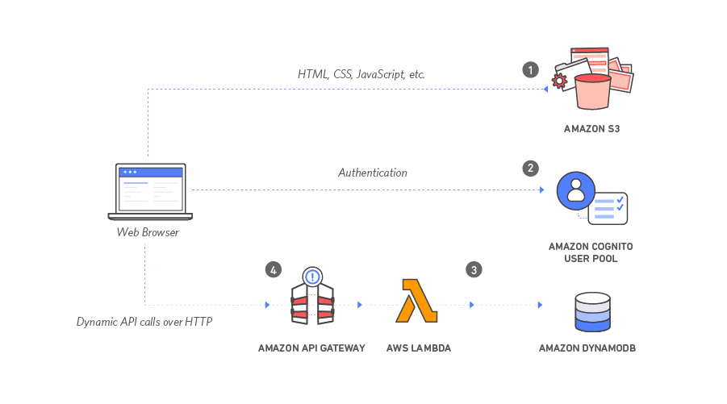

1. **Static Web Hosting:** Amazon S3 hosts static web resources including HTML, CSS, JavaScript, and image files which are loaded in the user's browser.
2. **User Management:**  Amazon Cognito provides user management and authentication functions to secure the backend API.
3. **Serverless Backend:** Amazon DynamoDB provides a persistence layer where data can be stored by the API's Lambda function.
4. **RESTful API:** JavaScript executed in the browser sends and receives data from a public backend API built using Lambda and API Gateway.

*Use Case 2: Setup Jenkins Build Server:*

Overview

In this project, you will learn how to deploy and host Jenkins, an open-source automation software predominantly used for CI/CD (Continuous Integration/Continuous Deployment). You will use Amazon Elastic Compute Cloud (EC2) in a public subnet within your own Amazon Virtual Private Cloud (VPC) and you will also set up an Amazon Elastic Block Store (EBS) volume.

Application Architecture

The application architecture uses [**AWS EC2**](https://aws.amazon.com/lambda/)**, AWS EBS, Elastic IP, VPC, Subnets** as pictured below:

