Vani AI: Invention Details

1. Title of the Invention
**Vani AI: A Multimodal, Multi-Agent Desktop & Mobile Orchestration Ecosystem**

2. Detailed Block Diagram / Architecture
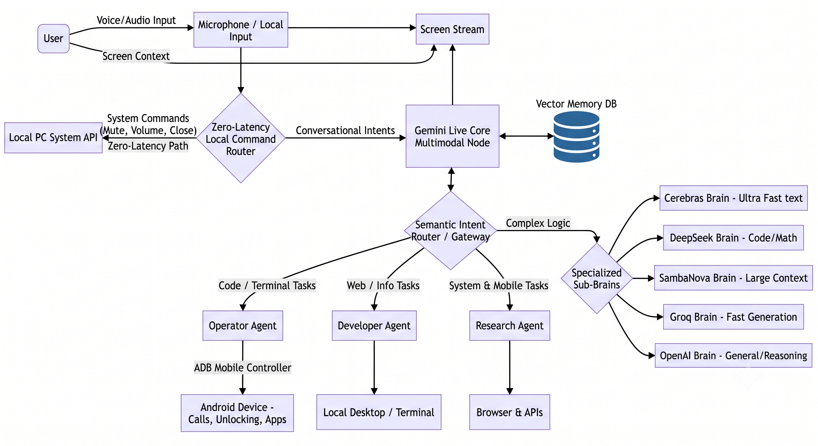

3. What Exactly is New?
The core novelty lies in the **hybrid architecture** that combines a real-time, human-like conversational multimodal model (Gemini Live) with a **dynamic multi-agent delegation system** and **cross-device execution**. Specifically:
- **Dynamic "Sub-Brain" Routing:** Rather than relying on a single monolithic Large Language Model (LLM) for all tasks, the system dynamically routes intents to specialized models hosted on specific hardware architectures based on the task requirement (e.g., Cerebras/Groq for extreme low-latency generation, SambaNova for massive context window ingestion, DeepSeek for complex logic/coding).
- **Deep Mobile Bridging from Desktop AI:** It introduces an Operator Agent that uses an Android Debug Bridge (ADB) connection to natively and autonomously control a connected mobile device (e.g., unlocking the phone via PIN simulation, placing calls, sending texts) entirely via natural language spoken to the desktop assistant.
- **Zero-Latency Bypass:** Incorporates a local regex-based command router that intercepts time-sensitive physical system commands (volume, app closing, muting) to execute them instantaneously, completely bypassing the cloud AI layer.

4. How is it Technically Different from Google Assistant, Siri, Alexa, ChatGPT Voice Systems, etc.?
- **Execution vs. Conversation:** ChatGPT Voice and standard consumer assistants (Siri, Alexa, Google Assistant) are primarily conversational or locked into highly restricted, sandboxed APIs (e.g., "turn on the lights"). Vani acts as an autonomous agent capable of executing arbitrary code, terminal commands, and complex desktop manipulation.
- **Model Agnosticism & Routing:** ChatGPT operates entirely on OpenAI models. Siri operates on Apple Intelligence/internal routing. Vani is model-agnostic, leveraging a semantic routing gateway to distribute tasks across 10+ different open-source and proprietary models depending on the compute and specialization required.
- **Cross-Platform Deep Control:** Google Assistant on a phone can control the phone, and Cortana on a PC could control a PC. Vani uniquely sits on the desktop but can physically manipulate a connected mobile device at the OS level (via ADB) without requiring an app installed on the mobile device itself.

5. Prior-Art / Patent References Checked
*Here are several relevant patents in the fields of multi-agent voice assistants, intent routing, and contextual device control:*
- **US 9,386,152 B2** - *Intelligent automated agent and interactive voice response for a contact center* (Covers task delegation and routing logic based on real-time availability and context).
- **US 11,573,990** - *Search-based natural language intent determination* (Details multi-service, multi-agent systems interpreting user commands and delegating tasks).
- **US 10,740,370 B2** - *Dialog agent for conducting task-oriented computer-based communications* (Focuses on conversational agents operating in multi-agent environments).
- **US 8,296,383 B2** - *Electronic devices with voice command and contextual data processing capabilities* (Addresses multi-agent implementations for contextual data management).
- **WO 2019/231537 A1** - *Virtual assistant operation in multi-device environments* (Techniques for routing voice requests to specific capable devices).
- **US 12,002,467** - *Voice command system and voice command method* (Managing task performance and routing among a collection of devices).
- **US 2019/0287517 A1** - *Intelligent routing of interactions in customer service environments*.
- **US 9,547,647 B2** - *Voice-based media searching and processing*.

6. What Technical Problem Does the Invention Solve, and What Measurable Technical Improvement Does It Provide?
**Technical Problem:**
Current voice assistants suffer from latency in standard operations, vendor lock-in preventing the use of optimal specialized models for specific tasks (e.g., using a general model for coding instead of a code-specialized model), and severe ecosystem fragmentation where a PC assistant cannot execute complex tasks on the user's mobile device seamlessly.
**Measurable Technical Improvements:**
- **Reduced Latency:** By intercepting hardware/system commands locally, the system achieves near-zero latency for system execution compared to the ~1-3 second roundtrip of cloud-based assistants. Furthermore, delegating text-heavy tasks to specialized LPU (Language Processing Unit) hardware (e.g., Cerebras, Groq) measurably reduces time-to-first-token and overall generation time.
- **Increased Execution Accuracy via Specialization:** By dynamically routing complex mathematical or coding queries to models like DeepSeek, and massive context tasks to SambaNova, the system avoids the token limit and hallucination rate of a single general-purpose conversational model.
- **Unified Interface Efficiency:** The ADB mobile integration eliminates the physical user step of switching devices. A user can seamlessly route a phone call or send a mobile SMS through a PC headset using desktop voice commands, streamlining multi-device workflow into a single interface.

