V.A.N.I. AI: Complete API Architecture, Workflow & Upgrade Roadmap
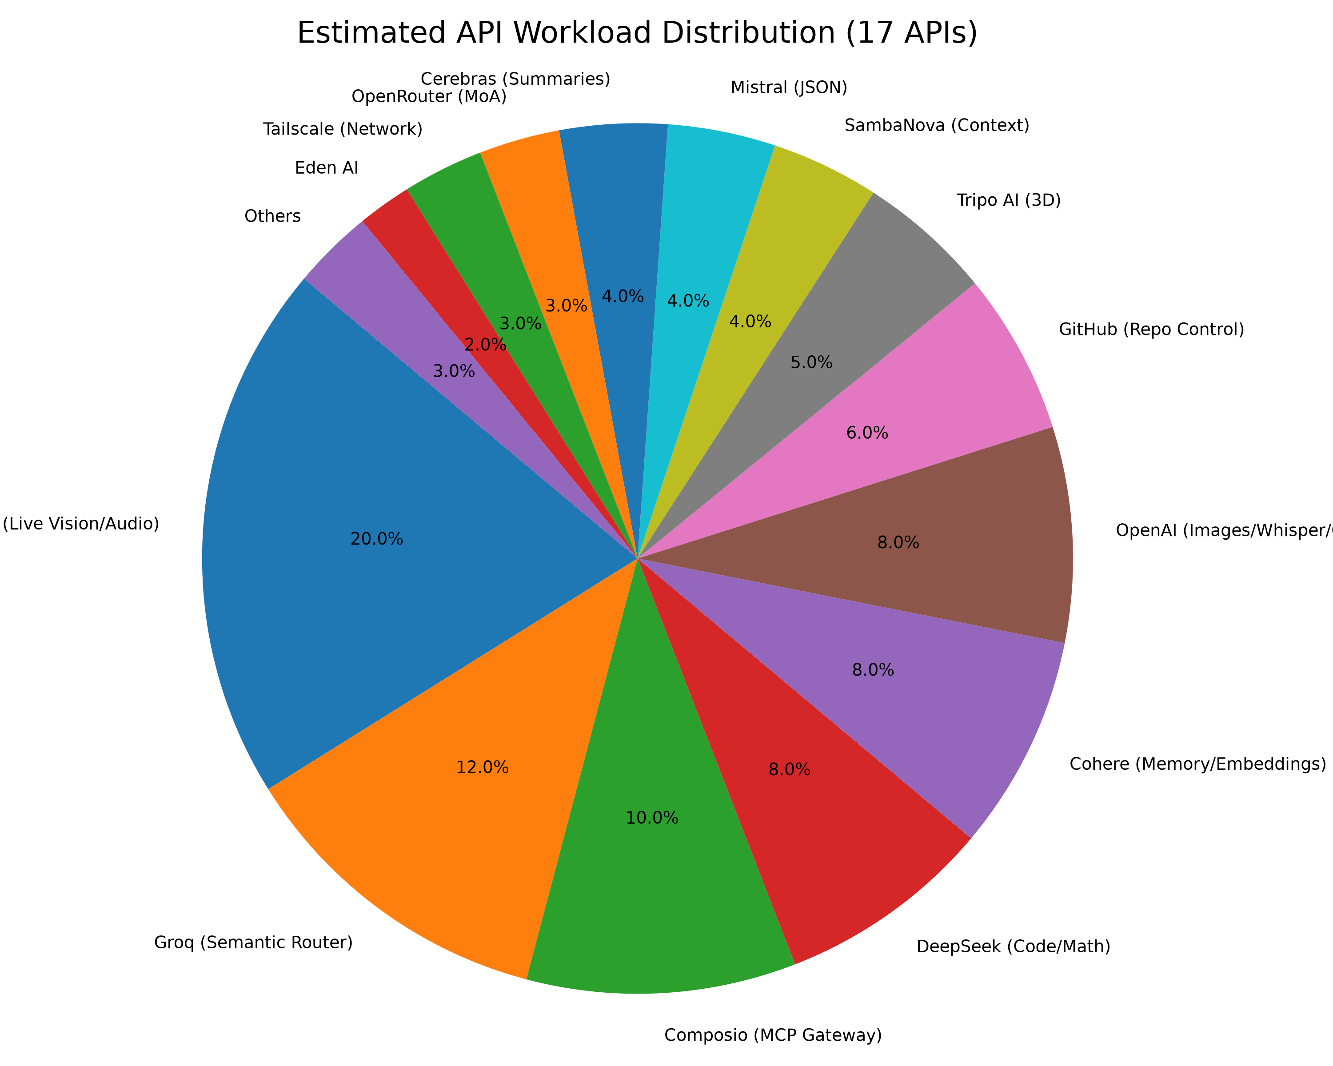

1. Introduction and How the Code Works in VANI
V.A.N.I. (Virtual Artificial Network Intelligence) is not just another wrapper for a single large language model; it is a highly intricate, multi-agent artificial intelligence ecosystem designed to operate autonomously and seamlessly within the Windows desktop environment. At its core, V.A.N.I. functions through a Python-based backend that orchestrates a vast array of highly specialized API providers. By leveraging Python's robust asynchronous capabilities, multithreading, and direct operating system hooks, V.A.N.I. breaks out of the traditional chat-box constraints, interacting directly with local files, system processes, and the user's graphical interface via a sleek PyQt6 dashboard.
The fundamental design philosophy behind V.A.N.I. is modularity and the 'Division of Labor'. If an AI system relies solely on one API (like OpenAI's GPT-4) to do everything—from transcribing audio and analyzing images to writing code and routing logic—it quickly encounters severe bottlenecks. These bottlenecks manifest as expensive API bills, frequent rate-limiting, and sluggish response times (often taking several seconds just to parse a simple intent). To completely circumvent these issues, the codebase for V.A.N.I. utilizes a massive 'Mixture of Agents' (MoA) and 'Mixture of APIs' approach, integrating 17 specialized APIs.
When the user interacts with V.A.N.I., the code immediately initiates a highly optimized workflow. Audio input is captured natively via the 'sounddevice' module. If visual context is required, the 'vision_computer_use' script hooks into the desktop to capture the current screen state. This multimodal input doesn't just go to a generic chatbot; it is intercepted by a Memory Manager. The Memory Manager script cross-references the incoming prompt against local JSON databases (like chat_history.json) and vector databases. By doing this, the code ensures that V.A.N.I. has full, persistent context of who the user is, what they were doing yesterday, and what their preferences are, making the interaction feel genuinely continuous and personal.
Once the context is packaged, the most critical part of the codebase executes: The Semantic Router. Instead of using a slow, heavy model to figure out what the user wants, the code pings Groq (running Llama-3). Because Groq uses specialized hardware (LPUs), it classifies the user's intent in under 100 milliseconds. Based on this ultra-fast classification, the code dynamically routes the task to one of seven specialized Python classes known as 'Companions' (e.g., Operator Agent, Developer Agent, Creator Agent). These classes then execute discrete Python scripts in the 'actions/' directory to manipulate the system or query external data. This complex routing logic is what makes V.A.N.I. feel instantly responsive.

2. Detailed API Roles: What API Does What
With 17 specialized APIs integrated, V.A.N.I. acts as a massive conductor, directing traffic to the most appropriate provider based on the task's specific needs. This section defines exactly what each API does and why it was selected for that role.
THE CORE INFRASTRUCTURE (Always Active)
• Google Gemini (20% Workload): Gemini serves as the primary multimodal engine. Because it supports native, real-time live streaming of audio and visual data, it handles the persistent 'eyes and ears' loop of the assistant. It is the central nervous system.
• Groq (12% Workload): As mentioned, Groq is the Semantic Router. It evaluates every single user prompt first. It is chosen strictly for its lightning-fast inference speed, ensuring zero lag in decision making.
• Cohere (8% Workload): Cohere is responsible for Vector Memory. It generates 100% of the vector embeddings, indexing V.A.N.I.'s long-term knowledge base so that past conversations can be semantically searched in milliseconds.
• Tailscale (3% Workload): Handling secure networking, Tailscale manages VPN tunnels, allowing V.A.N.I. to interact securely across remote servers without exposing local ports to the open internet.
THE HEAVY LIFTERS (Reasoning, Code & Automation)
• Composio (10% Workload): Acting as the MCP (Model Context Protocol) Gateway, Composio allows V.A.N.I.'s agents to interact with hundreds of external business, finance, and cloud tools without needing custom code for each one.
• DeepSeek (8% Workload): Dedicated entirely to the Developer Agent, DeepSeek handles complex coding tasks, mathematics, and logic generation. It was selected because of its exceptionally high benchmarks in software engineering tasks.
• OpenAI (8% Workload): OpenAI acts as the 'Synthesizer'. It handles high-end audio transcription fallback via Whisper, generates photorealistic images via DALL-E 3, and serves as a highly reliable fallback for factual queries via GPT-4o.
• GitHub (6% Workload): The GitHub API handles 100% of code repository interactions. It pushes code, reads project structures, and manages version control.
THE SPECIALISTS (Speed, 3D & Structure)
• Tripo AI (5% Workload): The '3D Architect'. Whenever a user asks for a 3D model, this specialized API takes the text prompt and generates a downloadable 3D mesh.
• SambaNova (4% Workload): Chosen for its massive context windows, SambaNova is utilized when V.A.N.I. needs to read whole books, huge code repositories, or ultra-long documents.
• Mistral AI (4% Workload): Mistral handles tasks requiring extremely strict adherence to formats and JSON schemas, ensuring backend data pipelines don't break.
• Cerebras (4% Workload): The 'Sprinter'. Used for rapid summarization of large terminal logs or conversational histories due to its incredible token generation speed.
• OpenRouter (3% Workload): The Gatekeeper. Used as a Mixture-of-Agents (MoA) fallback. When a primary API fails, OpenRouter seamlessly redirects traffic to open-source alternatives.
THE MICRO-TASKERS (Niche Capabilities)
• Eden AI (2% Workload): The primary engine for fast, cost-effective Speech-to-Text transcription.
• NVIDIA (1% Workload): Runs Nemotron models for deep logic and consensus checking in complex reasoning trees.
• Hugging Face (1% Workload): Handles specific NLP micro-tasks like sentiment analysis and Named Entity Recognition.
• Cloudflare (1% Workload): Serves as an edge-intelligence fallback for rapid text generation near the user's geographic location.

3. V.A.N.I.'s Agentic Workflow
The workflow of V.A.N.I. represents a paradigm shift from traditional procedural software to Agentic AI. In procedural software, the user clicks a button, and the software executes a hard-coded function. In V.A.N.I., the user gives a high-level goal, and the system autonomously figures out the steps required to achieve it.
This begins with Multimodal Context Aggregation. When a command is issued, V.A.N.I. does not just look at the text transcript. She evaluates the state of the Windows desktop, checks the active window via 'pygetwindow', looks at the current system resource usage (CPU, RAM, GPU), and pulls relevant past context from Cohere's vector database. This aggregated state is then fed into the Groq Semantic Router.
The Router then delegates the goal to one of the Sub-Agents. For instance, if the user says, 'My computer is running slow, fix it,' the Router identifies this as a system-level command and assigns it to the Operator Agent. The Operator Agent, powered primarily by Gemini, evaluates the system metrics. It might decide to use the 'cmd_control' tool to list running processes, identify a memory leak in a specific application, and then use the 'close_app' tool to terminate it—all without asking the user for step-by-step instructions. If the user asks to 'build a new python game', the Developer Agent is invoked, utilizing DeepSeek to write the code, the 'file_controller' to save it, and the 'system_shell' to run it.
Perhaps the most sophisticated part of this workflow is the 'Hermes' autonomous agent. Hermes operates in a closed loop. If Hermes realizes it lacks a specific tool required to complete a user's request, it will literally write a new Python script, save it to the 'actions/' folder, and then execute it. It is capable of spawning parallel subagents to research topics while it codes, creating an asynchronous, self-improving workflow.
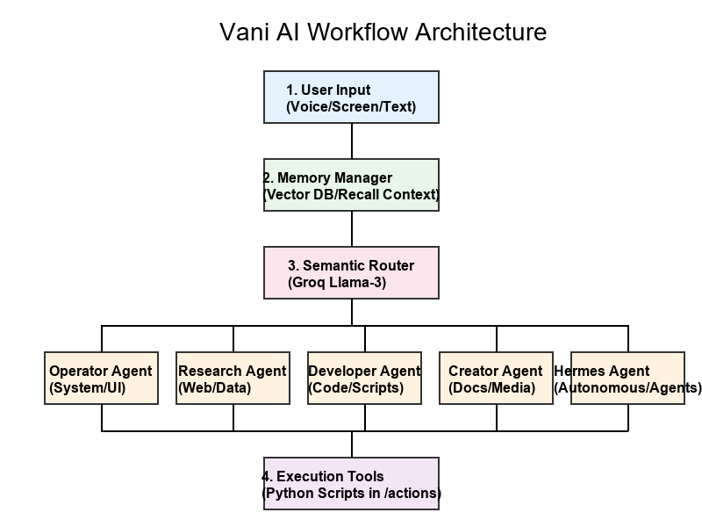

4. The Upgrade Roadmap: How Much Can We Upgrade V.A.N.I.?
Because V.A.N.I. is built on a highly decoupled, modular API architecture, the potential for future upgrades is virtually limitless. Unlike systems chained to a single provider, upgrading V.A.N.I. does not require waiting for one company to release a new model. We can swap individual components instantly.
1. Full Local Execution (Privacy & Offline Mode): The most immediate upgrade path is shifting the reliance on cloud APIs to Local LLMs. By integrating frameworks like Ollama or LM Studio, we can run quantized models (like Llama-3 8B or Phi-3) directly on the user's local GPU. This would allow the Operator Agent and Semantic Router to function perfectly even without an internet connection, ensuring absolute data privacy for sensitive system operations.
2. Advanced Multimodal Manipulation: Currently, V.A.N.I. can view the screen and generate 3D models via Tripo AI. The next upgrade involves closing the loop on physical UI interaction. By integrating advanced Computer Vision models (like UI-DETR) combined with PyAutoGUI, V.A.N.I. could visually identify buttons, text boxes, and elements on the screen that don't have standard accessibility hooks, and physically move the mouse to click them. This would allow her to operate literally any software, even legacy apps or video games, just like a human operator.
3. Swarm Intelligence & Multi-Device Control: Through the Tailscale network, V.A.N.I. currently has foundational secure networking. This can be upgraded into a true 'Swarm' architecture. A user could have an instance of V.A.N.I. running on their Desktop, their Laptop, and their home server. These instances could communicate autonomously via RPC. If the laptop V.A.N.I. needs to perform heavy 3D rendering, she could securely delegate that task to the Desktop V.A.N.I.'s GPU, retrieve the result, and present it to the user. Furthermore, deeper integration with the connected Android phone (via advanced ADB scripting) could allow V.A.N.I. to manage SMS, WhatsApp, and phone calls entirely from the desktop background.
4. Continuous Unsupervised Learning: The Hermes agent lays the groundwork for unsupervised learning. An upgrade here would involve giving V.A.N.I. a 'dream state' or downtime processing mode. When the PC is idle, V.A.N.I. could review the day's logs, refactor her own poorly performing scripts, pre-index heavily used files, and cache likely search queries for the next day, resulting in a system that genuinely gets faster and smarter over time.

5. Conclusion
In conclusion, V.A.N.I. represents the next step in Human-Computer Interaction. By distributing computational workloads across 17 distinct APIs, the architecture completely circumvents the traditional bottlenecks of AI development. It relies on Groq for instantaneous reflexes, Gemini for constant sensory perception, and heavy lifters like DeepSeek and Composio for complex problem solving. The result is an agentic ecosystem that is fast, resilient, highly context-aware, and infinitely upgradable.

