Vani AI - Complete Project Overview & Architecture Guide
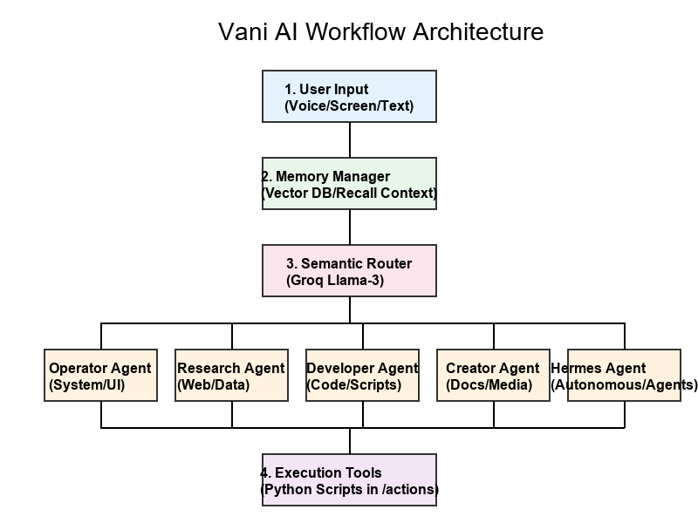

1. Introduction to Vani AI
Vani AI is a highly advanced, multi-modal Personal AI Assistant designed specifically to operate natively within the Windows desktop environment. Unlike conventional chatbots that are restricted to browser windows and text-based outputs, Vani is an 'agentic' system. This means that she can autonomously perform complex, multi-step actions directly on the host operating system. Whether it involves navigating the local file system, managing applications, scraping the internet for real-time information, writing and debugging Python scripts, or even directly controlling an connected Android phone via ADB, Vani is designed to be a comprehensive digital companion. Built using a combination of Google Gemini (utilizing the gemini-3.1-flash-live-preview for near-instant audio and visual processing), OpenRouter for diverse Large Language Model (LLM) access, and a suite of custom Python tools, Vani bridges the gap between conversational AI and local system automation. The project showcases how AI can move from simply answering questions to actively doing work on behalf of the user.

2. Core Architecture & Workflow
The architecture of Vani is fundamentally designed around a Multi-Agent Orchestration pattern. Rather than relying on a single monolithic LLM to handle everything from writing a poem to debugging a system shell, Vani distributes tasks to specialized sub-agents. The core workflow operates as follows:
Step 1: Input Reception & Multimodal Context. Vani continually listens to audio via the 'sounddevice' library, creating a seamless, hands-free voice interface. In addition to audio, Vani possesses deep screen-awareness capabilities. Through the 'vision_computer_use' integration, if a user refers to an item on their screen, Vani captures a screenshot and passes the visual context directly to the Gemini Live model. This enables true multimodal interactions where the user can ask, 'What error is showing on my screen right now?' and receive an accurate answer.
Step 2: Memory Management. A sophisticated memory module intercepts inputs before any action is taken. Vani utilizes JSON-based local storage (such as chat_history.json and vector_db.json) along with vector embedding structures to maintain long-term conversational context. This ensures that Vani remembers user preferences, past commands, and project-specific details across different sessions without requiring constant repetition from the user.
Step 3: Semantic Routing. The brain of the operation is the 'SemanticRouter' class situated in 'orchestrator.py'. Once the context is established, Vani uses Groq (typically running a high-speed open-source model like Llama-3) to perform ultra-low-latency intent classification. Groq analyzes the user's intent and determines exactly which of the 7 specialized sub-agents is best equipped to handle the request. This routing is entirely invisible to the user but is critical for maintaining high speed and precision.
Step 4: Delegation and Execution. Upon routing, the request is passed to a specific Companion (Sub-Agent). The Companion then utilizes a pre-defined set of Python tools (located in the 'actions' directory) to execute the required commands. Tools can range from 'browser_control' to 'system_shell', allowing for a massive breadth of functionality.

3. The 7 Specialized Sub-Agents (Companions)
Vani operates through 7 distinct Companions, each configured with its own persona, system prompt, and allowed toolset:
• Operator Agent: The system administrator. The Operator has high-level permissions to control computer settings, launch and close applications, handle desktop layout, and directly interface with connected mobile devices. If a user says, 'Close all my browser windows and focus my IDE', the Operator handles it.
• Research Agent: The data analyst. This agent is restricted from making dangerous system changes but excels at fetching real-time data. It scrapes web pages, fetches live weather data, checks Google Flights, queries free APIs, and pulls metadata and transcripts from YouTube videos to summarize information thoroughly.
• Developer Agent: The software engineer. Equipped with tools like 'code_helper', 'dev_agent', and 'github_controller', this agent can write standalone scripts, execute terminal shell commands, format code, and debug errors. It acts as an interactive, highly capable pair-programmer.
• Creator Agent: The creative coordinator. This agent processes uploaded CSV or PDF documents, manages tasks and reminders, generates dynamic PowerPoint presentations, and can send WhatsApp or Telegram messages. It is designed for administrative and content-generation tasks.
• LLM Brain Manager: A unique multi-model orchestrator. It manages delegations to various LLM providers (including Gemini, OpenRouter, OpenAI, and DeepSeek) based on task complexity, ensuring the optimal AI model is used for generic reasoning or text-generation tasks.
• 3D Architect: A highly specialized agent for visual design. It uses underlying tools to render, model, and create 3D assets or geometric structures requested by the user.
• Hermes Agent: Perhaps the most advanced feature of Vani, Hermes is an autonomous, self-improving subsystem. Hermes can write Python scripts to solve new, unprecedented problems. It can spawn isolated parallel subagents to work on different tasks simultaneously and runs scheduled background automations. It operates in a closed loop, meaning it learns from experience to build its own tools and expand Vani's capabilities autonomously.

4. Technology Stack & UI Development
Vani's backend is heavily built on Python 3.12, taking advantage of modern asynchronous programming features (asyncio) and multithreading. This ensures that while Vani is performing a long-running task—like scraping a massive website, rendering a 3D model, or downloading a heavy file—her audio reception and User Interface do not freeze or hang.
The User Interface itself is crafted using PyQt6, establishing a sleek, persistent dashboard on the desktop. As defined in 'core/ui.py', the dashboard natively displays vital system metrics including CPU utilization, RAM usage, Network I/O, GPU load, and System Temperatures. By utilizing packages like 'psutil' and 'subprocess' (to query utilities like 'nvidia-smi'), the UI acts as a comprehensive heads-up display for the entire operating system. Furthermore, Vani is heavily integrated with Microsoft Windows APIs (using libraries such as pywinauto and pygetwindow) to achieve seamless desktop control.

5. Key Use Cases & Interview Talking Points
When explaining Vani during an interview, it is critical to highlight how it solves real-world workflow inefficiencies through agentic AI:
A. Real-World Multimodality: Emphasize that Vani is not just text-in, text-out. By allowing the AI to actually 'see' the user's screen and 'hear' their voice, the friction of interacting with a computer is vastly reduced. A user can literally point at an error code on their monitor and ask for a fix, and Vani will ingest the visual context and respond accurately.
B. The Semantic Router Architecture: The implementation of a low-latency Groq router is an excellent engineering decision. Interviewers will appreciate the architectural forethought of not sending every single request to an expensive, slow model like GPT-4, but instead using a rapid intent-classifier to dispatch tasks to specialized agents.
C. System-Level Execution & Safety: Reiterate that Vani writes and executes code locally. The Developer agent doesn't just provide a code snippet to copy-paste; it can write a Python script, execute it, read the terminal output, and debug it autonomously if it fails. Discussing how you sandbox or manage the safety of these operations is a great talking point.
D. Autonomous Expansion (Hermes): Discuss the Hermes agent. The ability of an AI system to recognize it lacks a tool, write the Python code to create that tool, and then utilize it, represents the cutting edge of modern Agentic AI development and showcases a deep understanding of autonomous systems.

