**AI Assisted Problem Solving Using Python**

**Date: 28-10-2025**

**Name: Machavaram Satwik**

**M tech – 1st Year**

**HTNO: 2505B04301**

**Lab 2: Exploring Additional AI Coding Tools – Gemini (Colab) and Cursor AI**

**Task Description-1**

* Use Google Gemini in Colab to write a function that reads a CSV file and calculates mean, min, max.

**Expected Output-1**

* Functional code with output and screenshot

**Prompt**

Create a CSV file and write a function that reads a CSV file and calculates mean, min, max and print output.

**CSV file**

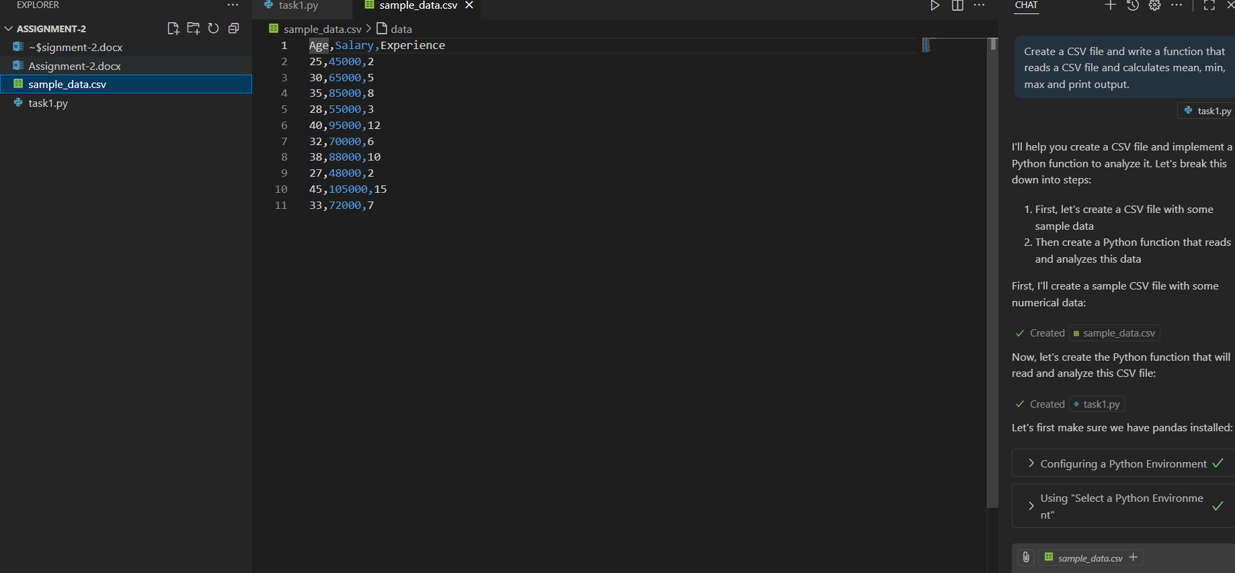

**Code:**

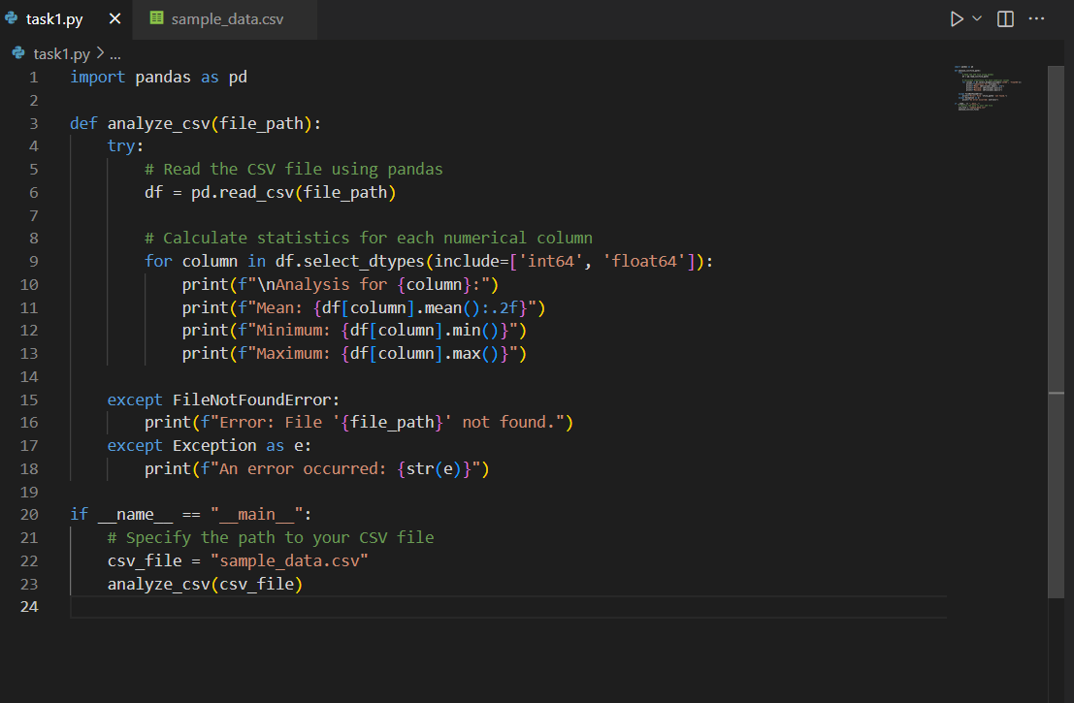

**Output:**

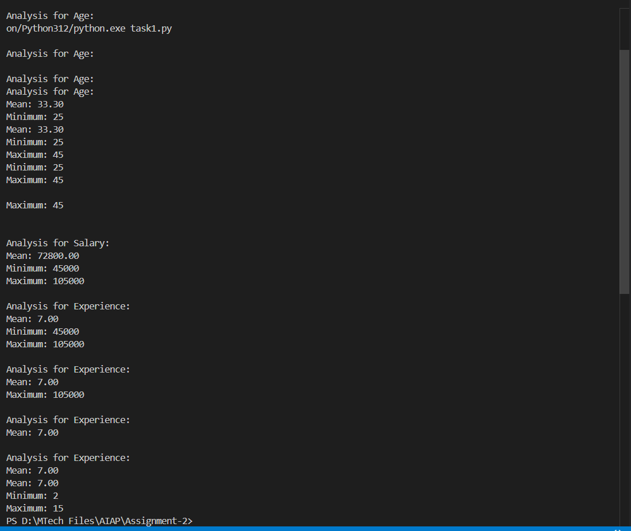

**Task Description-2**

* Compare Gemini and Copilot outputs for a palindrome check function.

**Expected Output-2**

* Side-by-side comparison and observations

**Prompt**

Generate a python function to check palindrome function by taking user input manually.

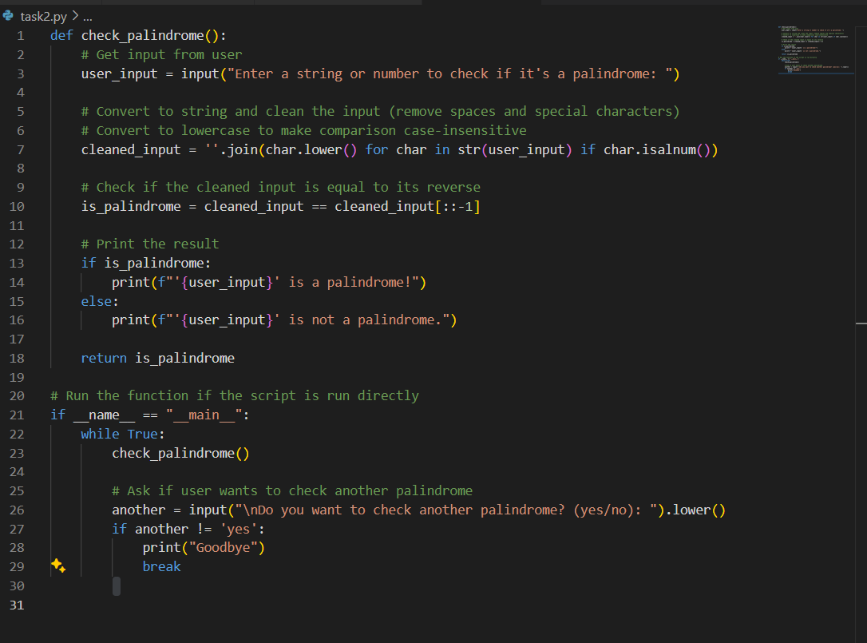

**Output:**

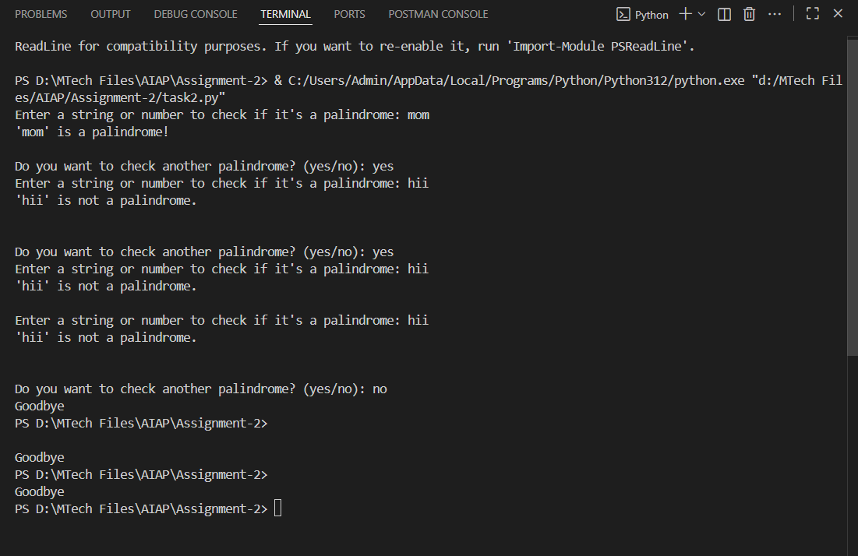

**Task Description-3**

* Ask Gemini to explain a Python function (to calculate area of various shapes) line by line..

**Expected Output-3**

* Detailed explanation with code snippet

**Prompt**

Write a Python function to calculate area of various shapes and explain line by line.

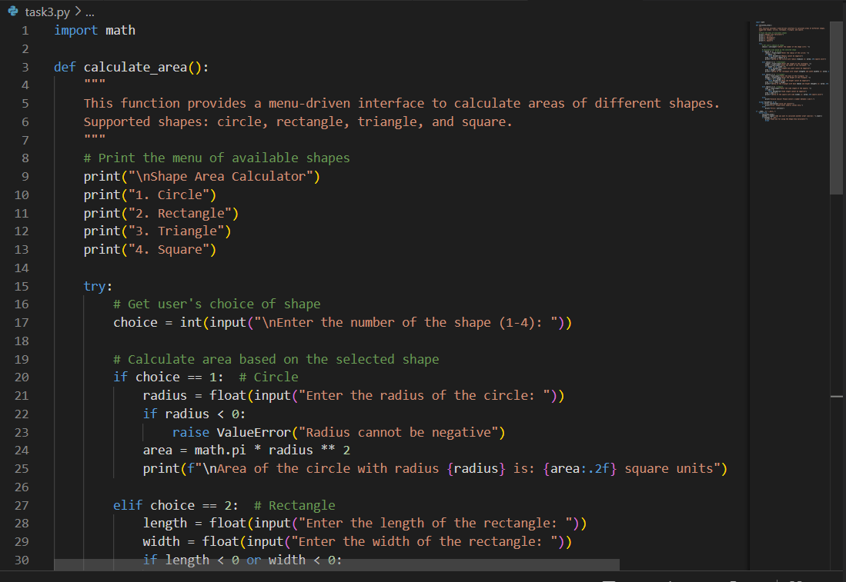

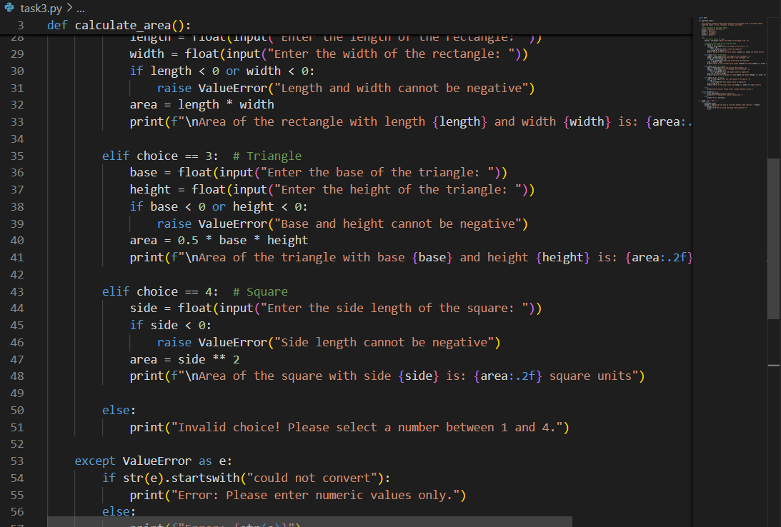

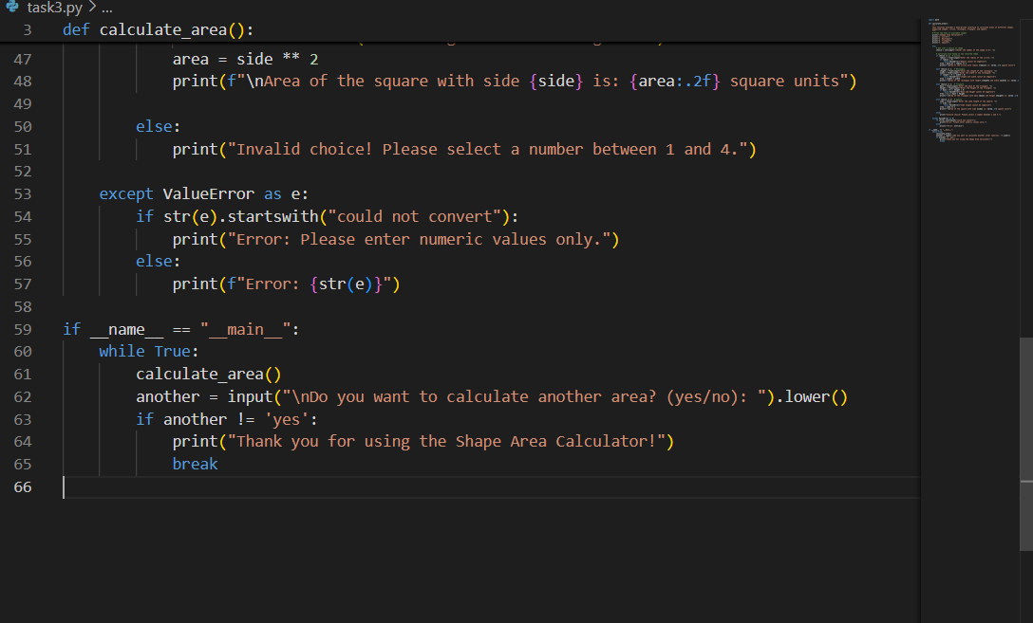

**Output:**

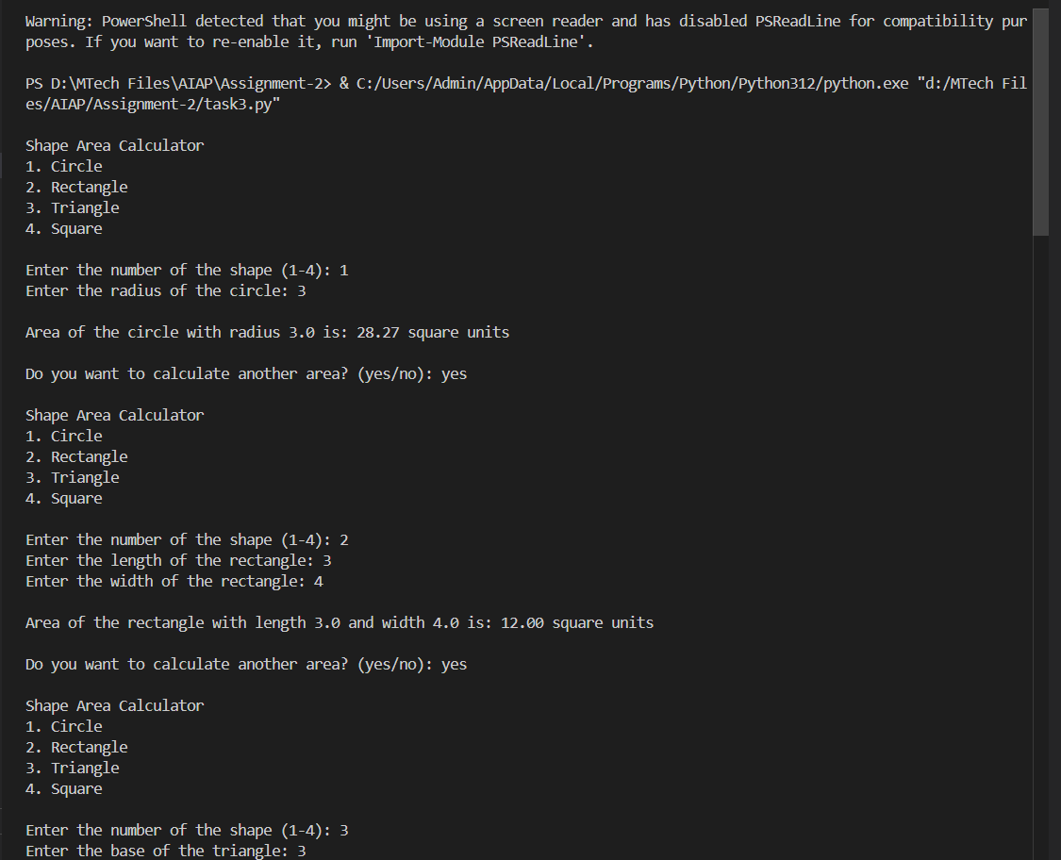

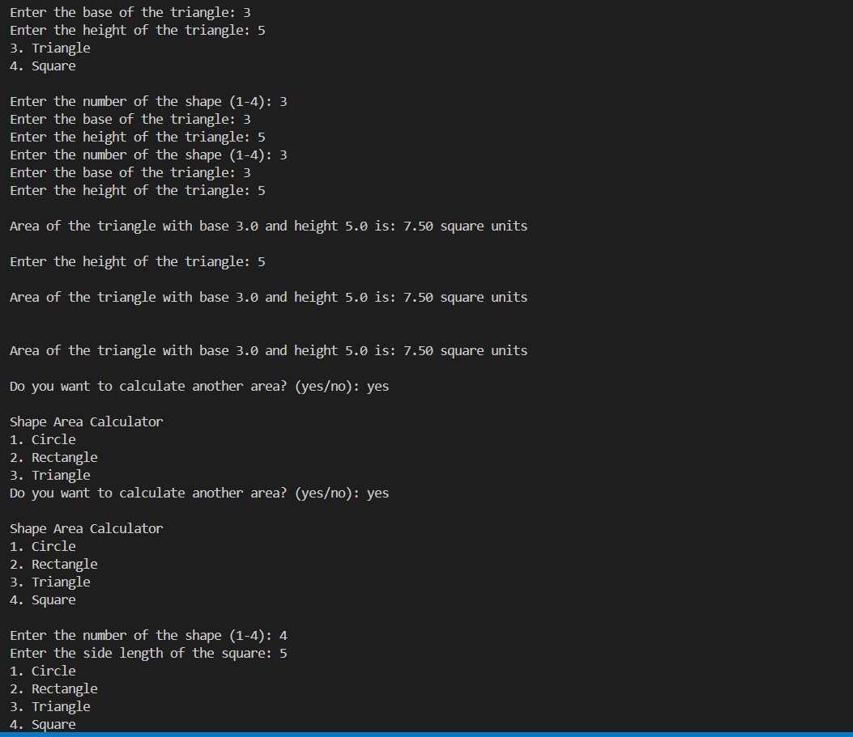

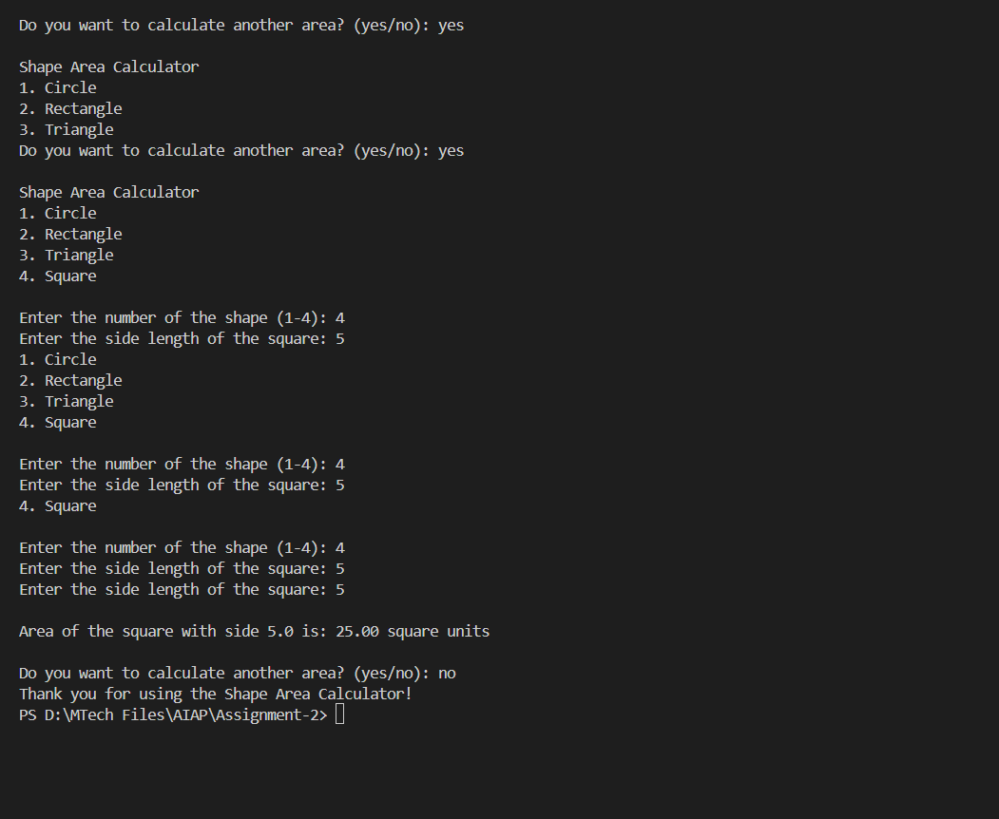

**Task Description-4**

* Install and configure Cursor AI. Use it to generate a Python function (e.g., sum of squares).

**Expected Output-4**

* Screenshots of working environments with few prompts to generate python code

**Prompt**

Generate a Python function sum of squares by taking user input manually.

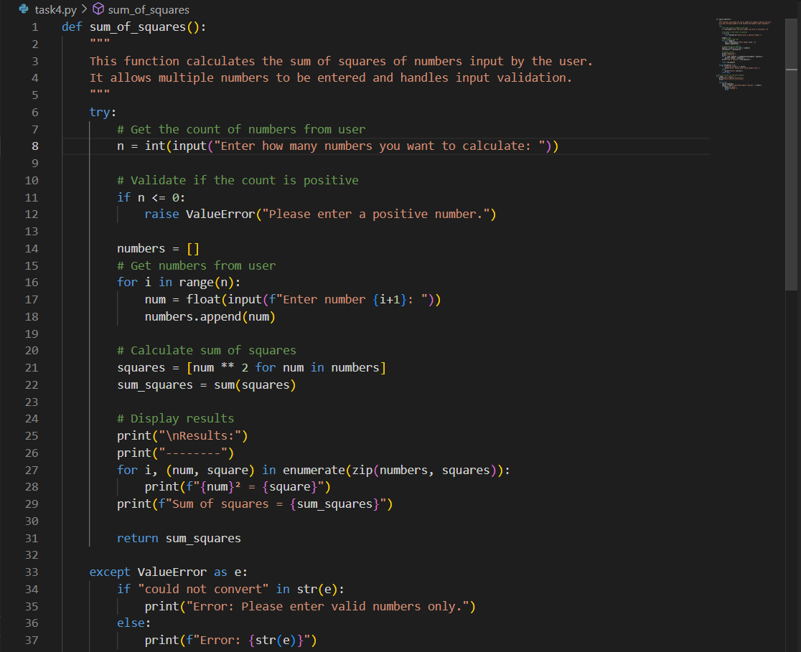

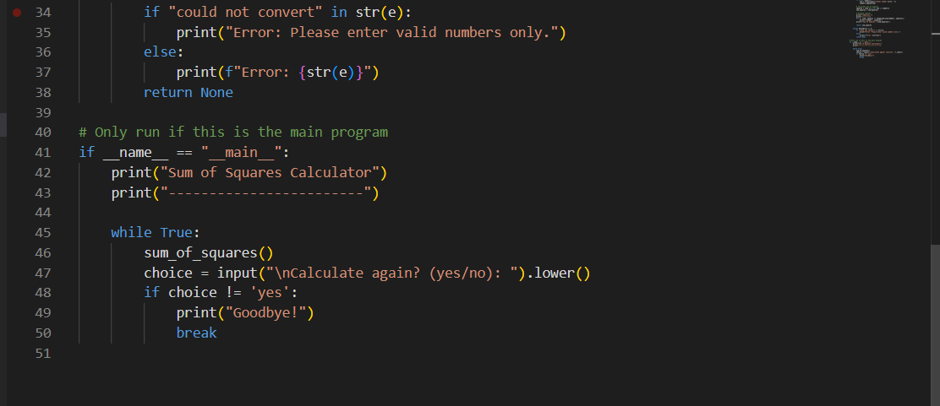

**Output:**

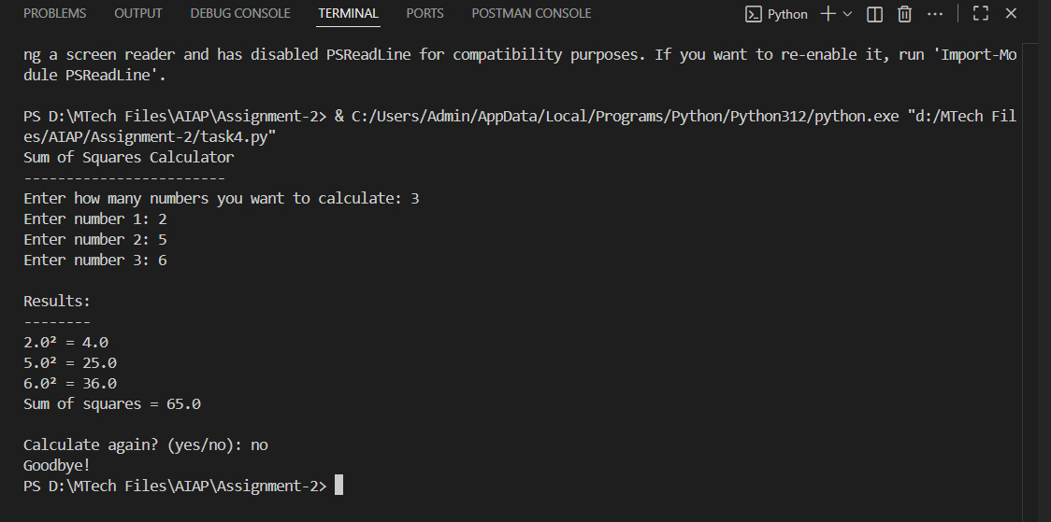

**Task Description-5**

* Student need to write code to calculate sum of odd number and even numbers in the list

**Expected Output-5**

* Refactored code written by student with improved logic

**Prompt-1**

write code to calculate sum of odd number and even numbers in the list by taking user input manually.

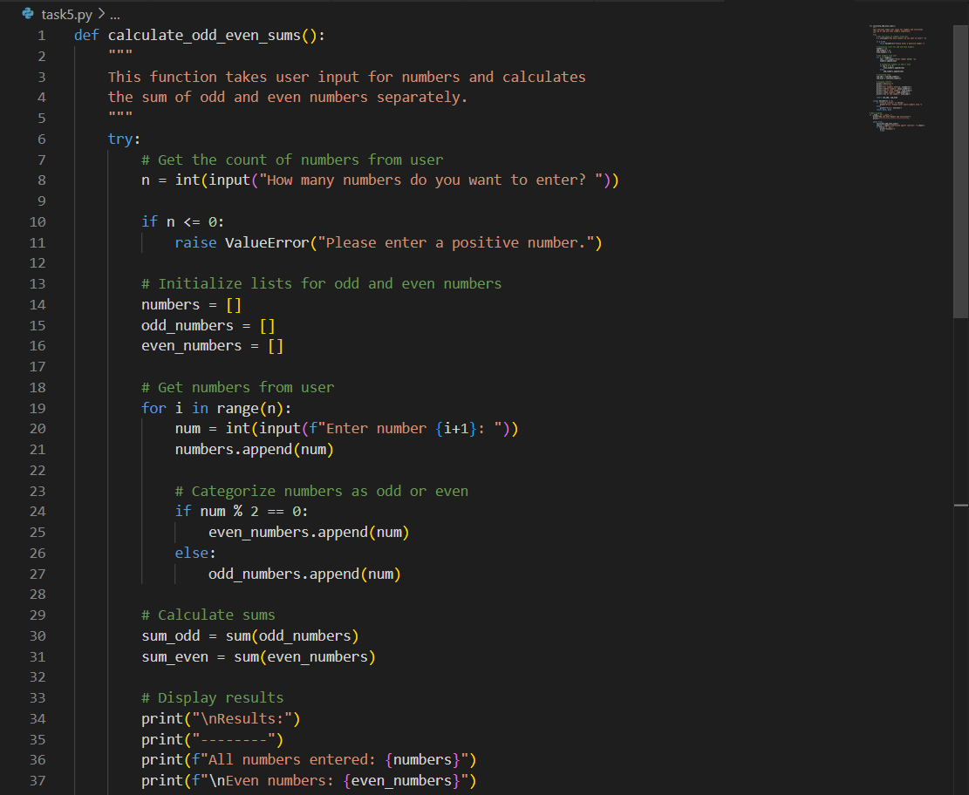

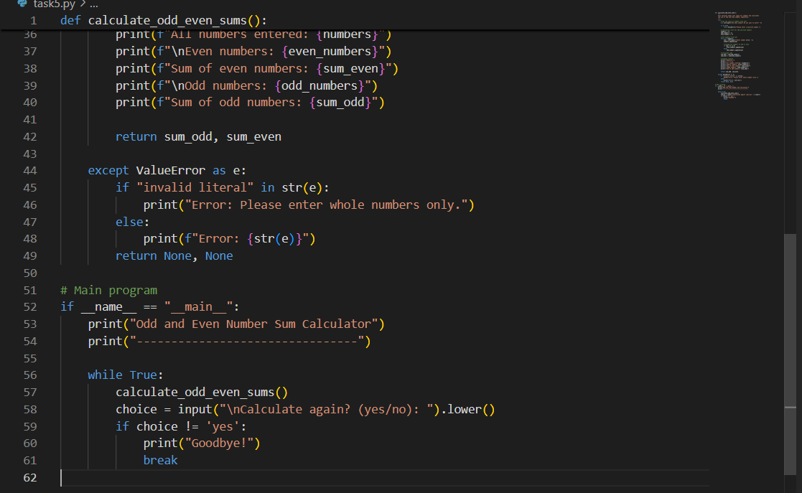

**Output**

