Python Programming Lab Task Sets

Set 3
- Implement a Python class for a stack data structure (`push`, `pop`, `peek`). Use GitHub Copilot to generate code, test its handling of edge cases, and explain any improvements made.
(Each question carries 5 marks)
Prompt:
Implement a python class for stack data structure for push, pop, peek by taking user input manually.
Code:
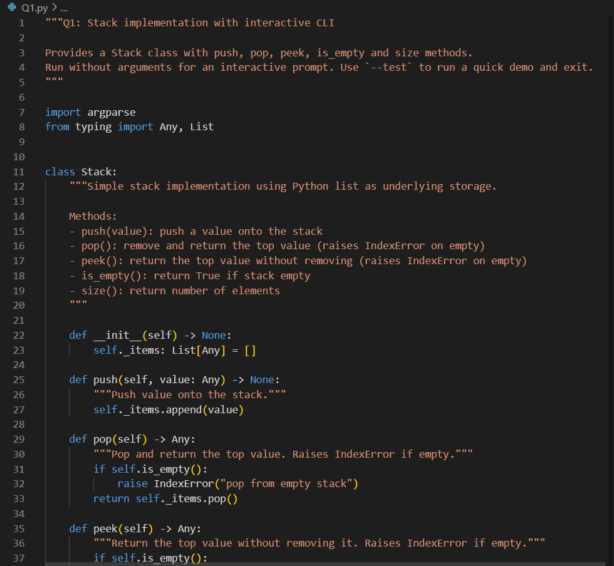

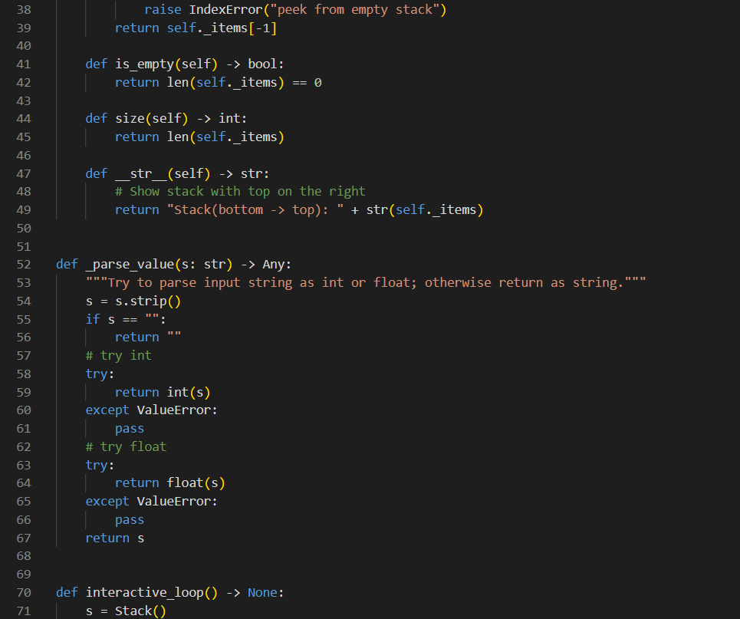
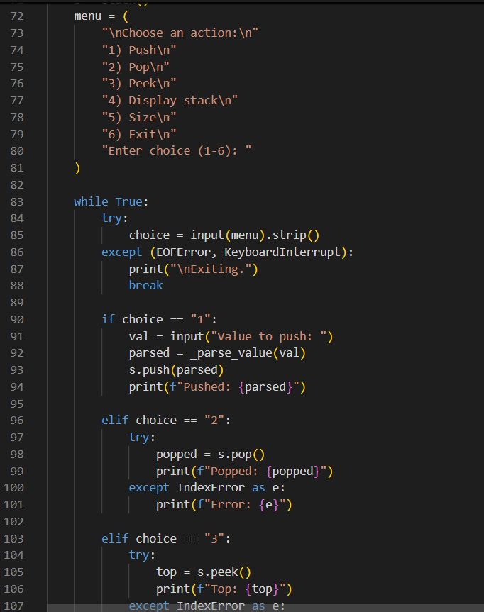
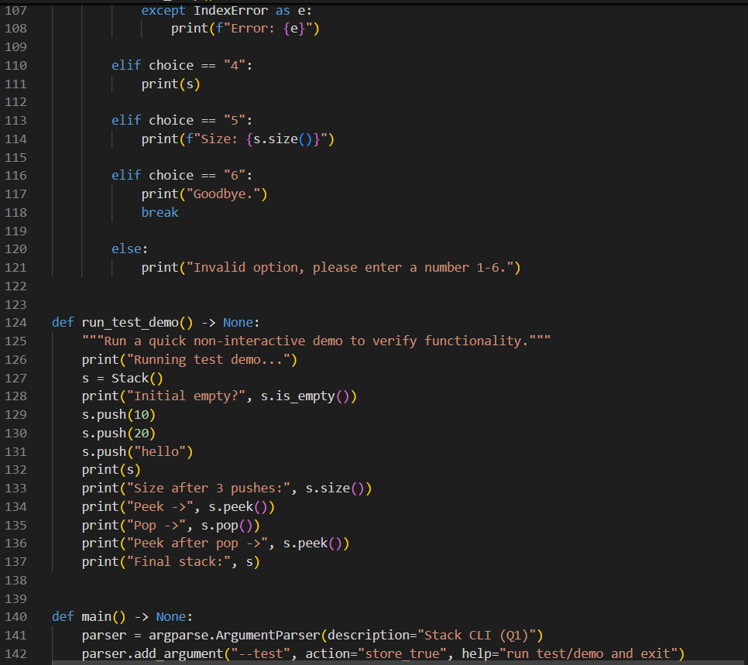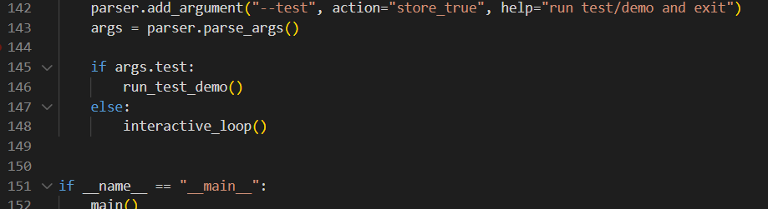

Output:
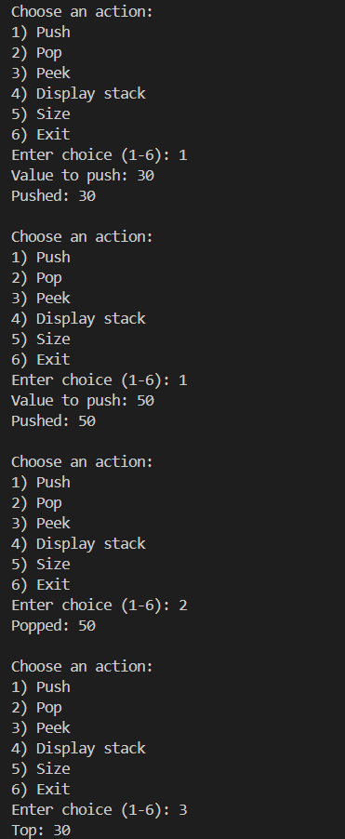
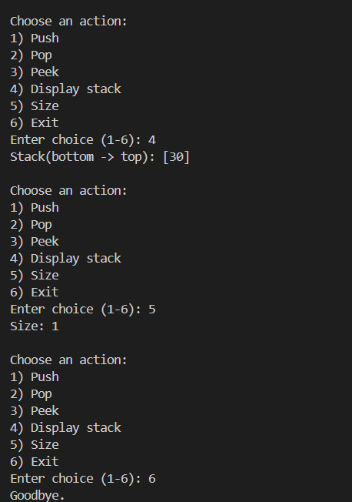

Explaination:

- Refactor a poorly commented Python function using an AI assistant for automatic documentation. Evaluate clarity and completeness versus manual comments.
(Each question carries 5 marks)
Prompt:
# Function to find the largest of two numbers
def largest(a, b):
# Compare both values
if a > b:
return a # a is bigger
else:
return b # b is bigger or equal

# Testing the function
result = largest(10, 7) # Call the function
print("Largest number is:", result) # Print the output

Refactor the poorly commented Python function by suitable commenting.
Code:
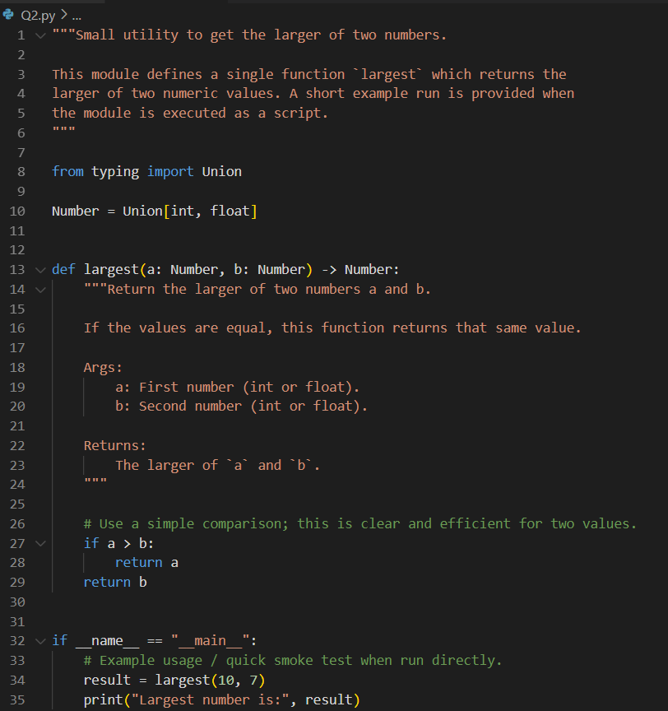

Output:
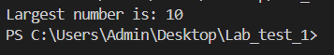
Explaination:
In my earlier version, the comments were very simple and only explained what each line was doing, without giving much insight into the actual purpose of the function. The updated version generated by the AI is much more structured and professional. It includes a module-level docstring, proper type hints, and a detailed function docstring that clearly explains what the function does, the kind of inputs it accepts, and what it returns. These improvements make the code easier to understand at a higher level rather than just reading step-by-step comments.

