AgroBand

DESIGNED IN SOLIDWORKS – SATWIK DUDEJA

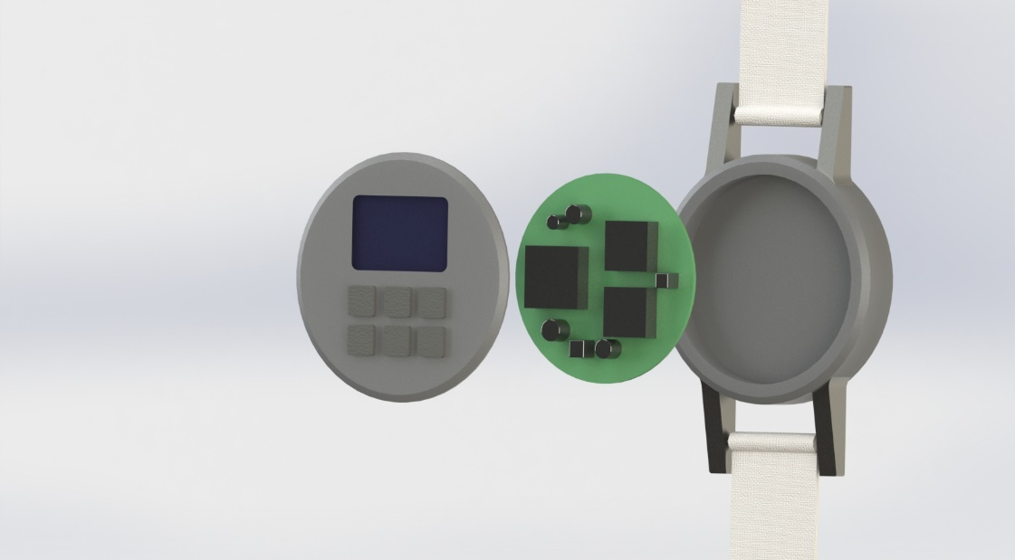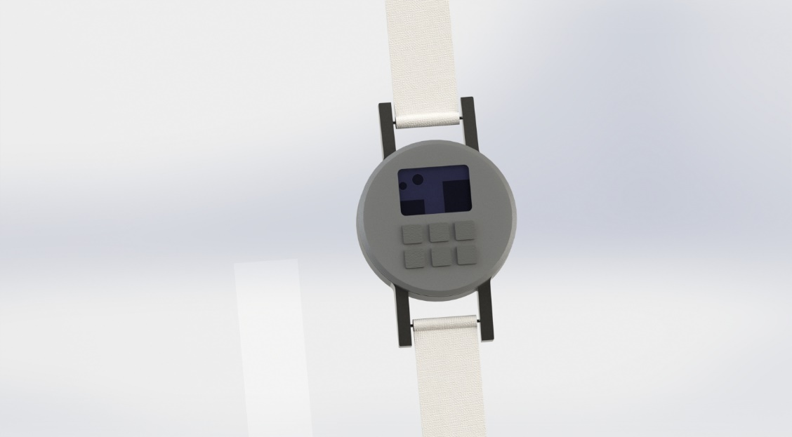

Key Features –

1. Fitted with a GPS Module, to monitor herds, for identification, and to keep a track of unusual behaviour of individual cows.
2. Heat sensor to determine cow illness in real time, conception rates, and suitable time for insemination; identify animals under heat/cold stress.
3. Can be placed on neck/legs/tail of the cows to avoid unwanted tampering. If placed on the neck, AgroBand can also monitor feeding and rumination (with an ingestible chip).
4. Soft material fibre band prevents any sort of discomfort for the cows.