Blockchain Lab

**Lab L2: Smart Contract Programming**

## **Exercise 1a: Hello-world Contract with Remix**

Solidity Program as provided:

Steps:

1. Write the Code
2. Compile it
3. Deploy it
4. Execute the Greet Function

Program Output

## **Exercise 1b (with 20% bonus): Hello-world Contract with Solc and On-Campus Ethereum**

Steps:

1). Write Sol file code

2). Compile using solc

Compiling

1). Modify .bin and .abi files

BIN FILE

ABI FILE

1). Connect to ethereum network

2). Load and Deploy contract

>loadScript(“hello.abi”)

>loadScript(“hello.bin”)

3). Execute Contract

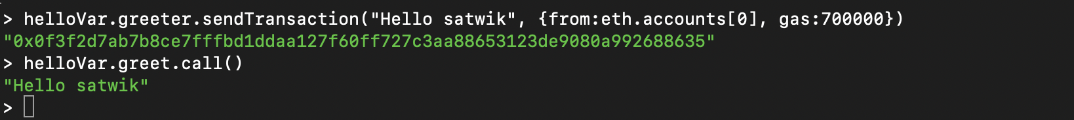

Output display

## 

## **Exercise 2: Find the Maximum**

Steps:

1). Write the Code

Program

2). Compile and modify .bin and .abi files

BIN FILE

ABI FILE

1). Connect to ethereum network and deploy contract

>loadScript(“findmaximum.bin”)

>loadScript(“findmaximum.abi”)

2). Execute contract



Contract Execution

Contract Call

## 

## **Exercise 3: Rock-paper-scissors game**

## Steps:

Step 1: Write Code:

Code Part 1

Code Part 2

Code Part 3

Step 2. Compile the smart contract & Deploy

Step 3. Provide Accounts to play game

Account 1

Account 2

Step 4: Register both accounts with 5 ethers

Registered Accounts

Step 5. Execute ‘Play’ with their respective choices

Player 1: Scissors Player 2: Rock

Step 6. After both accounts choose their choice, winner is declared and ethers are transferred

Ether Transfer

WINNER: Player 2