SUMMARY

USC ID/s: 4534167714, 3888315499, 6300850270, 1214333928, 3038472455

Datapoints
M+N | Time in MS (Basic) | Time in MS (Efficient) | Memory in KB (Basic) | Memory in KB (Efficient)
16 | 0.438 | 0.089 | 60752 | 60768
64 | 1.809 | 0.878 | 102384 | 102384
128 | 1.847 | 2.981 | 102416 | 102416
256 | 5.871 | 10.554 | 102432 | 102432
384 | 13.406 | 24.468 | 102432 | 102432
512 | 23.448 | 42.795 | 102656 | 102656
768 | 56.978 | 99.601 | 102800 | 102800
1024 | 101.145 | 172.909 | 103792 | 103808
1280 | 162.608 | 271.665 | 108432 | 104368
1536 | 228.236 | 357.424 | 84640 | 68304
2048 | 430.541 | 676.470 | 106112 | 75424
2560 | 676.031 | 1070.075 | 128368 | 80304
3072 | 934.767 | 1473.812 | 161536 | 91952
3584 | 1313.007 | 2085.271 | 197952 | 102752
3968 | 1632.035 | 2635.740 | 227280 | 102384

Insights

Graph1 – Memory vs Problem Size (M+N)

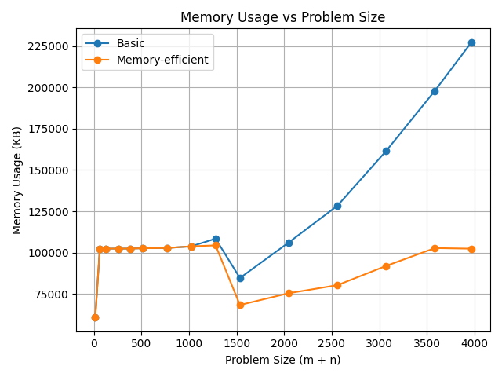

Nature of the Graph (Logarithmic/ Linear/ Polynomial/ Exponential)
Basic: Polynomial
Efficient: Linear

Explanation:
The blue line representing the memory usage of the basic function is consistently above the orange line representing the memory usage of the efficient function. This makes sense, since the efficient function is optimized to reduce memory usage, using only O(m + n) space. The basic algorithm uses O(mn) space, as seen by the blue line’s much steeper, accelerating growth.
Note: memory appears high and flat before problem size is 1500 because Python’s baseline memory overhead dominates small inputs. The drop near 1500 is because Python’s memory allocator reuses and releases memory in chunks, causing temporary decreases even though overall memory usage increases with input size.

Graph2 – Time vs Problem Size (M+N)

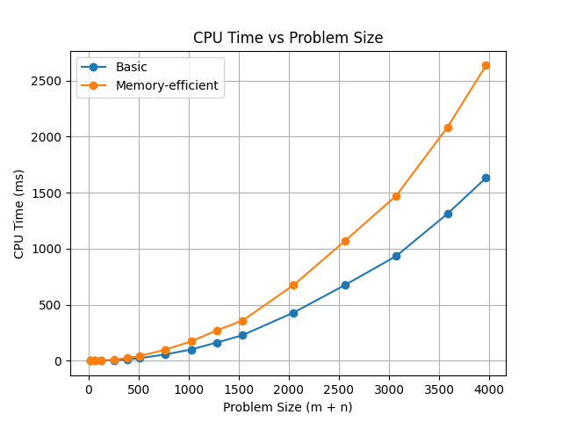

Nature of the Graph (Logarithmic/ Linear/ Polynomial/ Exponential)
Basic: Polynomial
Efficient: Polynomial

Explanation:
Both the basic and memory efficient solutions have a runtime of O(mn). Since m and n grow proportionally, O(mn) in this graph behaves like O((m+n)²), which explains the upward-curving (quadratic-like) shape of both lines. The memory-efficient algorithm has additional overhead from the divide-and-conquer recursion, making it slower in practice despite matching the basic algorithm’s asymptotic time complexity. As a result, the memory efficient solution (orange line) uses more time than the basic algorithm (blue line).

Contribution
(Please mention what each member did if you think everyone in the group does not have an equal contribution, otherwise, write “Equal Contribution”)
<USC ID/s>: <Equal Contribution>

4534167714, 3888315499, 6300850270, 1214333928, 3038472455: Equal Contribution

