STUDENT CASE STUDY EXECUTION REPORT
Department | FED
Subject | DSA-2
Academic Year | I-III Semester (2025-26)
Faculty Name | Dr Sukanya leddala
Student Name | NAEENI SATWIKA
Roll Number | 2520090151
Branch | CSE (AI & DS)
Course Outcome | Apply graph algorithms and Union-Find techniques for solving real-world network optimization problems.

Work Done Summary
In this case study, we analyzed an Uber driver-dispatch routing system using the Bellman-Ford Algorithm with negative-edge incentives.
The work focused on:
- Representing city zones as graph vertices.
- Representing road routes as directed weighted edges.
- Handling negative edge weights caused by surge incentives.
- Applying Bellman-Ford Algorithm for shortest path computation.
- Performing edge relaxation for V−1 iterations.
- Detecting possible negative cycles.
- Reconstructing the shortest route from IND to EC.
- Comparing Bellman-Ford with Dijkstra’s limitations on negative weights.
- Understanding why runtime negative-cycle checks remain important.

Implementation Details
- Modeled Uber zones as graph nodes:
  - IND
  - KOR
  - MGR
  - HSR
  - BTM
  - JPN
  - EC
- Represented directed roads using weighted edges.
- Included negative incentive edges:
KOR → BTM = -5
HSR → JPN = -3
- Initialized distance array:
dist[source] = 0
- Set all other distances to infinity.
- Performed Bellman-Ford relaxation for:
V−1=6V-1=6V−1=6
iterations.
- Relaxed all edges sequentially during each iteration.
- Updated predecessor array to reconstruct paths.
- Detected convergence before the final iteration.
- Performed an additional V-th pass to detect negative cycles.
- Reconstructed shortest path from EC back to IND using predecessor links.
- Verified that no negative cycle existed in the graph.
RESULTS:SCREENSHOTS/Output:
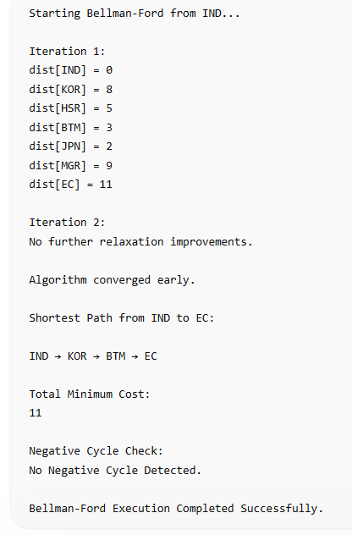

Conclusion
In this case study, Bellman-Ford Algorithm was used because the Uber dispatch graph contained negative-weight edges created by surge incentives.
Unlike Dijkstra’s Algorithm, Bellman-Ford correctly handles negative edge weights by repeatedly relaxing all edges and updating shortest paths over multiple iterations. The algorithm also provides negative-cycle detection, which is critical for ensuring route stability and preventing invalid dispatch calculations.
The shortest path successfully utilized the negative incentive edge KOR → BTM to reduce total route cost. This demonstrates how Bellman-Ford is highly suitable for real-world transportation, pricing, and routing systems where dynamic incentives and negative adjustments may exist.

Github Link:
