STUDENT CASE STUDY EXECUTION REPORT
Department | FED
Subject | DSA-2
Academic Year | I-III Semester (2025-26)
Faculty Name | Dr Sukanya leddala
Student Name | NAEENI SATWIKA
Roll Number | 2520090151
Branch | CS & IT
Course Outcome | Apply graph algorithms and Union-Find techniques for solving real-world network optimization problems.

Work Done Summary
In this case study, we analyzed Spotify’s monthly-listener leaderboard problem using Heap Data Structures for efficient Top-K queries.
The work focused on:
- Finding the top 5 artists from a stream of listener counts.
- Using a min-heap to maintain the current top-k artists.
- Performing single-pass heap processing.
- Replacing the heap minimum when a larger value appears.
- Comparing heap-based top-k selection with full sorting.
- Understanding heap construction and heapify operations.
- Comparing heapsort with quicksort and merge sort.
- Studying time and space complexity of heap operations.

Implementation Details
- Considered listener counts for 12 artists:
45, 12, 78, 23, 56, 89, 34, 67, 18, 91, 50, 39
- Created a min-heap of size:
k = 5
- Inserted the first 5 artists directly into the heap.
- For each remaining artist:
  - Compared listener count with heap minimum.
  - If larger, removed heap minimum.
  - Inserted the new artist into the heap.
- Maintained only the top-5 largest listener counts in the heap.
- Used heapify operations to maintain min-heap property.
- Extracted heap contents after processing all artists.
- Sorted final heap contents in descending order.
- Compared heap-based top-k complexity against full sorting.
- Demonstrated why heap-based processing is faster for very large datasets like Spotify analytics.
RESULTS:SCREENSHOTS/Output:
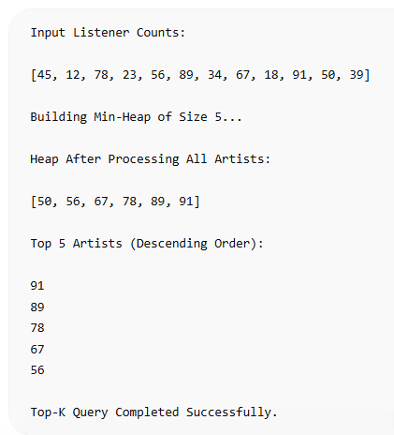

Conclusion
In this case study, a min-heap was used because it efficiently maintains the top-k largest elements while scanning a massive dataset only once.
Instead of fully sorting all artist listener counts, the heap stored only the current best candidates, significantly reducing both computation and memory usage. Heap operations such as insertion, deletion, and heapify ensured efficient maintenance of the leaderboard.
This approach is highly suitable for large-scale streaming analytics systems like Spotify, where millions of records must be processed continuously and real-time top-k queries are required efficiently.

Github Link:


