STUDENT CASE STUDY EXECUTION REPORT
Department | FED
Subject | DSA-2
Academic Year | I-III Semester (2025-26)
Faculty Name | Dr Sukanya leddala
Student Name | NAEENI SATWIKA
Roll Number | 2520090151
Branch | CS & IT
Course Outcome | Apply graph algorithms and Union-Find techniques for solving real-world network optimization problems.

Work Done Summary
In this case study, we analyzed the Steel-Mill Rod-Cutting problem using Dynamic Programming (DP) to maximize revenue from cutting a steel rod into smaller pieces.
The work focused on:
- Solving the rod-cutting optimization problem using DP.
- Building the DP table for rod lengths 0 to 10.
- Computing maximum obtainable revenue for each rod length.
- Finding the optimal cut sequence.
- Comparing top-down memoization and bottom-up tabulation.
- Understanding the relation between rod cutting and unbounded knapsack.
- Recovering the actual cuts used in the optimal solution.
- Studying variations such as bounded rod-cutting and cutting cost models.

Implementation Details
- Considered rod length:
10
- Used price table:
[0, 1, 5, 8, 9, 10, 17, 17, 20, 24, 30]
- Created DP array:
dp[0...10]
where:
- dp[i] stores maximum revenue for rod length i.
- Initialized:
dp[0] = 0
- For every rod length i:
  - Tried every possible first cut k.
  - Computed:
dp[i]=max⁡(price[k]+dp[i−k])dp[i]=\max(price[k]+dp[i-k])dp[i]=max(price[k]+dp[i−k])
- Maintained a cut[] array to record the optimal first cut.
- Filled the DP table bottom-up from length 1 to 10.
- Computed maximum obtainable revenue for every rod length.
- Backtracked using cut[] to recover optimal cut sequence.
- Verified that no further cutting produced higher revenue than the DP solution.
- Compared memoized top-down recursion with bottom-up DP.
- Explained the connection between rod-cutting and unbounded knapsack problems.
- analytics.
RESULTS:SCREENSHOTS/Output:
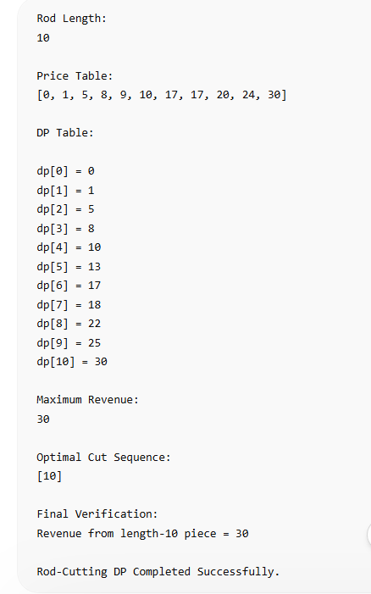

Conclusion
In this case study, Dynamic Programming was used because it efficiently solves the rod-cutting optimization problem by breaking it into overlapping subproblems.
The DP approach systematically computed the maximum obtainable revenue for every rod length and reused previously computed solutions to avoid redundant calculations. A cut[] array was also maintained to reconstruct the optimal cutting sequence.
The final solution showed that selling the rod as a single length-10 piece produced the maximum revenue of 30, meaning additional cuts were unnecessary. This approach is highly useful in manufacturing, production planning, inventory optimization, and industrial resource allocation systems.

Github Link:


