STUDENT CASE STUDY EXECUTION REPORT
Department | FED
Subject | DSA-2
Academic Year | I-III Semester (2025-26)
Faculty Name | Dr Sukanya leddala
Student Name | NAEENI SATWIKA
Roll Number | 2520090151
Branch | CS & IT
Course Outcome | Apply graph algorithms and Union-Find techniques for solving real-world network optimization problems.

Work Done Summary
In this case study, we analyzed a BST-based collision audit system used by Razorpay UPI transaction monitoring.
The work focused on:
- Storing recent transaction IDs in a Binary Search Tree (BST).
- Detecting duplicate transaction IDs within a sliding window.
- Evaluating BST height behavior for random insertions.
- Comparing expected BST depth with observed depth.
- Analyzing why the BST became unbalanced.
- Studying insertion-order effects on BST performance.
- Investigating possible timestamp-prefix ordering issues.
- Understanding how skewed insertions increase BST depth.

Implementation Details
- Modeled transaction IDs as BST nodes.
- Inserted approximately 30,000 recent UPI transaction IDs.
- Used lexicographic ordering for BST insertion.
- Expected random insertion behavior for balanced depth growth.
- Calculated expected BST height using:
E[height]≈1.39log⁡2nE[height]\approx1.39\log_2 nE[height]≈1.39log2​n
- Substituted:
n=30000n=30000n=30000
- Computed expected height:
1.39log⁡2(30000)≈201.39\log_2(30000)\approx201.39log2​(30000)≈20
- Compared expected height with observed depth:
Observed BST Depth = 24
Expected BST Depth ≈ 20
- Identified that the tree became more skewed than expected.
- Investigated possible causes:
  - Timestamp prefixes dominating ordering
  - Sequential insertion patterns
  - Non-uniform ID generation
  - Similar transaction prefixes
- Explained how near-sorted insertions increase BST depth and reduce efficiency.
RESULTS:SCREENSHOTS/Output:

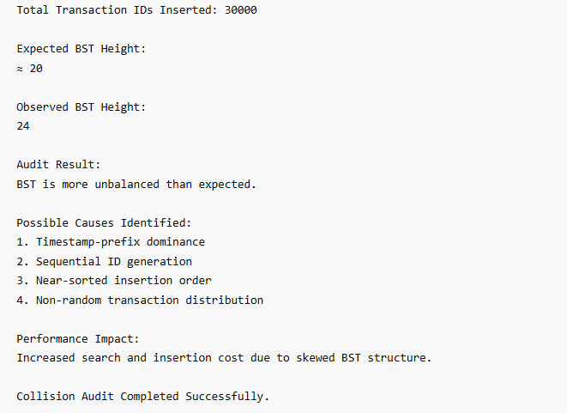

Conclusion
In this case study, a Binary Search Tree (BST) was used to efficiently store and audit recent UPI transaction IDs for duplicate detection.
The expected BST height for random insertions was approximately logarithmic, but the observed depth of 24 indicated partial imbalance in the tree structure. This suggested that transaction IDs were not being inserted in fully random order.
Factors such as timestamp-based prefixes, sequential ID generation, and clustered insertion patterns likely caused skewed BST growth. As the BST becomes unbalanced, search and insertion operations move closer to linear-time complexity.
This analysis demonstrates the importance of balanced tree structures and randomized key distributions in large-scale financial transaction systems.
Github Link:


