STUDENT CASE STUDY EXECUTION REPORT
Department | FED
Subject | DSA-2
Academic Year | I-III Semester (2025-26)
Faculty Name | Dr Sukanya leddala
Student Name | NAEENI SATWIKA
Roll Number | 2520090151
Branch | CS & IT
Course Outcome | Apply graph algorithms and Union-Find techniques for solving real-world network optimization problems.

Work Done Summary
In this case study, we analyzed DuckDB columnar storage optimization using interval skip-indexing (zone maps) for fast filtering operations.
The work focused on:
- Understanding zone-map indexing in column-store databases.
- Storing (min, max) values for each data block.
- Using zone maps to skip irrelevant blocks during queries.
- Computing zone-map storage overhead.
- Analyzing filtering efficiency for clustered and non-clustered data.
- Comparing random filtering vs timestamp-range filtering.
- Studying how clustering improves skip-index effectiveness.
- Understanding why column stores use sorted ingestion strategies.

Implementation Details
- Considered a table containing:
1 billion rows
- Divided data into:
100,000 blocks
- Each block contained:
10,000 rows
- Stored zone-map metadata for every block:
  - Minimum timestamp
  - Maximum timestamp
- Used zone maps to determine whether a block overlaps the query range.
- Skipped blocks whose (min, max) interval did not intersect the filter condition.
- Calculated storage overhead of maintaining zone maps.
- Analyzed non-clustered filtering where matching rows are randomly distributed.
- Analyzed clustered filtering where timestamps are stored contiguously.
- Demonstrated that clustered data allows entire blocks to be skipped efficiently.
- Explained asymptotic effectiveness of zone-map pruning.
- Studied why sort-on-write improves query performance in column stores.
RESULTS:SCREENSHOTS/Output:
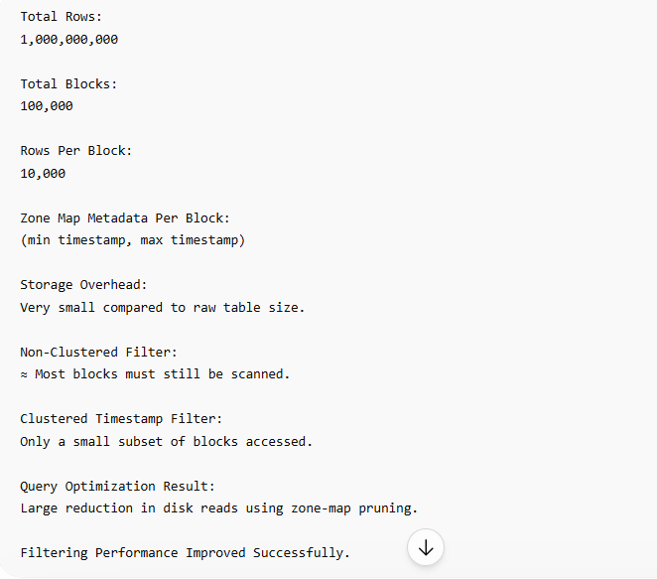

Conclusion
In this case study, DuckDB-style zone-map indexing was used because it efficiently reduces unnecessary disk reads in large column-store databases.
By storing only the minimum and maximum values for each block, the query engine can quickly determine whether a block may contain matching records. This enables entire blocks to be skipped without reading them into memory.
Zone maps are highly effective when data is clustered or sorted, especially for timestamp-range queries. For randomly distributed data, pruning effectiveness decreases because matching rows are scattered across many blocks.
This approach is widely used in modern analytical databases such as DuckDB, Snowflake, BigQuery, and Parquet systems to improve large-scale query performance and reduce I/O costs.
Github Link: https://github.com/ampssubrahmanyasreepad-svg/DSA-CaseStudies-correct
