STUDENT CASE STUDY EXECUTION REPORT
Department | FED
Subject | DSA-2
Academic Year | I-III Semester (2025-26)
Faculty Name | Dr Sukanya leddala
Student Name | NAEENI SATWIKA
Roll Number | 2520090151
Branch | CS & IT
Course Outcome | Apply graph algorithms and Union-Find techniques for solving real-world network optimization problems.

Work Done Summary
In this case study, Depth First Search (DFS) was used to analyze a microservice call graph and identify all downstream services reachable from a given API request.
The work focused on:
- Representing microservices as graph vertices.
- Representing service calls as directed edges.
- Constructing the microservice call graph.
- Performing DFS traversal from the API service.
- Visiting neighboring services in alphabetical order.
- Recording the DFS discovery order.
- Recording the DFS finishing order.
- Identifying all downstream reachable services.
- Analyzing traversal complexity.
- Understanding how distributed tracing systems use call-graph traversal for debugging and latency analysis.

Implementation Details

Microservices
api
auth
catalog
cart
payment
inventory
ship
notif
analytics

Directed Service Calls
api → auth
api → catalog
api → cart
cart → inventory
cart → payment
payment → notif
payment → analytics
ship → inventory
ship → notif
catalog → inventory
auth → analytics
payment → ship

DFS Traversal
- Started DFS from service:
api
- Followed alphabetical neighbor order.
- Marked each service as visited.
- Recursively explored all downstream dependencies.
- Recorded discovery and finish times.

DFS Discovery Order
api
auth
analytics
catalog
inventory
cart
payment
notif
ship

DFS Finish Order (Postorder)
analytics
auth
inventory
catalog
notif
ship
payment
cart
api

Reachable Services from API
auth
analytics
catalog
inventory
cart
payment
notif
ship
Total Reachable Services:
8

Complexity Analysis

Time Complexity
O(V + E)
Where:
V = 9 vertices
E = 12 edges
Therefore:
O(9 + 12)
= O(21)

Space Complexity
O(V)
for visited array and recursion stack.
RESULTS:SCREENSHOTS/Output:
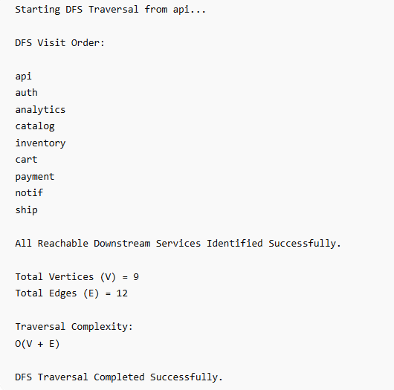

Conclusion
In this case study, DFS was used because it efficiently explores all reachable downstream services in a directed microservice call graph.
The traversal helped identify the exact dependency chain starting from the API gateway and ensured that all connected services were discovered systematically. Using alphabetical neighbor ordering also produced a deterministic traversal sequence.
This approach is highly useful in distributed tracing systems such as Jaeger and Zipkin, where service dependency analysis helps engineers diagnose latency bottlenecks, cascading failures, and complex service-chain behaviors in large-scale cloud applications.
Github Link:
