INTRODUCTION TO DATA SCIENCE / PROJECT REPORT

Used Car Price Prediction
A machine learning study using CarDekho listings
Prepared by | Satwik Abhay
Project team | Karan Veer Panda | Pranay Pareek | Utsav Verma

Project summary
We combined and cleaned four CarDekho listing files, then compared three approaches for estimating used-car asking prices. The prepared data contains 12,705 listings. On a held-out set of 476 listings for model years 2020–2022, the random forest was the strongest model compared, with a mean absolute error (MAE) of ₹7.106 lakh and an R² of 0.739. Its errors remain too large for the estimate to be treated as a dependable market valuation.
Prepared listings | Held-out listings | Best model | Random forest MAE
12,705 | 476 | Random forest | ₹7.106 lakh

A local Streamlit application lets users enter car details, view an estimate, explore the data, and compare model scores. It is an educational demonstration, not a professional pricing service.

1 Introduction
Used-car asking prices vary with vehicle age, kilometres driven, make and model, fuel, transmission, ownership history, and available specifications. This project asks how accurately those recorded details can estimate a listing’s resale asking price. We compare simple and more flexible regression methods on the same held-out set.

Objectives
- Combine CarDekho CSV sources into a consistent dataset for analysis.
- Remove duplicate listings and recognizable two-wheelers while retaining original source files.
- Explore how asking prices vary with model year, mileage, fuel type, and other available details.
- Compare a median-price baseline, linear regression, and random forest regression.
- Present the results through a local Streamlit application and explain its limitations.

2 Dataset
The records come from the Vehicle Dataset from CarDekho collection on Kaggle. Before cleaning, the four included files contained 14,828 records in total. Preparation removed 101 recognizable motorcycles or scooters and 2,022 duplicate listings, leaving 12,705 records. The prepared cars have model years from 1983 through 2022.
Source file | Listings retained | Median price (₹ lakh) | Model years
CarDekho 301-row sample | 198 | 5.25 | 2003–2018
CarDekho details sample | 3,529 | 3.50 | 1992–2020
CarDekho details v3 | 6,924 | 4.00 | 1983–2020
CarDekho details v4 | 2,054 | 8.25 | 1988–2022
Total | 12,705 | — | 1983–2022

The target is selling price, standardized to Indian rupees and reported in lakh (₹1 lakh = ₹100,000). Predictors include make, a two-token model family, model year, kilometres driven, fuel type, seller type, transmission, owner history, mileage, engine size, maximum power, and seating capacity. Present_Price was excluded because it is not consistently available across sources.

3 Data preparation
The source files use different column names and formats. The workflow standardized names, numeric fields, prices, make and model labels, fuel categories, and owner-count categories. Rows missing essential price, year, kilometres, fuel, or transmission information, along with invalid prices or distances, were excluded. Duplicate listings were identified from normalized listing details; when duplicate records differed in completeness, the more complete record was retained. Source identifiers were preserved for traceability and excluded from model inputs. Technical fields missing from some sources are handled in the modelling pipeline.

4 Modelling and evaluation
We used a model-year holdout. The models trained on listings with model years through 2019 and were evaluated on listings from model years 2020–2022. The training set contained 12,229 listings and the test set contained 476. This evaluates newer model-year cars within the available data; it is not a test on current 2026 market prices.
Metric | Meaning
MAE | Average absolute prediction error, in ₹ lakh. Lower is better.
RMSE | Error measure that penalizes large misses more, in ₹ lakh. Lower is better.
R² | Measures fit relative to a mean-based reference. Higher is generally better; negative is worse than that reference.

The median baseline predicts the training-set median for every test listing. Linear regression estimates price from a linear combination of the inputs. Random forest regression combines many decision trees and can represent more complex patterns. All three approaches were evaluated on the same test records.

5 Results
Model | MAE (₹ lakh) | RMSE (₹ lakh) | R²
Random forest | 7.106 | 16.133 | 0.739
Linear regression | 9.429 | 20.655 | 0.573
Median baseline | 22.711 | 38.859 | −0.512

Random forest had the lowest MAE and RMSE and the highest R² among the three approaches. Its MAE means that the absolute difference between predicted and actual test prices averaged about ₹7.106 lakh. Linear regression also outperformed the median baseline. The baseline’s negative R² indicates that predicting a single median value performed poorly on this test set.
The random forest’s RMSE is much larger than its MAE, indicating some predictions miss by substantially more than the typical absolute error. The scatter plot also shows underestimation among some expensive listings. The model is useful for this project’s comparison, but not as a dependable quote for an individual car.

6 Prediction plot
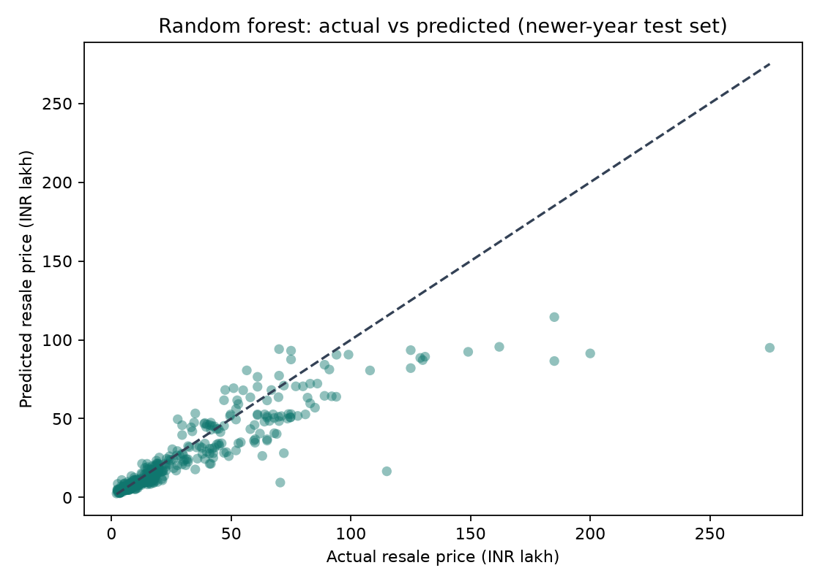
Figure 1. Actual and predicted prices for the 2020–2022 model-year test set. Points closer to the dashed diagonal are more accurate. Several expensive cars fall below the line, indicating underestimation.
Most lower- and mid-priced listings fall closer to the reference line, while several expensive cars fall below it. This shows that errors vary across the price range and helps explain why average metrics do not describe every individual prediction.

7 Streamlit application
The Streamlit application runs locally from the project environment. Users can choose a prediction model, enter vehicle details, receive an estimated price, explore interactive charts, and compare model scores. Inputs include make and model family, model year, kilometres driven, fuel type, seller, transmission, owner history, and optional technical specifications. The data ends at model year 2022. The app permits newer model-year entries for exploration but warns that they are outside the observed training range. A local run is not publicly accessible unless the app is separately hosted.

8 Limitations
- The newest observed model year is 2022, so the results may not reflect current market conditions.
- Asking prices may differ from completed sale prices.
- The source files are snapshots with different fields, collection periods, and coverage. Deduplication reduces overlap but may not remove every inconsistency.
- Condition, accident and service history, exact trim, local market, and listing date are not consistently available.
- The model-year holdout tests newer model years in this dataset, not future market performance.
- The dataset contains outliers and a wide price range; the MAE and RMSE show that large errors remain possible.

Conclusion
The project shows that machine-learning regression can improve on a simple median-price baseline for the prepared CarDekho listings. Random forest performed best in the model-year holdout, but its average error of ₹7.106 lakh and larger misses among expensive listings limit practical reliability. The Streamlit application makes the workflow easier to demonstrate and explore; its estimates should be treated as educational outputs rather than market valuations.

9 Project contributions
Satwik Abhay is the primary documented contributor. His work included setting up and coordinating the project workflow, organizing source CSV files, running and reviewing data preparation and model evaluation, selecting a cars-only analysis scope, examining plots and metrics, defining the Streamlit interface requirements, and running the app locally. AI assistance was used for code drafting and troubleshooting; project outputs and results were reviewed during development.
Karan Veer Panda, Pranay Pareek, and Utsav Verma are listed as project team members. Individual task allocations for these members were not recorded in the information available for this report, so no specific tasks are attributed to them here.

References
[1] Nehal Birla, “Vehicle Dataset from CarDekho,” Kaggle. https://www.kaggle.com/datasets/nehalbirla/vehicle-dataset-from-cardekho
[2] Project outputs: model_metrics.csv, source_summary.csv, and actual_vs_predicted.png in outputs/expanded_dataset/.

