LAB – 7
CLOCK SYNCHRONIZATION

Cristian Algorithm

server.py
import socket
import datetime
import time
# function used to initiate the Clock Server
def initiateClockServer():
s = socket.socket()
print("Socket successfully created")
# Server port
port = 8011
s.bind(('', port))
# Start listening to requests
s.listen(5)
print("Socket is listening...")
# Clock Server Running forever
while True:
# Establish connection with client
connection, address = s.accept()
print('Server connected to', address)
# Respond the client with server clock time
connection.send(str(datetime.datetime.now()).encode())
# Close the connection with the client process
connection.close()
# Driver function
if __name__ == '__main__':
# Trigger the Clock Server
initiateClockServer()

client.py

import socket
import datetime
from dateutil import parser
from timeit import default_timer as timer
def synchronizeTime():
s = socket.socket()
# Server port
port = 8011
# connect to the clock server on local computer
s.connect(('127.0.0.1', port))
request_time = timer()
# receive data from the server
server_time = parser.parse(s.recv(1024).decode())
response_time = timer()
actual_time = datetime.datetime.now()
print("Time returned by server: " + str(server_time))
process_delay_latency = response_time - request_time
print("Process Delay latency: " + str(process_delay_latency) + " seconds")
print("Actual clock time at client side: " + str(actual_time))
# synchronize process client clock time
client_time = server_time + datetime.timedelta(seconds = (process_delay_latency) / 2)
print("Synchronized process client time: " + str(client_time))
# calculate synchronization error
error = actual_time - client_time
print("Synchronization error : " + str(error.total_seconds()) + " seconds")
s.close()
# Driver function
if __name__ == '__main__':
synchronizeTime()

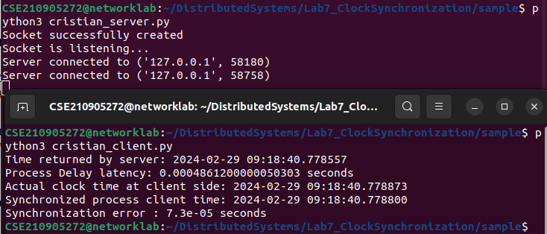
.

Berkeley’s algorithm

server.py
from timeit import default_timer as timer
from dateutil import parser
import threading
import datetime
import socket
import time

# client thread function used to send time at client side
def startSendingTime(slave_client):

while True:
# provide server with clock time at the client
slave_client.send(str(datetime.datetime.now()).encode())

print("Recent time sent successfully", end = "\n\n")
time.sleep(5)

# client thread function used to receive synchronized time
def startReceivingTime(slave_client):

while True:
# receive data from the server
Synchronized_time = parser.parse(slave_client.recv(1024).decode())

print("Synchronized time at the client is: " + str(Synchronized_time), end = "\n\n")

# function used to Synchronize client process time
def initiateSlaveClient(port = 8080):

slave_client = socket.socket()

# connect to the clock server on local computer
slave_client.connect(('127.0.0.1', port))

# start sending time to server
print("Starting to receive time from server\n")
send_time_thread = threading.Thread(target = startSendingTime, args = (slave_client, ))
send_time_thread.start()

# start recieving synchronized from server
print("Starting to recieving " + "synchronized time from server\n")
receive_time_thread = threading.Thread(target = startReceivingTime, args = (slave_client, ))
receive_time_thread.start()

# Driver function
if __name__ == '__main__':

# initialize the Slave / Client
initiateSlaveClient(port = 8080)

client.py

from timeit import default_timer as timer
from dateutil import parser
import threading
import datetime
import socket
import time

# client thread function used to send time at client side
def startSendingTime(slave_client):

while True:
# provide server with clock time at the client
slave_client.send(str(datetime.datetime.now()).encode())

print("Recent time sent successfully", end = "\n\n")
time.sleep(5)

# client thread function used to receive synchronized time
def startReceivingTime(slave_client):

while True:
# receive data from the server
Synchronized_time = parser.parse(slave_client.recv(1024).decode())

print("Synchronized time at the client is: " + str(Synchronized_time), end = "\n\n")

# function used to Synchronize client process time
def initiateSlaveClient(port = 8080):

slave_client = socket.socket()

# connect to the clock server on local computer
slave_client.connect(('127.0.0.1', port))

# start sending time to server
print("Starting to receive time from server\n")
send_time_thread = threading.Thread(target = startSendingTime, args = (slave_client, ))
send_time_thread.start()

# start recieving synchronized from server
print("Starting to recieving " + "synchronized time from server\n")
receive_time_thread = threading.Thread(target = startReceivingTime, args = (slave_client, ))
receive_time_thread.start()

# Driver function
if __name__ == '__main__':

# initialize the Slave / Client
initiateSlaveClient(port = 8080)

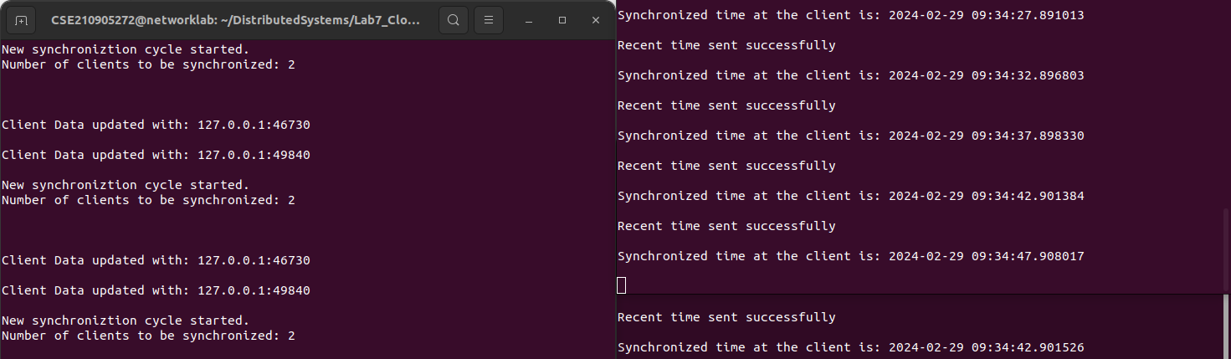
.

LAB EXERCISES

Q1) The Manipal Foodie is a renowned automated food processing outlet known for its tiffin
service to students. The various processes involved are food production, filling and
packing. Every day more than 3000 orders are received on an average from the students in
manipal. There are total of 4 production lines for orders received from KMC, MIT, TAPMI
and SOLS students, each of them has a digital clock which needs to be in synchronization
with the master clock. The master clock mounted in the testing lab controls the entire clock
system. Design an appropriate solution using Berkeley's algorithm for the above scenario.
Assume that the clocks at the institutes are slave/clients.

->
testinglab.py

from timeit import default_timer as timer
from dateutil import parser
import threading
import datetime
import socket
import time

# client thread function used to send time at client side
def startSendingTime(slave_client):

while True:
# provide server with clock time at the client
slave_client.send(str(datetime.datetime.now()).encode())

print("Recent time sent successfully", end = "\n\n")
time.sleep(5)

# client thread function used to receive synchronized time
def startReceivingTime(slave_client):

while True:
# receive data from the server
Synchronized_time = parser.parse(slave_client.recv(1024).decode())

print("Synchronized time at the client is: " + str(Synchronized_time), end = "\n\n")

# function used to Synchronize client process time
def initiateSlaveClient(port = 8080):

slave_client = socket.socket()

# connect to the clock server on local computer
slave_client.connect(('127.0.0.1', port))

# start sending time to server
print("This is the master clock at the testing lab.\n")
send_time_thread = threading.Thread(target = startSendingTime, args = (slave_client, ))
send_time_thread.start()

# start recieving synchronized from server
print("Starting to recieving " + "synchronized time from server\n")
receive_time_thread = threading.Thread(target = startReceivingTime, args = (slave_client, ))
receive_time_thread.start()

# Driver function
if __name__ == '__main__':

# initialize the Slave / Client
initiateSlaveClient(port = 8080)

commonCLient.py

from timeit import default_timer as timer
from dateutil import parser
import threading
import datetime
import socket
import time

# client thread function used to send time at client side
def startSendingTime(slave_client):

while True:
# provide server with clock time at the client
slave_client.send(str(datetime.datetime.now()).encode())

print("Recent time sent successfully", end = "\n\n")
time.sleep(5)

# client thread function used to receive synchronized time
def startReceivingTime(slave_client):

while True:
# receive data from the server
Synchronized_time = parser.parse(slave_client.recv(1024).decode())

print("Synchronized time is: " + str(Synchronized_time), end = "\n\n")

# function used to Synchronize client process time
def initiateSlaveClient(port = 8080):

slave_client = socket.socket()

# connect to the clock server on local computer
slave_client.connect(('127.0.0.1', port))

# start sending time to server
print("This is KMC time client.\nStarting to receive time from server\n")
send_time_thread = threading.Thread(target = startSendingTime, args = (slave_client, ))
send_time_thread.start()

# start recieving synchronized from server
print("Starting to recieving " + "synchronized time from server\n")
receive_time_thread = threading.Thread(target = startReceivingTime, args = (slave_client, ))
receive_time_thread.start()

# Driver function
if __name__ == '__main__':

# initialize the Slave / Client
initiateSlaveClient(port = 8080)

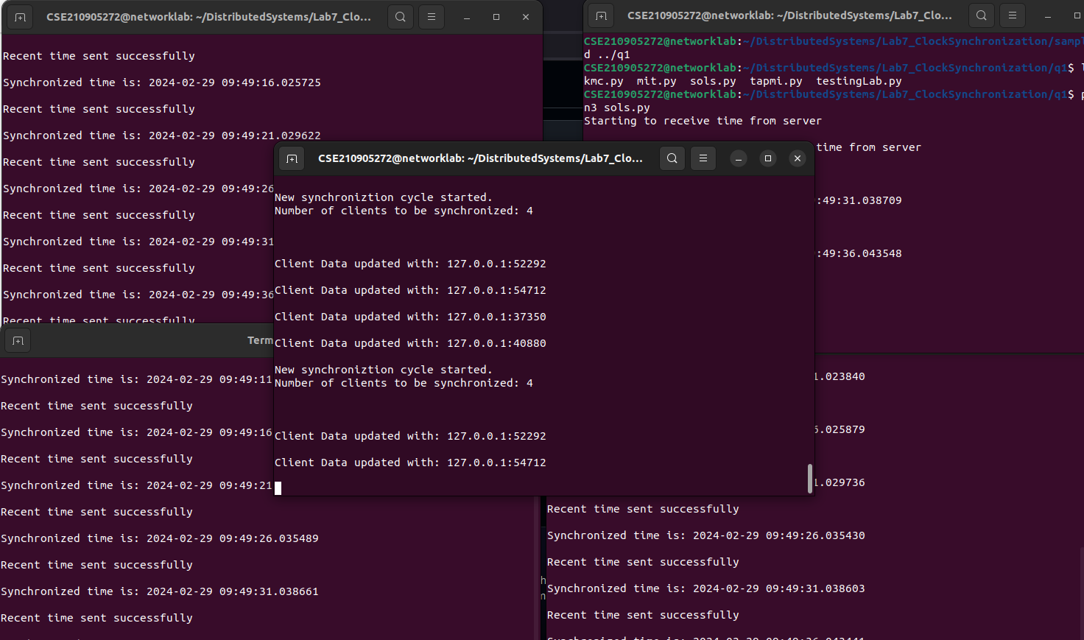
.

Q2) Manipal Buddy is a banking and education application for the students and staff of MIT, Manipal. Mr Vinay, a sixth semester student wants to pay the end semester exams fees for a re-registered course. He simultaneously wishes to register for a course on NPTEL through the app. To register for exam he uses the mobile app whereas to register for NPTEL course he uses his laptop to log in. As he needs to finish both the registrations on the same day, he tries to do both the tasks simultaneously. Analyse and demonstrate using a program how Cristian's algorithm can be used in the above case to synchronize the clocks. Assume the relevant parameters.

->server.py
import socket
import datetime
import time
# function used to initiate the Clock Server
def initiateClockServer():
s = socket.socket()
print("Socket successfully created")
# Server port
port = 8011
s.bind(('', port))
# Start listening to requests
s.listen(5)
print("Socket is listening...")
# Clock Server Running forever
while True:
# Establish connection with client
connection, address = s.accept()
print('Server connected to', address)
# Respond the client with server clock time
connection.send(str(datetime.datetime.now()).encode())
# Close the connection with the client process
connection.close()
# Driver function
if __name__ == '__main__':
# Trigger the Clock Server
initiateClockServer()

client.py

import socket
import datetime
from dateutil import parser
from timeit import default_timer as timer
def synchronizeTime():
s = socket.socket()
# Server port
port = 8011
# connect to the clock server on local computer
s.connect(('127.0.0.1', port))
request_time = timer()
# receive data from the server
server_time = parser.parse(s.recv(1024).decode())
response_time = timer()
actual_time = datetime.datetime.now()
print("Time returned by server: " + str(server_time))
process_delay_latency = response_time - request_time
print("Process Delay latency: " + str(process_delay_latency) + " seconds")
print("Actual clock time at client side: " + str(actual_time))
# synchronize process client clock time
client_time = server_time + datetime.timedelta(seconds = (process_delay_latency) / 2)
print("Synchronized process client time: " + str(client_time))
# calculate synchronization error
error = actual_time - client_time
print("Synchronization error : " + str(error.total_seconds()) + " seconds")
s.close()
# Driver function
if __name__ == '__main__':
synchronizeTime()

