LAB – 6
MAP REDUCE PROGRAMS AND PRACTICE -II
USING PYTHON

Write a mapper and reducer program for word count by defining separator instead of using “\t”.

sepmap.py

import sys

def read_input(file):
for line in file:
# split the line into words
yield line.split()

def main(separator='\t'):
# input comes from STDIN (standard input)
data = read_input(sys.stdin)
for words in data:
# write the results to STDOUT (standard output);
# what we output here will be the input for the
# Reduce step, i.e. the input for reducer.py# tab-delimited; the trivial word count is 1
for word in words:
print ('%s%s%d' % (word, separator, 1))
if __name__== "__main__":
main()

sepred.py
from itertools import groupby
from operator import itemgetter
import sys
def read_mapper_output(file, separator='\t'):
for line in file:
yield line.rstrip().split(separator, 1)
def main(separator='\t'):
# input comes from STDIN (standard input)
data = read_mapper_output(sys.stdin, separator=separator)
# groupby groups multiple word-count pairs by word,
# and creates an iterator that returns consecutive keys and their group:
# current_word - string containing a word (the key)
# group - iterator yielding all ["&lt;current_word&gt;", "&lt;count&gt;"] items
for current_word, group in groupby(data, itemgetter(0)):
try:
total_count = sum(int(count) for current_word, count in group)
print ("%s%s%d" %(current_word, separator, total_count))
except ValueError:
# count was not a number, so silently discard this item
pass
if __name__ == "__main__":
main()

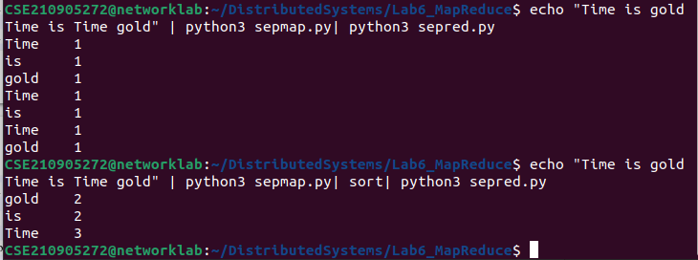

Exercise 4: Try to include separator using map reducing for the output of Heart Diseasedataset, covid_19_data dataset, example dataset and German Credit dataset.
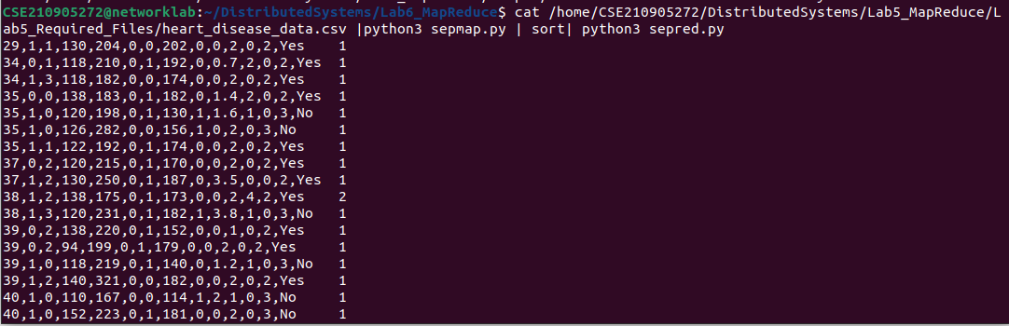
.
Write a map reduce program that returns the cost of the item that is most expensive, for each location in the dataset example.txt
itemmap_expensive.py
import fileinput
for line in fileinput.input():
data = line.strip().split("\t")
if len(data) == 6:
date, time, location, item, cost, payment = data
print ("{0}\t{1}".format(location, cost))
itemred_expensive.py
import fileinput
max_value = 0
old_key = None
for line in fileinput.input():
data = line.strip().split("\t")
if len(data) != 2:
# Something has gone wrong. Skip this line.
continue
current_key, current_value = data
# Refresh for new keys (i.e. locations in the example context)
if old_key and old_key != current_key:
print (old_key, "\t", max_value)
old_key = current_key
max_value = 0
old_key = current_key
if float(current_value) > float(max_value):
max_value = float(current_value)
if old_key != None:
print (old_key, "\t", max_value)
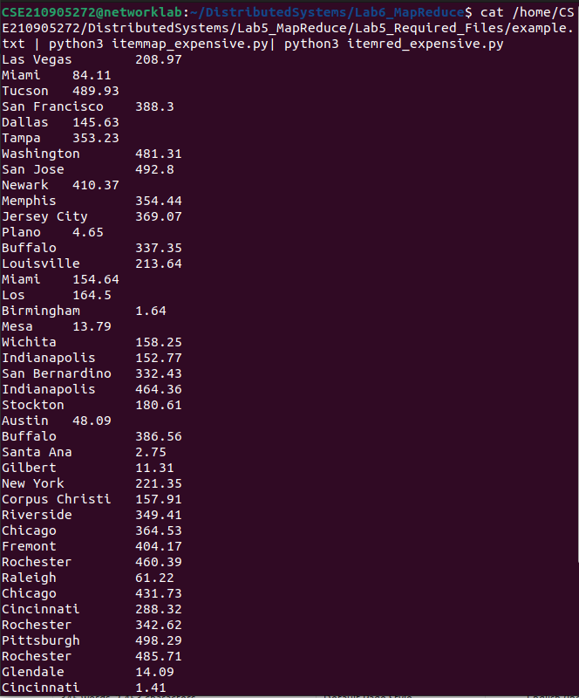
.

Exercise 5: Try to apply finding max value using map reduce concept for the output of Heart Disease dataset, covid_19_data dataset, example dataset and German Credit dataset

mapper:
import fileinput

for line in fileinput.input():
data = line.strip().split(",")
if len(data) == 14:
age,sex,cp,trestbps,chol,fbs,restecg,thalach,exang,oldpeak,slope,ca,thal,target = data
if not chol.isnumeric():
continue
print ("{0}\t{1}".format(age, chol))

reducer:
from itertools import groupby
from operator import itemgetter
import sys

def read_mapper_output(file, separator='\t'):
for line in file:
yield line.rstrip().split(separator, 1)

def main(separator='\t'):
# input comes from STDIN (standard input)
data = read_mapper_output(sys.stdin, separator=separator)
# groupby groups multiple word-count pairs by word,
# and creates an iterator that returns consecutive keys and their group:
# current_word - string containing a word (the key)
# group - iterator yielding all ["&lt;current_word&gt;", "&lt;count&gt;"] items
for current_word, group in groupby(data, itemgetter(0)):
try:
total_count = max(int(count) for current_word, count in group)
print ("%s%s%d" %(current_word, separator, total_count))
except ValueError:
# count was not a number, so silently discard this item
pass

if __name__ == "__main__":
main()

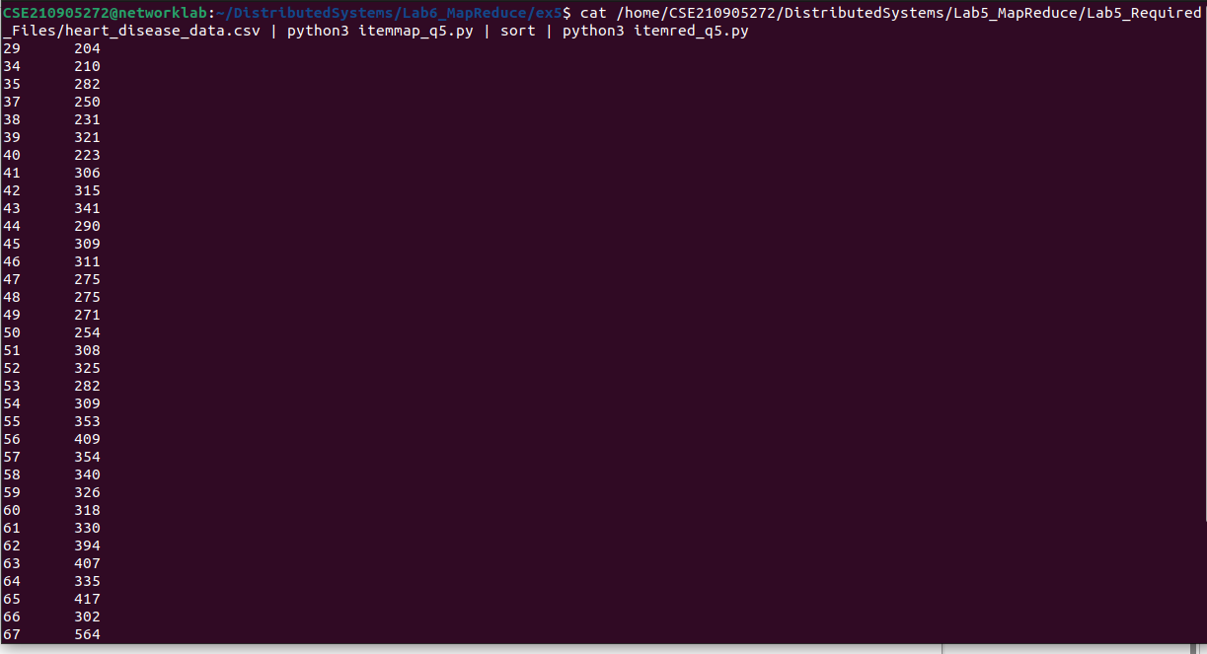

Exercise 6: Write a map reduce program that returns the highest number of confirmed Covid cases for each Country/ Region and display the summary operation of confirmed cases in the dataset covid_data_lab_ds.csv

mapper
import fileinput

for line in fileinput.input():
data = line.strip().split(",")
if len(data) == 8:
SNo, Observation, Province, Country, LastUpdate, Confirmed, Deaths, Recovered = data

if not Confirmed.isnumeric():
continue

print("{0}\t{1}".format(Country, Confirmed))

reducer

from itertools import groupby
from operator import itemgetter

import sys
import pandas as pd

lst=[]

def rmo(file: str, sep='\t'):
for line in file:
a = line.rstrip().split(sep, 1)
lst.append(int(a[1]))
yield a

def main(sep='\t'):
maxv = -1
data = rmo(sys.stdin, sep='\t')
loc = None
# print(groupby(data, itemgetter(0)))
for cw, g in groupby(data, itemgetter(0)):
try:
# lst = [count for _,count in g]
total_count = max(int(count) for _, count in g)
# print(lst)
if maxv<total_count:
maxv = total_count
loc = cw
print("Max in %s:%d" % (cw, total_count))
except ValueError:
pass

# print("Max Confirmed are in: %s%s%d" % (loc, sep, maxv))
# print(lst)
df = pd.DataFrame(lst,columns=['Confirmed'])
print('Summary of Confirmed Cases:')
summary = df['Confirmed'].describe().apply("{0:.4f}".format)
print(summary)

if __name__ == "__main__":
main()

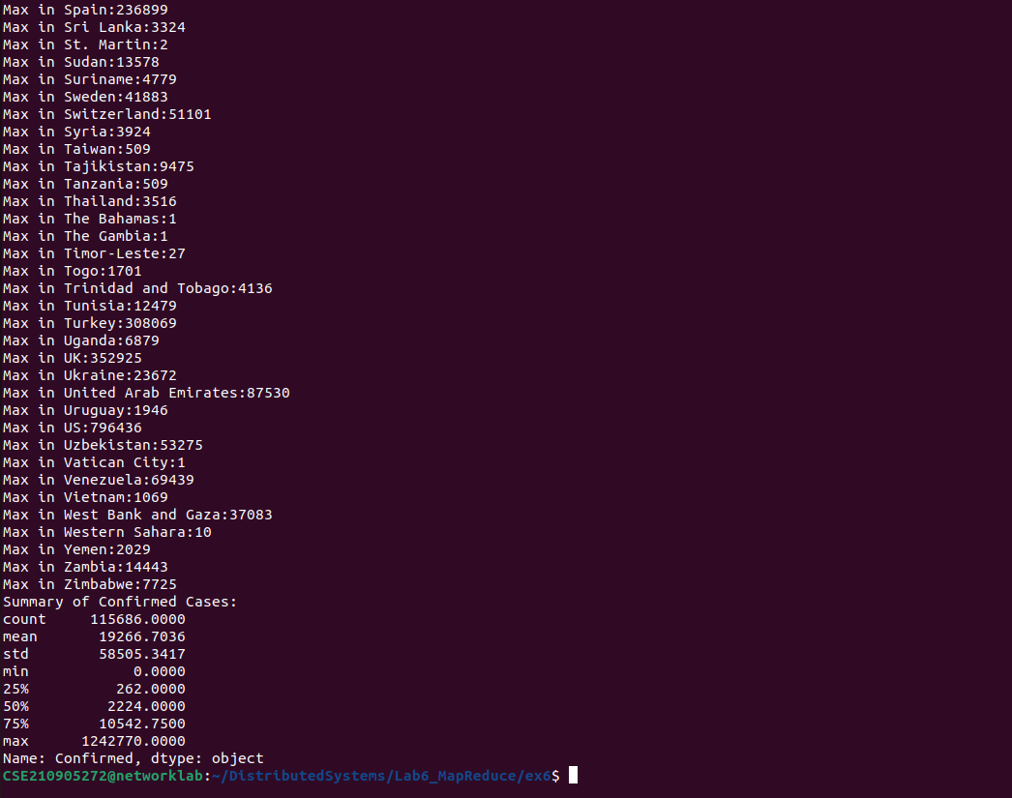

Exercise 7: Write a MapReduce program to count even or odd numbers in randomly generated natural numbers.
sepmap.py
import sys

def read_input(file):
for line in file:
yield line.strip()

def map_numbers(numbers):
for num in numbers:
num = int(num)
if num % 2 == 0:
yield "even", 1
else:
yield "odd", 1

def main():
data = read_input(sys.stdin)
for numbers in data:
numbers = numbers.split()
for key, value in map_numbers(numbers):
print(f"{key}\t{value}")

if __name__ == "__main__":
main()

sepred.py
import sys

def read_mapper_output(file):
for line in file:
yield line.strip().split("\t", 1)

def reduce_counts(data):
counts = {"even": 0, "odd": 0}
for key, value in data:
counts[key] += int(value)
return counts

def main():
data = read_mapper_output(sys.stdin)
counts = reduce_counts(data)
for key, value in counts.items():
print(f"{key}: {value}")

if __name__ == "__main__":
main()

