LAB – 1
PYTHON BASIC PRACTICE – I
SATWIK SAURAV(210905272)

1. Assigning Values to Variables
counter = 100 # An integer assignment
miles = 1000.0 # A floating point
name = "John" # A string
print (counter)
print (miles)
print (name)

2. Multiple Assignment

a=b=c=1
a, b, c = 1, 2, "john"

3. Python Numbers

a = 5 # integer assignment
b= 4.56 #floating point assignment
#mathematical operations with scalar variables
print (5*a)
print (a/2)
print(a**2)
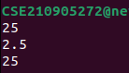

4. NumPy

str = 'Hello World!'
print (str) # Prints complete string
print (str[0]) # Prints first character of the string
print (str[2:5]) # Prints characters starting from 3rd to 5th
print (str[2:]) # Prints string starting from 3rd character
print (str * 2) # Prints string two times
print (str + "TEST") # Prints concatenated string

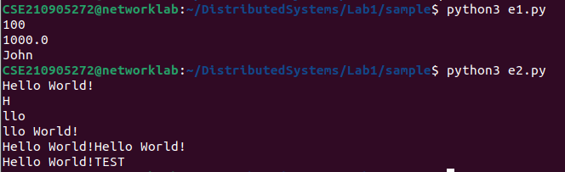

5. Updating a string

var1 = 'Hello World!'
print ("Updated String :", var1[:6] + 'Python')

6. String formatting operator

print( "My name is %s and weight is %d kg!" % ('Satwik', 80))
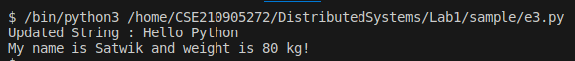

7. Built−in String methods

str = "this is string example...wow!!!";
print (str.capitalize())

str.count('s')

str.find('example')

print (str.lower())

print (str.replace("is", "was"))

print (str.swapcase())

print (str.title())
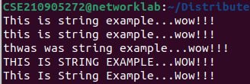

8. Python list

list = [ 'abcd', 786 , 2.23, 'john', 70.2 ]
tinylist = [123, 'john']
print (list) # Prints complete list
print (list[0]) # Prints first element of the list
print (list[1:3]) # Prints elements starting from 2nd till 3rd
print (list[2:]) # Prints elements starting from 3rd element
print (tinylist * 2) # Prints list two times
print (list + tinylist) # Prints concatenated lists

list = ['physics', 'chemistry', 1997, 2000]
list.append('maths')
print(list)

del list[2]

print(len(list))
print(list.count(‘physics’))

#will insert an item in the specified index
list = ['physics', 'chemistry', 1997, 2000];
list.insert (2, 'maths')
print(list)
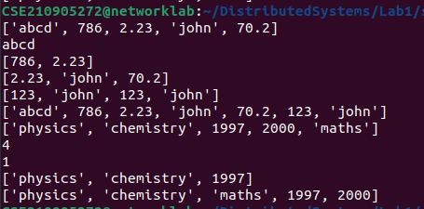

list.remove(‘chemistry’) #will remove the item specified

list.reverse() #will reverse the objects of the list in place.
print(list)

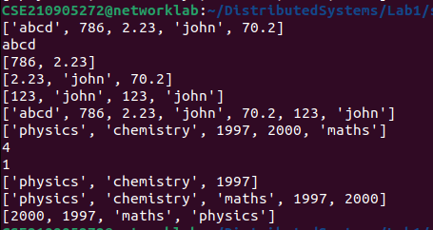

Python TUPLE
Tuples are lists that cannot be edited

tuple = ( 'abcd', 786 , 2.23, 'john', 70.2 )
list = [ 'abcd', 786 , 2.23, 'john', 70.2 ]
tuple[2] = 1000 # Invalid syntax with tuple
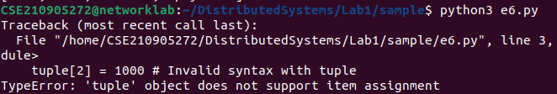
EXAMPLE 1:
num=float(input('Enter a number:'))
if num>0:
print('pos number')
elif num==0:
print('zero')
else:
print('Neg number')
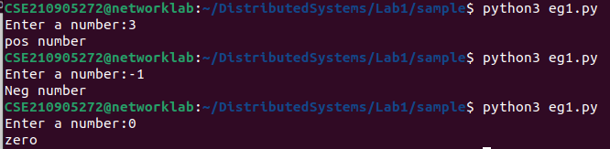
EXAMPLE 2:

x=float(input('Enter a number:'))
if x<10:
print('smaller')
if x>20:
print('bigger')
print('Finished')
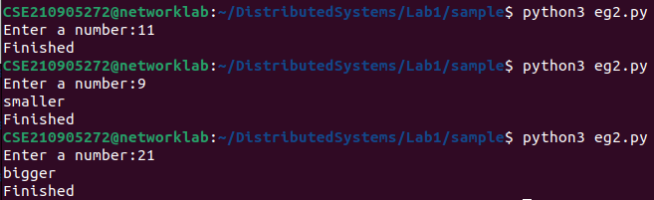

3

for i in range(5):
print(i)
if i>2:
print('Bigger than 2')
print('Done with i',i)

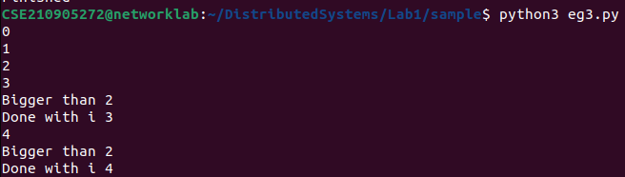
4

x=int(input('Enter a number:'))
for i in range(1,x+1):
if x%i ==0:
print(i)
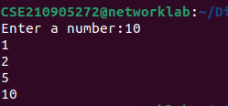

5
from math import *
x= [9, 41, 12, 3, 74, 15]
Largest=-inf
for i in x:
if i>Largest:
Largest=i
print(Largest)
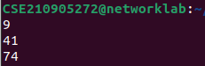

6
from math import *
x= [9, 41, 12, 3, 74, 15]
smallest=inf
for i in x:
if i<smallest:
smallest=i
print(smallest)

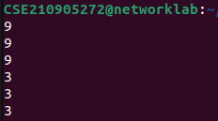

7

x= [9, 41, 12, 3, 74, 15]
count=sum=avg=0
for i in x:
count=count+1
sum=sum+i
avg=sum/count
print(count)
print(sum)
print(avg)

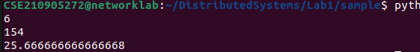

8

x= [9, 41, 12, 3, 74, 15]
for i in x:
if i>20:
print (i)
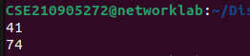

9
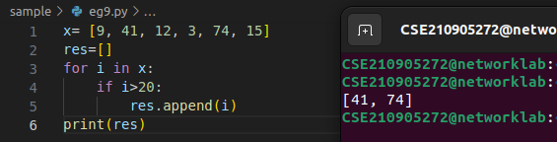
10

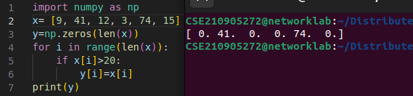

11

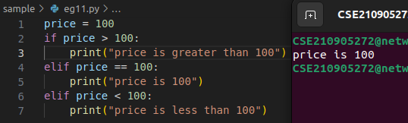
12

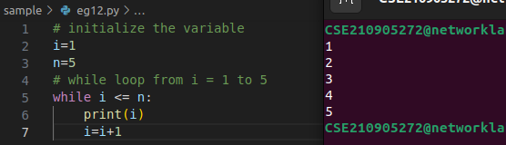

13

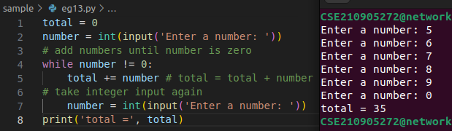

Q1)Write a program to find the area of rectangle. Take input from user.

x=int(input("Enter a: "))
y=int(input("Enter b: "))
x=x*y
print('Area: ', x)
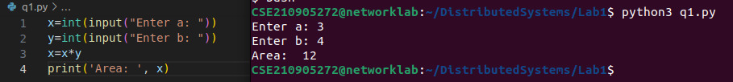
Q2) Write a program to find the area of rectangle. Take input from user.

x=3
y=4
print('x: ',x , 'y: ',y)
temp=x
x=y
y=temp
print(' SWap x: ',x , 'y: ',y)

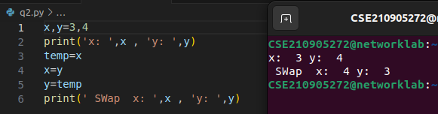
.

Q3) Write a program to find whether a number is even or odd.

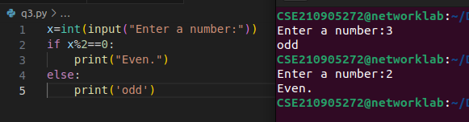
.

Q4)Write a program to check the largest among the given three numbers.

x=int(input(' Enter num: '))
y=int(input(' Enter num: '))
z=int(input(' Enter num: '))

if x>=y:
if(x>=z):
print(x, 'is the largest')
else:
print(z, 'is the largest')
elif y>=x:
if(y>=z):
print(y, 'is the largest')
else:
print(z, 'is the largest')
else:
print(z,'is the largest')

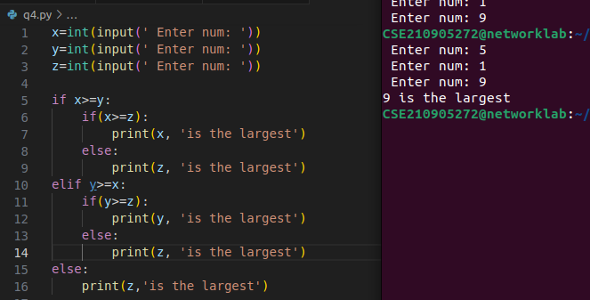
.

5.Write a program to demonstrate List functions and operations.

list = [ 'MIT', 12345 , 3.14, 'TTT', 69.2, 'MIT', 'CAT', 2323]
tinylist = [123, 'BALL']
print (list) # Prints complete list
print (list[0]) # Prints first element of the list
print (list[1:3]) # Prints elements starting from 2nd till 3rd
print (list[2:]) # Prints elements starting from 3rd element
print (tinylist * 2) # Prints list two times
print (list + tinylist) # Prints concatenated list
list.append('maths')
print(list)
del list[2]
print(len(list))
print('Number of times MIT occurs:' ,list.count('MIT'))
list.insert (2, 'maths')
print(list)
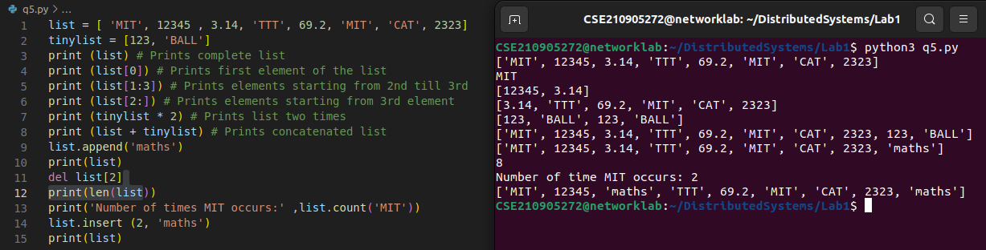
.

6) Consider the tuple(1,3,5,7,9,2,4,6,8,10). Write a program to print half its values in one line and
the other half in the next line.

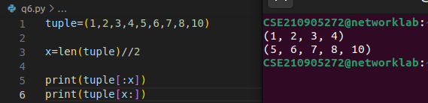
.

7) Consider the tuple (12, 7, 38, 56, 78 ). Write a program to print another tuple whose values are even number in the given tuple.

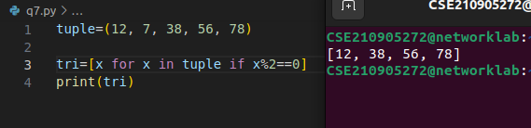
.
8) Write a Python program to print negative Numbers in a List using for loop. Eg. [11, −21, 0, 45, 66, −93].

