LAB – 2
PYTHON BASIC PRACTICE – II

Introduction to PANDAS

import pandas as pd
import numpy as np

s=pd.Series([3,9,-2,10,5])
s.sum()
s.min()
s.max()
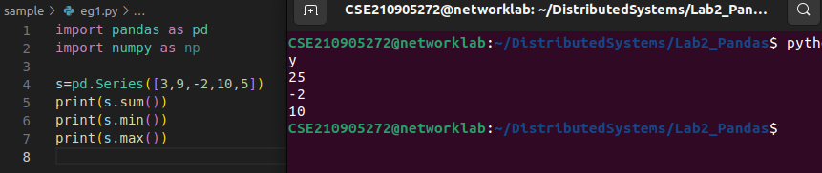

Creating a Data Frame

import pandas as pd
data = [['Dinesh',10],['Nithya',12],['Raji',13]]
df = pd.DataFrame(data,columns=['Name','Age'])
print(data)
print(df)
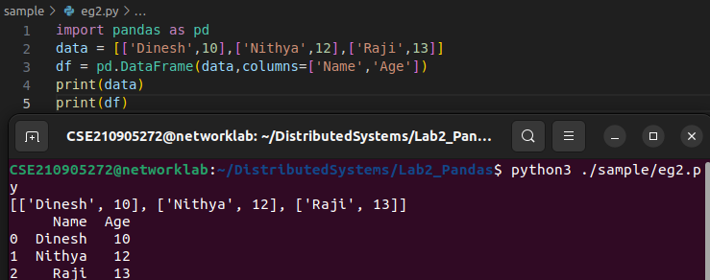
Indexed Data Frame

import pandas as pd

data = {'Name':['Kavitha', 'Sudha', 'Raju','Vignesh'],'Age':[28,34,29,42]}
df = pd.DataFrame(data, index=['rank1','rank2','rank3','rank4'])

print(data)
print(df)

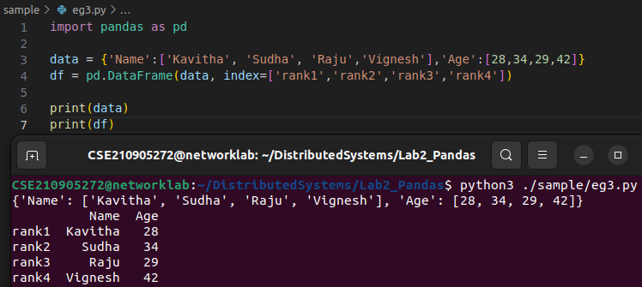

Creating a DataFrame using Dictionary

import pandas as pd
import numpy as np

df1=pd.DataFrame({'A':pd.Timestamp('20130102'),'B':np.array([3]*4,dtype='int32'),'C':pd.Categorical(['Male','Female','Male','Female'])})

print(df1.shape)
print(df1.dtypes)
print(df1.head())
print(df1.tail())
# print(df1.summary())
print(df1.T)
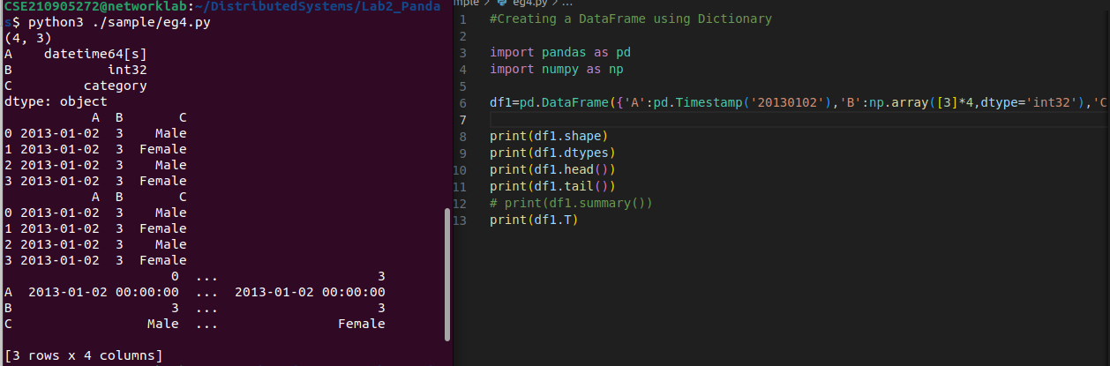
.
Creating a DataFrame using Dictionary

import pandas as pd
import numpy as np

dates=pd.date_range('20130101', periods=100)
df = pd.DataFrame(np.random.randn(100,4), index=dates, columns=list('ABCD'))
print(df.head()) #To view first 5 records
print(df.tail()) #To view last 5 records
print(df.index) #To view the index
print(df.columns) #To view the column names
print(df.T) #To transpose the df
print(df.sort_index(axis=1, ascending=False)) #Sorting by Axis
print(df.sort_values(by='B')) #Sorting by Values
print(df[0:3]) #Slicing the rows
print(df['20130105':'20130110']) #Slicing with index name
print(df.iloc[0]) #slicing with row and column index (like 2D Matrix)
print(df.iloc[0,:2]) #will fetch 1st row, first 2 columns
print(df.iloc[0,0]) #will fetch 1st row, 1st column element (single element)
print(df['A'])#which yields a Series
print(df['A','B']) #Selecting more than one column
print(df[['A','B']][:5]) #Selecting more than one column, with selected number of records

Boolean Indexing
df[df.A>0], will fetch all positive values of A column
Include a 6th column (a categorical) character data
df[‘F’]=[‘Male’,’Female’,’Female’,’Male’,’Female’,’Female’]
Setting by assigning with a numpy array
df.loc[:,’D’]=np.array([5]*len(df))
Deleting a row or column
df.drop (‘col_name’, axis =1, inplace=True)
will drop the column name specified in col_name
df.drop (‘row_index’, axis =0, inplace=True)
Df_new= pd.concat (df1, df2, axis=1)
Df_new.shape
D= pd.concat (A, B, axis=0)
D.shape
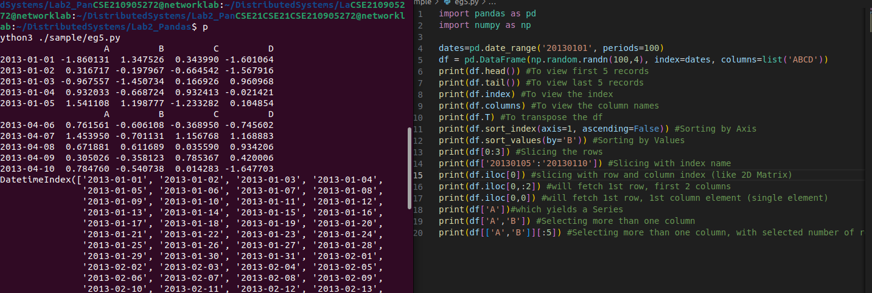
.

I/O operations
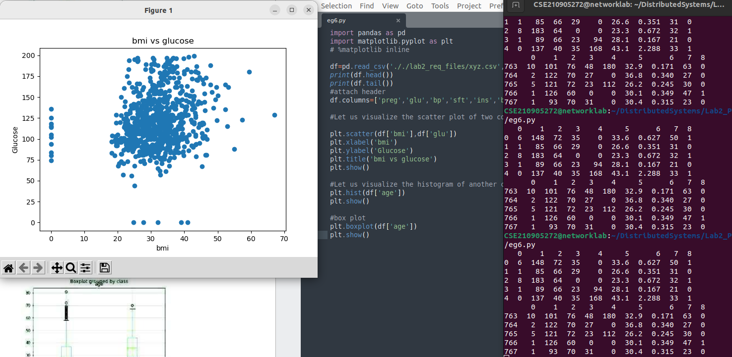

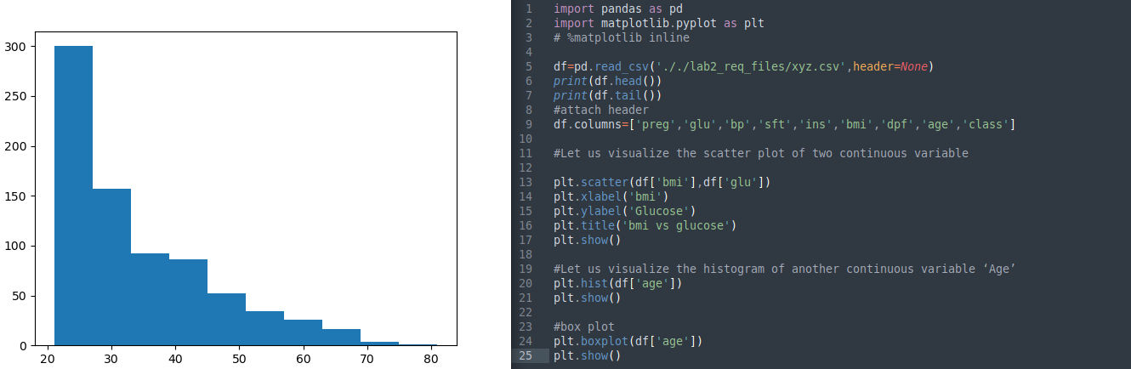
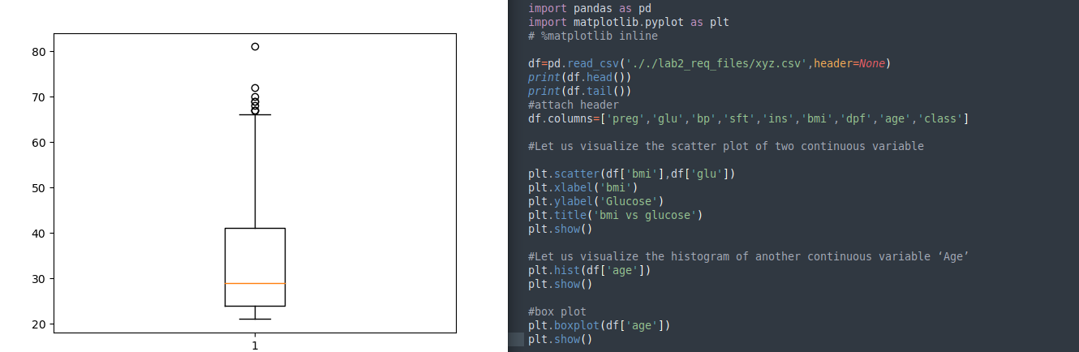

#W = pd.read_csv('xyz.xls',header=None)
#W.head() #XLS file format also, we can read using pd.read_csv
#D= np.loadtxt(‘xyz.data',delimiter=",")
#D[:5,:] # this file is loaded in Numpy 2D array format
# Reading a XLSX file format
#G=pd.read_excel(xyz.xlsx',sheet_name='Sheet1')
#Pandas can read table tabs off of html. For example:
B = pd.read_html('././lab2_req_files/Test runs-1.html')

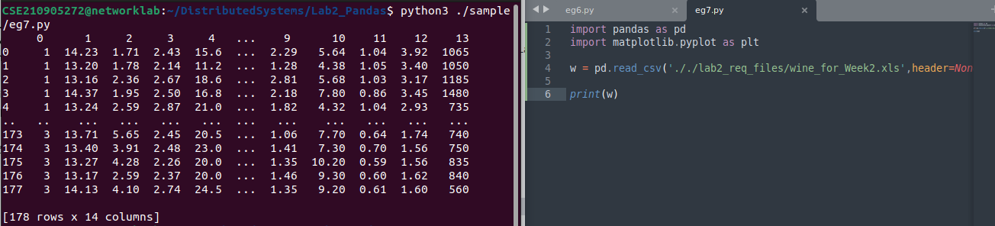
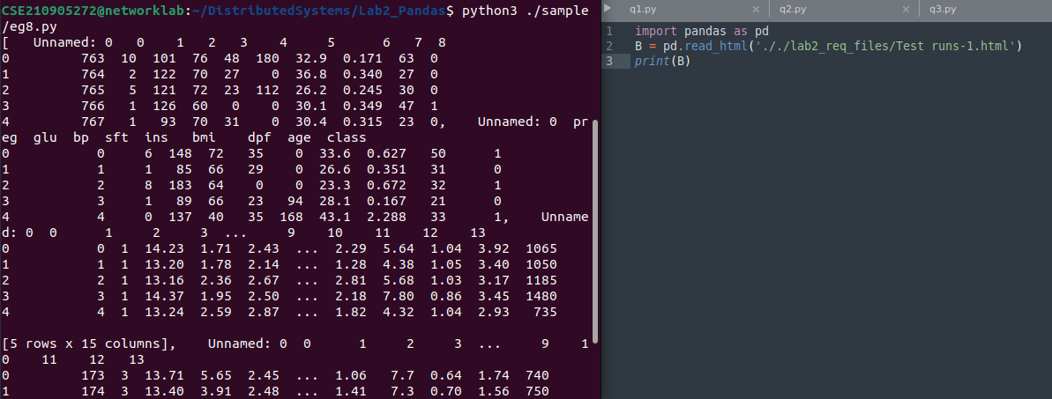
Reading a TXT file format
H = pd.read_table('HR_for_week2.txt')
.

LAB EXERCISES

Q1)Write a program to demonstrate while loop with else
->
i=0;
while(i<3):
print("Value of i is:",i)
i+=1
else:
print("now value of i is>3")
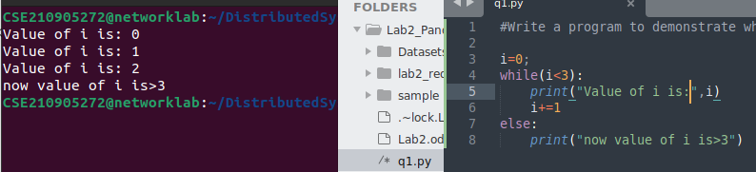
.
Q2)Write a program to print negative Numbers in a List using while loop.
->

from icecream import ic
list1 = [1,2,3,-1,2,-3, -9]
i=0
print("Negative numbers: ")
while i < len(list1):
if list1[i]<0:
print(list1[i])
i+=1
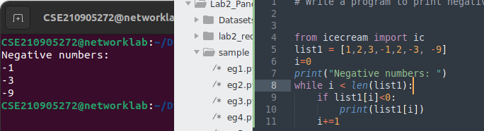

Q3Define a dictionary containing Students data {Name, Height, Qualification}.
a) Convert the dictionary into DataFrame
b) Declare a list that is to be converted into a new column (Address}
c) Using 'Address' as the column name and equate it to the list and display the result.)

->
import pandas as pd
from icecream import ic
import numpy as np
dict1={'Name':['A','B','C'], 'Height':[180,183,190], 'Qualification':'UG'}
studentData= pd.DataFrame(dict1)
print(studentData)

list1=['Shivaji Peth', 'Budhwar Peth', 'Mangalwar Peth']
studentData['Address']=list1
print(studentData)

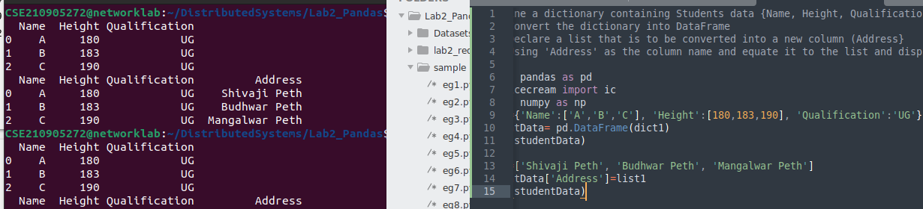
.

Q4) Define a dictionary containing Students data {Name, Height, Qualification}.
a) Convert the dictionary into DataFrame
b) Use DataFrame.insert() to add a column and display the result.

->
import pandas as pd
from icecream import ic
import numpy as np
dict1={'Name':['A','B','C'], 'Height':[180,183,190], 'Qualification':'UG'}
studentData= pd.DataFrame(dict1)

studentData.insert(1,"Address",['Shivaji Peth', 'Budhwar Peth', 'Mangalwar Peth'])
print(studentData)

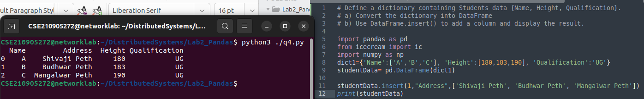
.
Q5)
a) Create two data frames df1 and df2. df1 contains one column ‘Name’ and df2 contains 4 columns ‘Maths’,
‘Physics’, ‘Chemistry’ and ‘Biology’ .
b) Concatenate two data frames df1 and df2. Now insert one column ‘Total’ to the new data frame df_new
and find the sum of all marks.

->
import pandas as pd
from icecream import ic
import numpy as np

df1=pd.DataFrame({'Name':['A', 'B']})
df2=pd.DataFrame({'Maths':[18,20], 'Physics':[20,19], 'Chemistry':[18,19], 'Biology':[19,20]})
# print(df1)
# print(df2)
dfNew=pd.concat([df1,df2],axis=1)
print(dfNew)
dfNew['Total']=df2['Maths']+df2['Physics']+df2['Chemistry']+df2['Biology']

print(dfNew)

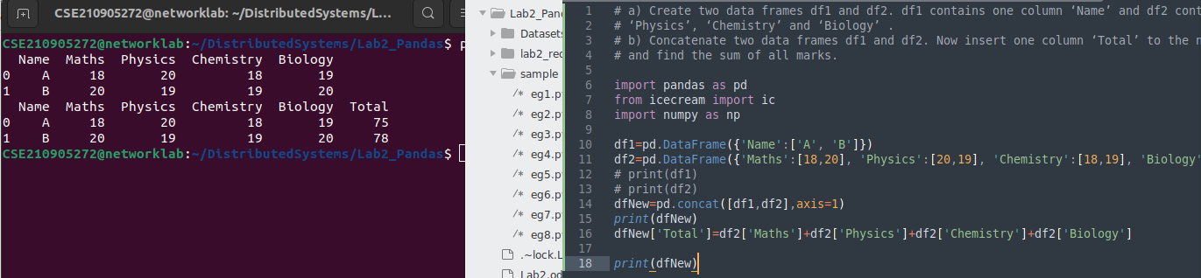
.

Q6) Create a data frame with column- Name, Quiz_1 /10, In-Sem_1 /15, Quiz_2 /10 and In-Sem_2 /15. Now insert a column
Total and find the total and mean as given in the below table.

->
import pandas as pd
from icecream import ic
import numpy as np

df=pd.DataFrame({'Name':['A','B'], 'Quiz1':[9,8], 'Insem1':[14,13], 'Quiz2':[8,10], 'Insem2':[12,14]})
df['Total']=df[['Quiz1','Insem1','Quiz2','Insem2']].sum()
df.loc['mean']=df[['Quiz1','Insem1','Quiz2','Insem2']].mean()
print(df)

