LAB – 4
SOCKET PROGRAMMING USING PYTHON

CONNECTION ORIENTED:

server.py

import socket
host = socket.gethostname()
port=12345
s=socket.socket()
s.bind((host,port))
s.listen(5)
conn,addr = s.accept()
print('Got connection from ',addr[0], '(', addr[1], ')')
print('Thank you for connecting')
while True:
data=conn.recv(1024)
if not data: break
conn.sendall(data)
conn.close()

client.py

import socket
host = socket.gethostname()
port=12345
s=socket.socket()
s.connect((host,port))

print('Welcome User!')
data=s.recv(1024)
s.close()

CONNECTION LESS:

server.py
import socket
sock =socket.socket(socket.AF_INET,socket.SOCK_DGRAM)# For UDP
udp_host = socket.gethostname()# Host IP
udp_port = 12345# specified port to connect

sock.bind((udp_host, udp_port))
while True:
print("Waiting for client...")
data,addr = sock.recvfrom(1024)#receive data from client
print("Received Messages:",data.decode()," from",addr)

client.py
import socket
sock = socket.socket(socket.AF_INET,socket.SOCK_DGRAM)# For UDP
udp_host = socket.gethostname()# Host IP
udp_port = 12345# specified port to connect

msg = "UDP Program!"
print("UDP target IP:", udp_host)
print("UDP target Port:", udp_port)
sock.sendto(msg.encode(),(udp_host,udp_port))

.

Q)# Write a program where client can send a message to the server and the server can receive
# the message and send, or echo, it back to the client

client.py
import socket
HOST = '127.0.0.1' # The server's hostname or IP address
PORT = 2053
# The port used by the server
with socket.socket(socket.AF_INET, socket.SOCK_STREAM) as s:
s.connect((HOST, PORT))
s.sendall(b'Hello, world')
data = s.recv(1024)
print('Received Connection')
print('Server:', data.decode())

server.py

import socket
HOST = '127.0.0.1' # Standard loopback interface address (localhost)
PORT = 2053
# Port to listen on (non-privileged ports are > 1023)
with socket.socket(socket.AF_INET, socket.SOCK_STREAM) as s:
s.bind((HOST, PORT))
s.listen()
conn, addr = s.accept()
with conn:
print('Connected by', addr)
while True:
data = conn.recv(1024)
if data:
print("Client: ",data.decode())
data = input("Enter message to client:");
if not data:
break;
# sending message as bytes to client.
conn.sendall(bytearray(data, 'utf-8'));
conn.close()
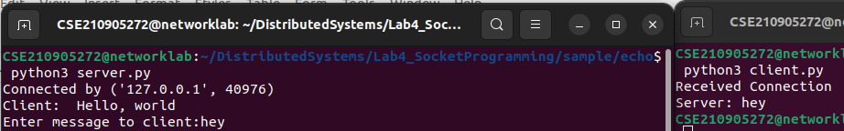
Q)Write a program to create TCP time server in Python
server.py
import socket
import time

# create a socket object
serversocket = socket.socket(
socket.AF_INET, socket.SOCK_STREAM)
# get local machine name
host = socket.gethostname()
port = 9991
# bind to the port
serversocket.bind((host, port))
# queue up to 5 requests
serversocket.listen(5)
while True:
# establish a connection
clientsocket,addr = serversocket.accept()
print("Got a connection from %s" % str(addr))
currentTime = time.ctime(time.time()) + "\r\n"
clientsocket.send(currentTime.encode('ascii'))
clientsocket.close()

client.py
import socket
# create a socket object
s = socket.socket(socket.AF_INET, socket.SOCK_STREAM)
# get local machine name
host = socket.gethostname()
port = 9991
# connection to hostname on the port.
s.connect((host, port))
# Receive no more than 1024 bytes
tm = s.recv(1024)
print(' Current time from Sever :', tm.decode())
s.close()

Q)Write a TCP chat server in python using socket programming.

Server.py
import socket
HOST = '127.0.0.1' # Standard loopback interface address (localhost)
PORT = 31621 # Port to listen on (non-privileged ports are > 1023)
s = socket.socket()
s.bind((HOST, PORT))
s.listen()
print("\nWaiting for incoming connections...\n")
conn, addr = s.accept()
print("Received connection from ", addr[0], "(", addr[1], ")\n")
s_name = conn.recv(1024)
s_name = s_name.decode()
print(s_name, "has connected to the chat room\nEnter [e] to exit chat room\n")
name = input(str("Enter your name: "))
conn.send(name.encode())
while True:
message = input(str("Me : "))
if message == "[e]":
message = "Left chat room!"
conn.send(message.encode())
print("\n")
break
conn.send(message.encode())
message = conn.recv(1024)
message = message.decode()
print(s_name, ":", message)

Client.py

import socket
HOST = '127.0.0.1' # Standard loopback interface address (localhost)
PORT = 31621
# Port to listen on (non-privileged ports are > 1023)
s = socket.socket()
name = input(str("\nEnter your name: "))
print("\nTrying to connect to ", HOST, "(", PORT, ")\n")
s.connect((HOST, PORT))
print("Connected...\n")
s.send(name.encode())
s_name = s.recv(1024)
s_name = s_name.decode()
print(s_name, "has joined the chat room\nEnter [e] to exit chat room\n")
while True:
message = s.recv(1024)
message = message.decode()
print(s_name, ":", message)
message = input(str("Me : "))
if message == "[e]":
message = "Left chat room!"
s.send(message.encode())
print("\n")
break
s.send(message.encode())

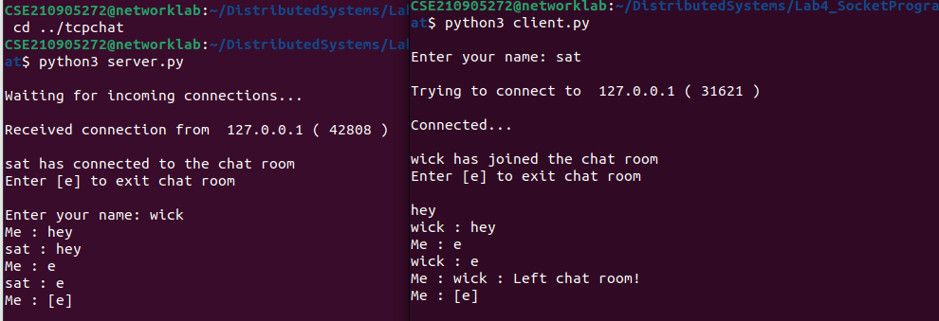
Q)Forking/ Threading (Concurrent Server)

server.py

import socket
import os
from _thread import *
ServerSocket = socket.socket()
host = '127.0.0.1'
port = 11596
ThreadCount = 0
try:
ServerSocket.bind((host, port))
except socket.error as e:
print(str(e))
print('Waitiing for a Connection..')
ServerSocket.listen(5)
def threaded_client(connection):
connection.send(str.encode('Welcome to the Server'))
while True:
data = connection.recv(2048)
print('Received from client :' + str(ThreadCount) +data.decode())
Inputs = input('Server Says: ')
if not data:
break
connection.sendall(Inputs.encode())
connection.close()
while True:
Client, address = ServerSocket.accept()
print('Connected to: ' + address[0] + ':' + str(address[1]))
start_new_thread(threaded_client, (Client, ))
ThreadCount += 1
print('Thread Number: ' + str(ThreadCount))
ServerSocket.close()

client.py

import socket
ClientSocket = socket.socket()
host = '127.0.0.1'
port = 11596
print('Waiting for connection')
try:
ClientSocket.connect((host, port))
except socket.error as e:
print(str(e))
Response = ClientSocket.recv(1024)
while True:
Input = input('Client Say Something: ')
ClientSocket.send(str.encode(Input))
Response = ClientSocket.recv(1024)
print('From Server : ' + Response.decode())
ClientSocket.close()
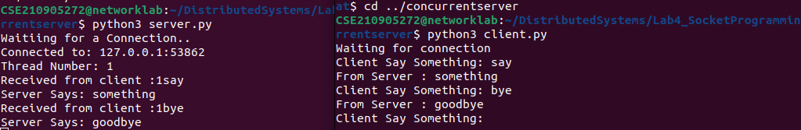

EXERCISE:

Q1)Write a UDP time server to display the current time and day.

Server.py
import socket
import time
udp_host = socket.gethostname()# Host IP
udp_port = 12345# specified port to connect

with socket.socket(socket.AF_INET, socket.SOCK_DGRAM) as s:
s.bind((udp_host, udp_port))
print(f"UDP server listening on {udp_host}:{udp_port}")

while True:
data, addr = s.recvfrom(1024)
print(f"Received request from {addr}")

now = time.ctime(time.time()) + "\r\n"

s.sendto(now.encode(), addr)

client.py
import socket
udp_host = socket.gethostname()# Host IP
udp_port = 12345# specified port to connect

with socket.socket(socket.AF_INET, socket.SOCK_DGRAM) as s:
# Send a request to the server
s.sendto(b'', (udp_host, udp_port))

# Wait for a response from the server
data, _ = s.recvfrom(1024)
print(f"Received time and day of week from server: {data.decode()}")
Q2)Write a UDP simple chat program for message send and receive.

Client.py
import socket
udp_host = socket.gethostname()# Host IP
udp_port = 12345# specified port to connect
addr = (udp_host, udp_port)

with socket.socket(socket.AF_INET, socket.SOCK_DGRAM) as s:
# Send a request to the server
s.sendto(b'', addr)

# Wait for a response from the server
# data, _ = s.recvfrom(1024)
now=input("Enter some text to send:")
s.sendto(now.encode(), addr)
print(f"Client Sent: {now}")
data, _ = s.recvfrom(1024)
print(f"Client Received: {data}")

Server.py
import socket
udp_host = socket.gethostname()# Host IP
udp_port = 12345# specified port to connect

# Create a UDP socket
with socket.socket(socket.AF_INET, socket.SOCK_DGRAM) as s:
s.bind((udp_host, udp_port))
print("###SERVER IS LISTENING###")

while True:
# Receive a request
data, addr = s.recvfrom(1024)
print(f"Received request from {addr}")
data1, _ = s.recvfrom(1024)
print(f"Server received:{data1}")
now=input("Enter some text to send:")
s.sendto(now.encode(), addr)
print(f"Server Sent: {now}")

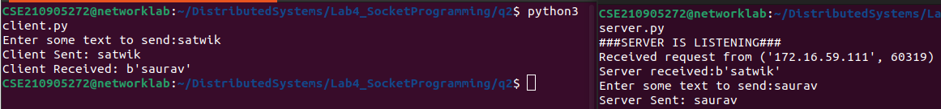
.

Q3)Write a TCP/UDP peer to peer chat system between two different machines.

Server.py
import socket
serv = ('172.16.59.52', 9991)
HOST, PORT = serv[0], serv[1]
s = socket.socket()
s.bind(serv)
s.listen()
print("waiting for incoming connections\n")
conn, addr = s.accept()
print("received connection from ", addr[0], "(", addr[1], ")\n")
s_name = conn.recv(1024).decode()
print(s_name, "has connected to the chat room")
print("enter 'bye' to exit chat room\n")
name = input(str("enter your name: "))
conn.send(name.encode())
while True:
msg = conn.recv(1024).decode()
if(msg=='bye'):
conn.close()
break
print(s_name, ":", msg)
msg = input(str("me: "))
if msg == "bye":
conn.send(msg.encode())
print("\n")
conn.close()
break
conn.send(msg.encode())

client.py
import socket
serv = ('172.16.59.52', 9991)
HOST, PORT = serv[0], serv[1]
s = socket.socket()
name = input(str("\nEnter your name: "))
print("\nTrying to connect to ", HOST, "(", PORT, ")\n")
s.connect(serv)
print("Connected...\n")
s.send(name.encode())
s_name = s.recv(1024).decode()
print(s_name, "has connected to the chat room")
print("\nEnter 'bye' to exit chat room\n")
while True:
msg = str(input("Me : "))
if msg == "bye":
print("Left chat room")
s.send(msg.encode())
print("\n")
s.close()
break
s.send(msg.encode())
msg = s.recv(1024).decode()
if(msg=='bye'):
print("exit initiated by server ")
s.close()
break
print(s_name, ":", msg)

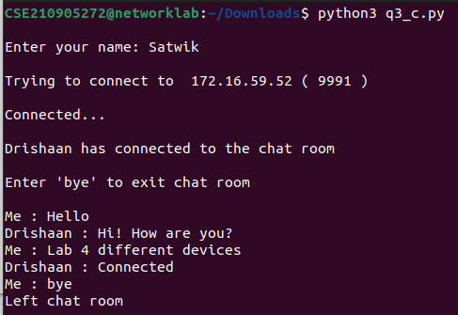

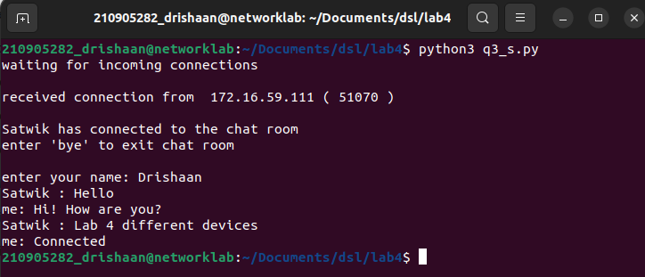

Q4)Try to debug the error in the code and execute it.

Server.py
import socket

serverIP = 'localhost'
serverPort = 16000
serverSock = socket.socket(socket.AF_INET, socket.SOCK_STREAM)
serverSock.bind((serverIP, serverPort))
serverSock.listen(1)
print("TCP server has started and is ready to receive")

while True:
connection, addr = serverSock.accept()
# data = connection.recv(1024)
data = connection.recv(1024).decode()
if not data: break

temp = [float(x) for x in data.split(' ')]

print("Received data:", temp)

length = len(temp)
maximum = max(temp)
minimum = min(temp)
total = sum(temp)
mean = total/length
msg = str(total) + " " + str(minimum) + " " + str(maximum) + " " + str(mean)
# connection.send(str(msg))
connection.send(str(msg).encode())

Client.py
import socket
serverIP = 'localhost'
serverPort = 16000
clientSock = socket.socket(socket.AF_INET, socket.SOCK_STREAM)
clientSock.connect((serverIP, serverPort))

message = input("Input integers with space in between: ").encode()
# clientSock.connect((serverIP, serverPort))
# message = raw_input("Input integers with space in between: ")
#message2 = input("Enter the length of the set: ").encode()

clientSock.send(message)
#clientSock.send(message2)

#data = clientSock.recv(1024)
data = clientSock.recv(1024).decode()

temp = [float(x) for x in data.split(' ')]

print("The total of all numbers is: " + str(temp[0]))
print("The lowest number is: " + str(temp[1]))
print("The highest number is: " + str(temp[2]))
print("The mean is: " + str(temp[3]))

clientSock.close()

