LAB – 5
MAP REDUCE PROGRAMS AND PRACTICE -I
USING PYTHON

mapper.py
import sys
# input comes from STDIN (standard input)
for line in sys.stdin:
# remove leading and trailing whitespace
line = line.strip()
# split the line into words
words = line.split()
# increase counters
for word in words:
# write the results to STDOUT (standard output);
# what we output here will be the input for the
# Reduce step, i.e. the input for reducer.py
#
# tab-delimited; the trivial word count is 1
print ('%s\t%s' % (word, 1))

reducer.py
from operator import itemgetter
import sys
current_word = None
current_count = 0
word = None
# input comes from STDIN
for line in sys.stdin:
# remove leading and trailing whitespace
line = line.strip()
# parse the input we got from mapper.py
word, count = line.split('\t', 1)
# convert count (currently a string) to int
try:
count = int(count)
except ValueError:
# count was not a number, so silently
# ignore/discard this line
continue
# this IF-switch only works because Hadoop sorts map output
# by key (here: word) before it is passed to the reducer
if current_word == word:
current_count += count
else:
if current_word:
# write result to STDOUT
print ('%s\t%s' % (current_word, current_count))
current_count = count
current_word = word
# do not forget to output the last word if needed!
if current_word == word:
print ('%s\t%s' % (current_word, current_count))

echo "a a a a v v f f hh hh fg tg fg gt nnn ccc ddd nnn ddd"|python3 mapper.py

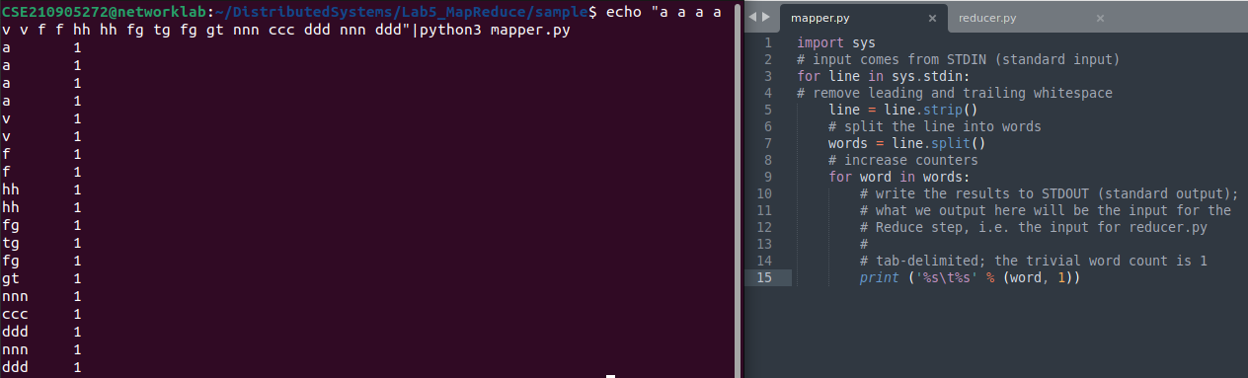

echo "a a a a v v f f hh hh fg tg fg gt nnn ccc ddd nnn ddd"|python3 mapper.py|python3 reducer.py

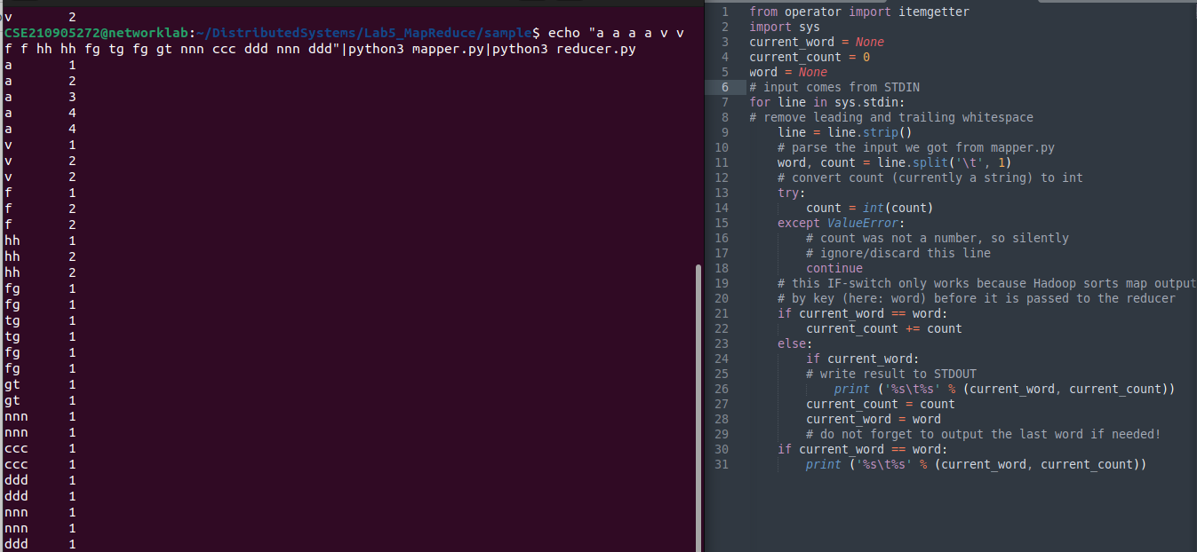

echo "a a a a v v f f hh hh fg tg fg gt nnn ccc ddd nnn ddd"|python3 mapper.py|sort|python3 reducer.py

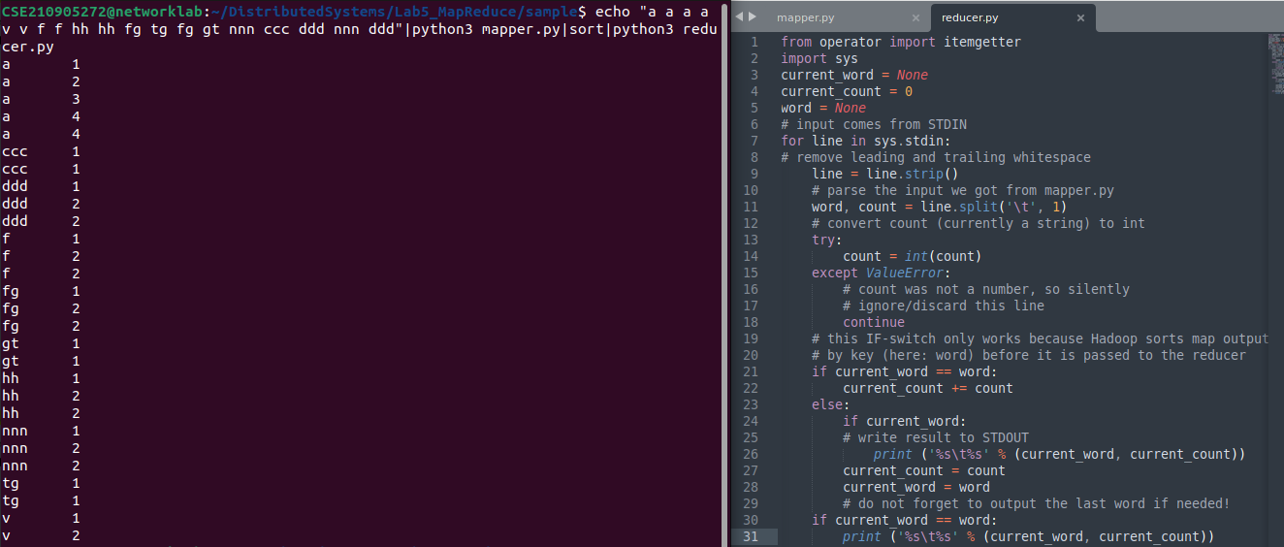

echo "a a a a v v f f hh hh fg tg fg gt nnn ccc ddd nnn ddd"|python3 mapper.py|python3 reducer.py > out.txt

