LAB – 3
PYTHON BASIC PRACTICE – III

import numpy as np

A = np.array ([2,5,10])
print(A.dtype)

B=np.array ([2.4,10.6,5.2])
print(B.dtype)

A=np.array([(3,4,5),(12,6,1)])
print(A)

Z=np.zeros((2,4)) # will create zero matrix of dimension 2x4
print(Z)

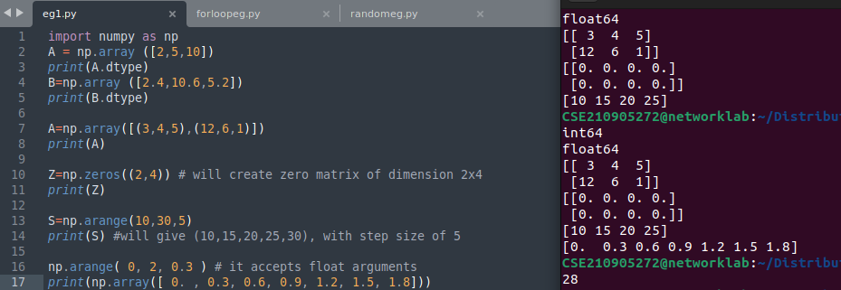
.

import random
print(random.choice([1,2,3,4,5]))#, this will pick one number from the list randomly
print(random.choice('python'))#, will pick one character from the string randomly
print(random.randrange(25,50))# will pick one integer between 25 to 50
print(random.randrange(25,50,2))#, will pick one integer between 25 to 50 with step size of 2
print(random.random())#, will pick a random number between 0 to 1
print(random.uniform(5,10))#, will pick a floating point number between 5 to 10
print(random.shuffle([1,2,3,4,5]))#, will shuffle the list elements
print(random.seed(10))#, to get same random value during every execution

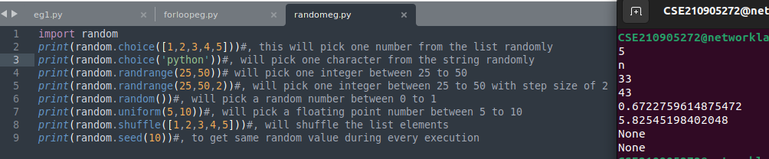
.

# Calculate sum of all the elements in a 2D Numpy Array (iterate over range)
import numpy as np

a=np.array([(3,2,9),(1,6,7)])
s=0
for i in range(a.shape[0]):
for j in range(a.shape[1]):
s+=a[i,j]
print(s)

# Calculate sum of all the elements in a 2D Numpy Array (iterate over elements)
s1=0
for row in a:
for col in row:
s1+=col
print(s1)

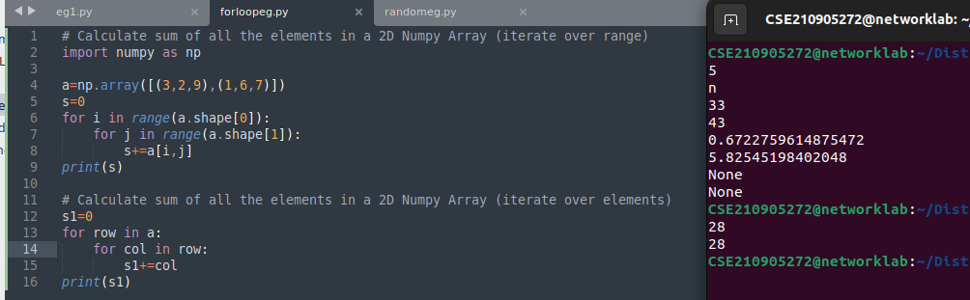
import numpy as np

a = np.arange(15).reshape(3, 5)
np.array([[ 0, 1, 2, 3, 4],
[ 5, 6, 7, 8, 9],
[10, 11, 12, 13, 14]])
#to check the dimension
print(a.shape)
print(a.size) # will return total elements in matrix (here 15)
# to transpose a matrix
print(a.T) # transposed to 5x3 matrix
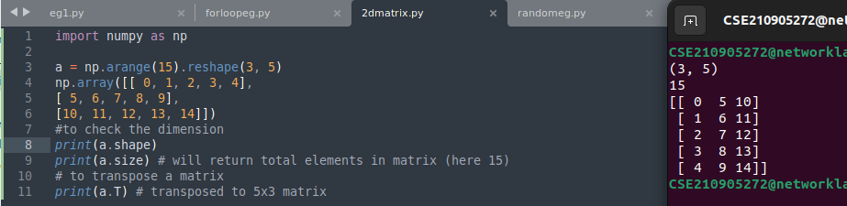

import numpy as np

c = np.arange(24).reshape(2,3,4) # 1st value indicates (no of planes) (3,4) is the dimension
print(c)

print(c.shape)
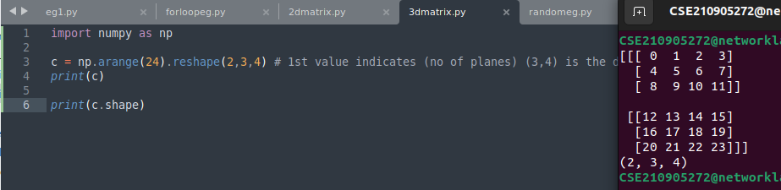
.

import numpy as np
a = np.array( [20,30,40,50] )
b = np.arange( 4 )
print(b)
# array([0, 1, 2, 3])
c = a−b
print(c)
# array([20, 29, 38, 47])

print(b**2)
array([0, 1, 4, 9])
10*np.sin(a)
array([ 9.12945251, −9.88031624, 7.4511316 , −2.62374854])
a<35
array([ True, True, False, False], dtype=bool)

import numpy as np
a = np.array([4.,2.])
b = np.array([3.,8.])
print(np.column_stack((a,b))) # returns a 2D array
print(np.array([[ 4., 3.],
[ 2., 8.]]))

np.hstack((a,b))
# the result is different
np.array([ 4., 2., 3., 8.])
print(np.hstack((a[0],b[0]))) # the result is the same
np.array([[ 4., 3.],
[ 2., 8.]])

import numpy as np
a = np.arange(10)**3
print(a)
np.array([ 0, 1, 8, 27, 64, 125, 216, 343, 512, 729])
print(a[2:5])
np.array([ 8, 27, 64])
print(a[0:6:2])
np.array([0,8,64,216])
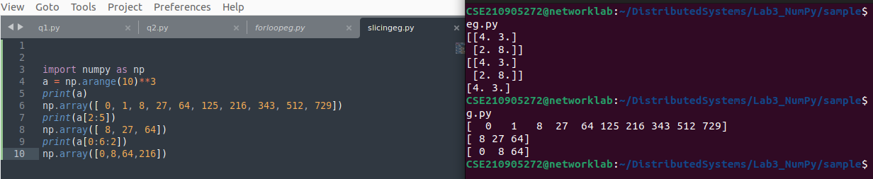

import numpy as np

A = np.array( [[1,1],[0,1]] )
B = np.array( [[2,0],[3,4]] )
print(A*B)
# elementwise product
np.array([[2, 0],
[0, 4]])
A.dot(B)
# matrix product
np.array([[5, 4],
[3, 4]])
# (OR)
np.dot(A, B)
np.array([[5, 4],
[3, 4]])
# another matrix product
b = np.arange(12).reshape(3,4)
print(b)
np.array([[ 0, 1, 2, 3],
[ 4, 5, 6, 7],
[ 8, 9, 10, 11]])
b.sum(axis=0)
np.array([12, 15, 18, 21])# sum of each column
b.sum(axis=1)
np.array([6, 22, 38])

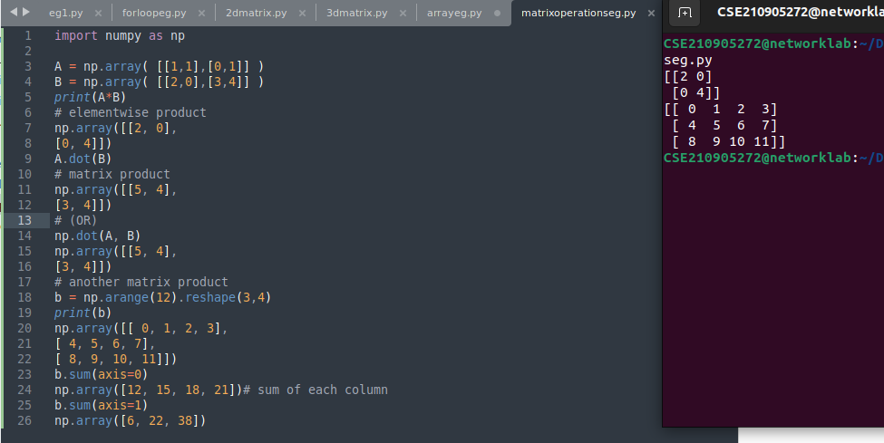
.

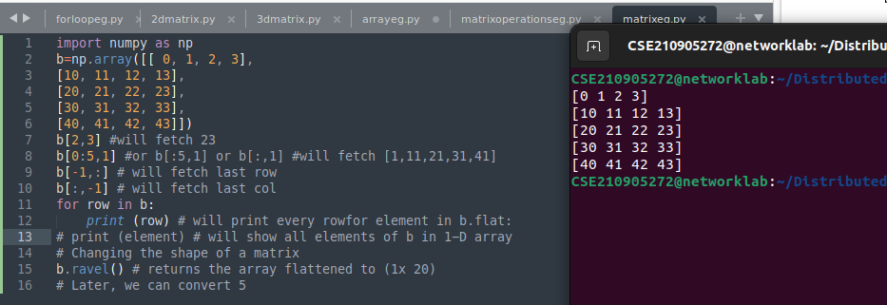
.

LAB EXERCISES:

Q1)Write a program to find the factors of a given number (get input from user) using for loop.




